Annual Report

2014-2015

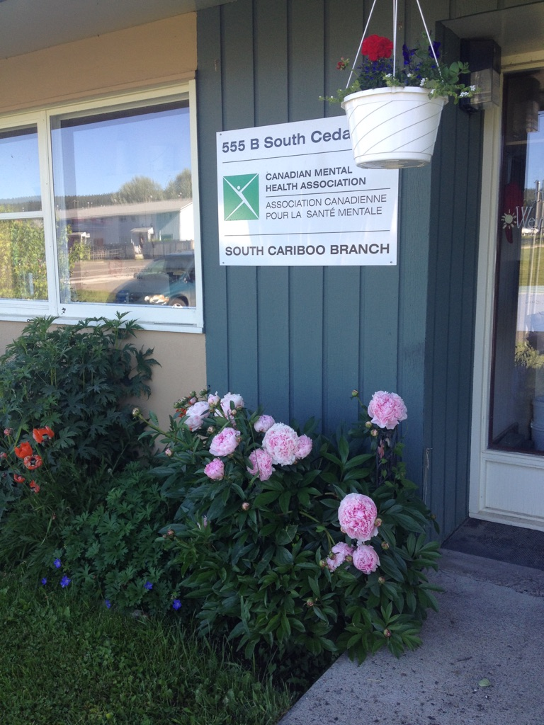

Agency Profile

Canadian Mental Health Association, South Cariboo Branch, is an autonomous, non-profit, charitable organization with ethical and legal responsibilities to the National and BC Divisions of CMHA. Our mandate emphasizes the importance of people with lived experience of mental illness being involved in the delivery of service and governance wherever possible.

Our Vision:

“Mentally Healthy People in a Healthy Society”

Our Mission:
Founded in 1918, The Canadian Mental Health Association (CMHA) is a national charity that helps maintain and improve mental health for all Canadians. As the nation-wide leader and champion for mental health, CMHA helps people access the community resources they need to build resilience and support recovery from mental illness.
In BC, mental health, substance use and addictive behaviour are within scope of the organization.
CMHA South Cariboo Branch believes in:

- Social justice
- Individual and collective responsibility
- Access to appropriate and adequate resources and supports
- Self-determination
- Maximum community inclusion
- Working collaboratively with our community partners

Geographic Catchment area:

The South Cariboo is a sub-region of the Cariboo Regional District in the Interior of British Columbia. Its main population center is the District Municipality of 100 Mile House, a community of approximately 2,000 residents. An additional 18,000 people live in the South Cariboo. The South Cariboo boundaries are roughly described as 70 Mile House in the South to Lac la Hache in the North, and the Fraser River to the West to Lac des Roches and Mahood Lake to the East. The region includes 100 Mile House and many smaller communities such as Forest Grove, Buffalo Creek, Lac la Hache, 108 Mile Ranch, Lone Butte, Sheridan Lake, Bridge Lake, and Watch Lake/Green Lake.

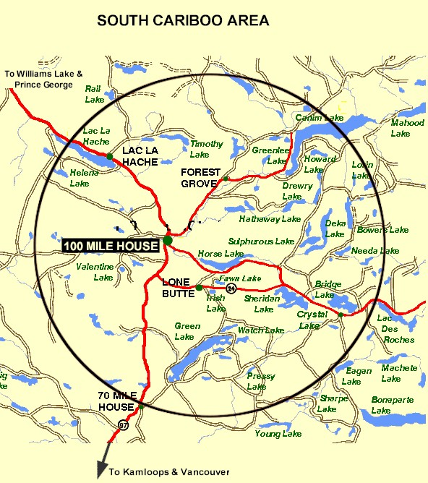

President’s Report:

Over the past year CMHA-SCB has seen many changes. Five long term Board Members retired and three new Board Members joined. In June of last year we hired our new Executive Director Susann Collins after our long term ED, Maggie Patterson-Dickey retired. We have gone through some steep learning curves both as a Board and staff, but I am sure we are stronger and more knowledgeable for it.

This next year will also provide us some new opportunities as we will be saying goodbye to four Board members. We will miss all of the support and focus that Valinda Boyd, Didi Henderson, Linda Savjord and Lynn Rollert have brought to our Board. We are also looking forward to the addition of another new Board member with diverse skill sets.

On behalf of the Board of Directors, I would like to thank Susann and her staff for all they do to help and support our clients. I would also like to thank the Board members for all their hard work and countless volunteer hours.

I will be stepping down as President of the Board after the election of the new Board, but, as our main focus for the next year will be acquiring Imagine Canada accreditation, I will stay on to assist with the Imagine Canada Standards accreditation process.

During my time as a board member I have learned a great deal and feel so grateful to have worked with so many incredible Board members, two wonderful Executive Directors and their professional staff who support us.

Thank you for the opportunity.
Jeanne Best, Board President/Chair

Executive Directors Report:

The June 24th, 2015 Annual General Meeting provides an opportunity for our members to gather together and take a moment to look back upon and celebrate what we have accomplished over this past very busy year. This year has passed by so quickly, it is hard to believe that I have been the Executive Director for a year now.
I want to sincerely thank the CMHA Board of Directors and CMHA staff members for their continuing hard work and dedication: heroes all. My work would be much more difficult without their support and assistance throughout the year. They are a group of dedicated compassionate people whose support and exemplary service to CMHA South Cariboo Branch accomplishes so much to improve the lives of the citizens of our community.
Thank you as well to our members – you are the heart of our organization.
I would also like to thank community agencies, community members and volunteers that have allowed us to promote mental health through awareness events and assisted us to achieve our fundraising goals over the past year. Events like Mental Health Week, Ride Don’t Hide, Mental Illness Awareness Week and Beyond the Blues were all successful events that met our goals of increasing mental health awareness, reducing the stigma associated with mental illness and of raising the profile of CMHA’s work in the South Cariboo. This is an invaluable part of our work – locally, in BC and across Canada. We continue to work to solidify our operations, services, and administrative processes as well as to improve the overall efficiency of our agency. At the same time we work collaboratively with other local agencies, and maintain a grassroots approach to meeting the needs of our community. We remain formally connected to the South Cariboo Community Planning Council, and to ‘Stemete7uw’i - A Gathering Place for the South Cariboo’ as organizational members.
We continue to look for ways to build our Branch’s capacity to foster key supports in our community. Through partnerships with other local non-profits, we add value to our Homelessness support and food security programs, such as “Soup de Tour” and the Emergency Transportation program. These programs are made possible with the help of the South Cariboo Health Foundation, the United Way, the Cariboo Regional District, private donors, and also, through the fundraising efforts of our Board of Directors.
In addition to providing support to the Board of Directors by overseeing CMHA SCB operations, a large part of my work is involvement with our CMHA BC Division provincial movement. We are one of 14 branches of CMHA BC Division, and 135 branches Canada wide. Together, we continue our work in building a stronger, more cohesive movement promoting mental health across Canada.
Over the next year we will be working very hard, as we, along with other BC CMHA branches do the work to become accredited with Imagine Canada. Imagine Canada’s National Standards Program is a Canada-wide set of shared standards for charities and nonprofits designed to strengthen practices in five fundamental areas: board governance; financial accountability and transparency; fundraising; staff management; and volunteer involvement. It is a rigorous, peer-reviewed process and the accreditation designation indicates an organization is dedicated to operational excellence, and is worthy of public trust and confidence.
Susann Collins, Executive Director

History of Canadian Mental Health Association

CMHA National: One of Canada’s Oldest Non-Profits:

The Canadian Mental Health Association is one of the oldest national, charitable organizations in Canada and the oldest national mental health charity. Each year, CMHA divisions and branches across Canada provide service to more than 100,000 Canadians through the combined efforts of more than 10,000 volunteers and staff in locally run organizations in more than 120 communities. Visit CMHA National’s website for more information.
CMHA was founded in 1918 by Dr. Clarence M. Hincks, Dr. Charles K. Clarke and Clifford W. Beers as the Canadian National Committee for Mental Hygiene. The original goals of the organization centered on war recruits, mental examination of post-war immigrants, prevention, and support for adequate facilities and care for the treatment of mental illness.
Dr. Hincks became director of the association in 1924. He developed an interest in patients whose work and productive lives were hampered by what was then seen as malfunctions of the mind. He suffered from periodic bouts of depression all his life, so his empathy toward his fellow sufferers, coupled with a profound knowledge of medicine and early twentieth-century psychological developments in Europe revolutionized the conditions and treatment of mental health patients in Canada.
CMHA is uniquely positioned in Canada as a charity that brings together community-based experience and expertise on the prevention of mental illness and community supports for the mental well-being of all Canadians. We are not only unique in our mental health promotion approach but also in our ability to speak to issues spanning the broad range of mental disorders and the full spectrum of those affected from those at risk, to those newly diagnosed, to those who have been living with a psychiatric disability over the longer-term, as well as family, friends and community gatekeepers.
CMHA BC Division’s Beginnings
In 1952, with the assistance of Clarence M. Hincks, British Columbia saw the creation of a BC Division of CMHA. The office started with a federal mental health grant which was gradually diminished over three years as other sources of funding were found. CMHA volunteers became involved in the support of patients at Riverview Hospital and ran the thrift store. At one point, BC Division had employed more people with mental illness than any division in the country. Throughout its history, the division has advocated for changes to legislation and policy affecting people with a mental illness ensuring the availability of community alternatives, access to housing, and income supports. In its monitoring and systemic advocacy role, BC Division has played an important role in the reform of the mental health care system, as well as in community-based research and evaluation, employment supports, public education, and branch support. This history would not be complete if it did not also reflect the pride BC Division has felt being part of a network of CMHA branches in communities across BC whose grassroots involvement and direct services – such as housing, employment services, crisis lines, and support groups to name a few – have touched the lives of countless British Columbians. CMHA BC Division was officially incorporated on October 6, 1953.

CMHA South Cariboo Branch

CMHA in 100 Mile was started by a group of concerned individuals in the late 1980’s. The group’s early meetings took place in the Rosewood Building on Birch Avenue, and included individuals living with mental illness; their friends and family members; mental health service providers and local physicians. As mental health support services in the South Cariboo at that time were very limited, the initial goal for members was to begin to develop resources and a network of support - both for individuals living with a mental illness, and to those who were part of their lives. The branch was incorporated in June 1992. The branch’s early goals were to be actively involved in the development of psychiatric services to our community, and to find funds to develop a clubhouse or drop in center where people who live with mental illness could congregate, socialize and receive the help needed to live successfully in their homes and community. Since its inception, CMHA South Cariboo Branch has grown from a one staff office to a multi-program system. We continue to take pride in our identity as a grassroots organization that adapts to serve the need of our community.
Prevention is fundamental to all of the services we provide and is reflected through the work of the branch during Mental Health Week, Mental Illness Awareness Week, the ‘Give Hope’ Campaign, and through community information displays, health fairs and public awareness campaigns. It is also reflected in the services we provide to individuals who live with a serious and persistent mental illness. The South Cariboo Branch is proud to be among the 14 branches that make up Canadian Mental Health Association BC Division and one of 135 branches across Canada.

Philosophy and Principles of Service and Support:

CMHA South Cariboo Branch provides services that are person centered and adhere to the Framework for Support. The Framework is the central philosophy guiding the activities of CMHA. This philosophy holds that a mental health consumer (someone who uses mental health services) is at the center of any supportive mental health system. The Community Resource Base, as shown below, outlines a range of possible resources in addition to the formal mental health system which can provide support to a person with mental illness. Housing, income, work and education represent four basic elements of citizenship.

The Framework for Support

The Framework is the central philosophy guiding the activities of CMHA. This philosophy holds that the person experiencing mental illness is at the center of any supportive mental health system.
The Community Resource Base outlines a range of possible resources in addition to the formal mental health system which can provide support to a person with mental illness. Housing, income, work and education represent four basic elements of citizenship.
The ultimate goal of the Framework is to ensure that people with serious mental health problems live fulfilling lives in the community. The Framework for Support is referred to as the most comprehensive model for mental health planning by federal and provincial governments as well as by the Centre for Community Change in the US, and the Government of Ireland.

Community Awareness Events
Mental Health Week

CMHA’s Mental Health Week is an annual national event that takes place during the first week in May to encourage people from all walks of life to learn, talk, reflect and engage with others on all issues relating to mental health. CMHA Branches across the nation held special events to celebrate.
CMHA South Cariboo Branch held a series of client focused and mental health resource promotional events, including several fun filled events at the Peter Skene Ogden High School, a popular booth at our local annual Women’s Fair, and a celebratory barbeque held at our Clubhouse.

Mental Illness Awareness Week

Mental Illness Awareness Week (MIAW) is an annual national public education campaign designed to help open the eyes of Canadians to the reality of mental illness. The week was established in 1992 by the Canadian Psychiatric Association, and is now coordinated by the Canadian Alliance on Mental Illness and Mental Health (CAMIMH) in cooperation with all its member organizations and many other supporters across Canada. Campaign elements include: a grassroots public education initiative; a nationally-distributed poster and bookmark series; the annual Champions of Mental Health Awards event in Ottawa and an education initiative with federal Members of Parliament, both in their home ridings and on Parliament Hill.

Why Mental Illness Awareness Week?
For too long, Canadians with mental illnesses have been in the shadows. Too few Canadians know about the burden of mental illness on our society and too few sufferers seek help when they need it. Mental Illness Awareness Week seeks to raise awareness of the level of mental illness in Canada; to reduce negative stigma about mental illness amongst the general population and health care professionals; and to promote the positive effects of best practice in prevention, diagnosis and medical treatment.
Despite the fact that one in five Canadians is affected by mental illness, a persistent stigma prevents millions from getting the help they need. The continuing theme of Mental Illness Awareness Week—Face Mental Illness—is designed to change that.

Beyond the Blues Screening and Education Day is held annually in October during the first Thursday of Mental Illness Awareness Week. The South Cariboo Branch started participating in the 1990’s and continues to participate yearly. This year, in partnership with staff from other organizations in the community, the event included the Peter Skene Ogden Senior Secondary School, the Outback School and the Youth Zone.

Fundraising Report

This past year we participated in a number of fundraising events; some new to us and some familiar such as Ride Don’t Hide. We raised a total of $5,097.00, and also succeeded in raising awareness of the organization and the importance of mental health through our fundraising activities. The following are the main fundraising activities we participated in this past year:

Ride Don’t Hide Community Bike Ride
Last June we held our 3rd consecutive Ride Don’t Hide Community Bike Ride around the 108 & Sepa Lakes, raising a gross total of $4,915.00. (Net $4475.20)
We had beautiful weather, and many volunteers pitched in to make it run smoothly (thank you Valinda for the delicious pulled pork!).
Our riders numbers were down, and we have concluded that we still get the bulk of funds raised from this event from Corporate donations instead of riders who ask for sponsorship.

Christmas Play
In December, we were given an opportunity to support a Christmas Play by running the “Front of the House”; taking /selling tickets, as well as overseeing refreshments at intermission.
The Director & Producer, Nicole Weir, allowed us to put an insert in the program describing our organization and some of our programs, and we collected donations in a box at the door, and also free-will donations from the complimentary refreshments at intermission.
This totalled $530.00 after 4 performances.
We shared duties at the door between CMHA staff and directors, which was lot of fun, and enabled us to interact with the public once again, and raising awareness of what we do.

Give Hope Campaign
This year the board raised $1230.35 for our Give Hope Campaign, which provides clients with Christmas Packages full of practical and specialty items.
Central GM also raised $200 for Give Hope with their Tree of Light Campaign.

Broom-ball Streetfest /Family Fun Night
This was an inaugural event for 100 Mile House, and organizers invited local non-profit organizations to have information booths in the Community Hall and sponsor/run a game or activity as a fundraising opportunity.
Kathie Cadrin (director) set up a Donut Eating Contest, and fortunately the R.C.M.P. stepped up! Tickets were sold at $5.00 each to enter the competition, and contestants had their hands tied behind their backs while they ate as many donuts as they could that were hanging on a line. (she hopes next year they can be powdered).
A total of $116.00 was raised at this event. Once again, this was a perfect chance to be a part of a larger community event and increase our presence publicly.
Didi Henderson, Director

Scholarship Report

This year we had 2 applicants for the CMHA-SCB $500.00 Scholarship. The Scholarship is designed to help a student pursuing a career related to mental health (such as psychiatry or a Community Mental Health Worker).
None of the applicants fit the criteria this year, so PSO was contacted and informed we would not be awarding one this year.
Didi Henderson, Director

Operations Funding

BC Housing Management Commission provides funding for: Homes BC - Cariboo Trail Terrace Affordable Housing Program, Homeless Outreach Services, Homeless Outreach Subsidy and the Extreme Weather Response programs.

Interior Health Authority, Mental Health & Addictions Services provides the funding for services for people who live with serious and persistent mental illness. Our programs are rehabilitative in nature; recovery based, and focus on supporting and improving the quality of everyday living and on community inclusion. Programs and services include: Supported-Independent Living Outreach Life Skills Support, Service Access Coordinator and Rent Subsidy programs, Emergency Home Support, Work Incentive Program and our Clubhouse program.

Grants:
United Way provides funding for the Emergency Transportation Program.
This past year The South Cariboo Health Foundation, the District of 100 Mile House, and Interior Health’s IPCC Flex fund funded Soup de Tour, a community partnership program. Soup de Tour is operated by the ‘Soup Group’ a dedicated group of volunteers who work to make the soup. We are grateful for their contribution to food security in our community. Marnie Jensen continues to support the Soup Group in the role of Volunteer Coordinator. Thanks Marnie!

2014/15 Operations Budget:
Revenue :
I.HA.: $ 194,429.45
B.C. Housing-H.O.W/Subsidies: $ 261,043.64
Grant IPCC/United Way: $ 9,000.00
Fundraising and Donations: $ 14,694.45
Rental (CTT): $ 114,964.00
Rental Office Space: $ 4,800.00
Miscellaneous: $ 3,027.97

=================Total: $ 601,959.51

Nicole Bissat - Finance Coordinator

Program Reports

Supported Independent Living Program (funded by Interior Health Authority):
The Supported Independent Living (SIL) program supports clients to live independently in the community by providing: emotional support and encouragement, life skills coaching in areas such as budgeting, nutrition, self-care and wellness. Clients are referred through Interior Health Authority Mental Health Services. A care plan is developed by the client and their Health Team, which can consist of Interior Health Case Managers, Psychiatrist, Doctor, Canadian Mental Health Supported Independent Worker, and other health care professionals. Canadian Mental Health's outreach worker makes appointments with the client to help them with the identified goals as outlined in their plan. Care plans are adjusted as necessary according to what the individual needs.
The Soup de Tour and Community Kitchen programs continue on as group SIL activities. The SIL worker and two clients join with the larger group of community volunteers every other week to make the soup that is distributed to the Food Bank, Loaves and Fishes emergency Food Bank, Womens Center, Family Enrichment Center and the CMHA lunch program.
The Sunday Community Kitchen is an opportunity for a small, fun, interactive social activity. This program supports clients in all aspects of meal preparation and healthy eating.
This past year, myself, Interior Health Mental Health Case manager, and the client have met to review and update their care plan and goals. While some clients receive care from the Supportive Living program indefinitely, with support, teaching and mentoring clients are encouraged to maximize their potential for a more independent lifestyle.
Irene Spencer-Mental Health Outreach and Support Worker

Activity and Drop-In Clubhouse Program (funded by Interior Health Authority):
The Clubhouse Programs are designed to provide opportunities for clients to congregate for social support, recreation, to improve their quality of life and to facilitate successful community engagement. The Clubhouse members are involved in all aspects of the program operations. We provide a variety of leisure activities as well, in order to encourage social relationships. The Clubhouse is all about choice, respect and education. An important part of the program is in working together to prepare a nutritious lunch for members. Every Monday we have a baking program so that we have baked goods throughout the week and learn new skills along the way. Chores are divided up and everyone works in unison; both members and staff. Daily activities include billiards, board and card games, karaoke, crafts, outside games such as Croquet and Frisbee, walk-a-bouts to explore events and services in the community(or just plain walks),and daily chats about day to day life.
This year we built a garden with raised beds and have been actively growing our own food. Having our hands in the earth is very therapeutic and has been enjoyed by the clients immensely. We also completed a compost project to go with our gardening theme. With the help of an activity grant, we were able to purchase a laptop for client use, two bicycles with helmets and locks, as well as baseball gloves and balls and a ping pong table. We were also able to offer some of our clients movie passes to the local theatre, gas cards to help with transportation costs and vouchers for the local farmers market. Grant money was also used to purchase some model cars and airplanes which clients have been spending time building. We have also started quilting projects and I am sure these will be a great success. Time spent in the Clubhouse is designed to help members regain self-worth, purpose and confidence.
(Marilyn Gallagher and) Kathy Provost - CMHA Activity Workers

Homeless Outreach Program (funded by BC Housing)
The Homeless Outreach Program helps break the cycle of homelessness by assisting people who are homeless or at risk of homelessness to access housing, and by connecting them to income assistance, health services, life-skills training, crisis intervention, rent supplement funding and other services.
Communities differ from one another in many ways; therefore we emphasize creating local solutions for local issues. As such, part of our role has been in providing assistance for clients with the disability benefit application process, and with the landlord tenancy dispute resolution process.
While there continue to be many new people experiencing homelessness issues, many of our ongoing clients are also continuing to experience homelessness issues and are returning for assistance with maintaining stable housing, or for assistance with a variety of other issues, including financial, addictions and mental health. I continue to receive numerous individuals sent to me from income assistance regarding supplement funding, assisting them with applying for income assistance and paying bills. Our clients continue to be fairly evenly distributed between males and females, and ages 19 and up.
Our Extreme Weather emergency shelter program went from November 1, 2014 to April 30, 2015. The funding allows us to have, on a very small scale, an emergency shelter in the form of a motel room for the winter (5-6) months.
Julie Pettigrew - Homeless Outreach Worker

Cariboo Trail Terrace – (Homes BC) Housing Report:
Cariboo Trail Terrace is a subsidized family housing development, funded through BC Housing and the community to serve qualified residents.
“Subsidized housing developments are for people with low to moderate incomes, including seniors, people with disabilities, individuals at risk of homelessness, women (with or without children) at risk of violence, Aboriginal people and low-income families.” ^{(From BC Housing Association})
This past year Cariboo Trail Terrace has seen quite a lot of change: Susann Collins, with the assistance of the very capable Nicole Bissat, are now looking after management of the complex, Rob Skidmore is our Maintenance person, providing great assistance, dedication and a lot of know-how, and Shelly Recollet is our janitor extraordinaire.
We purchased a coin operated washing machine and a dryer for the tenant’s laundry room. This brings us back up to a total of two washers and two dryers; these new additions have been a great relief for tenants, as they allow for much more opportunity to get laundry done.
This past October, we went through an Operational Review with BC Housing. Part of the preparation for this review included developing an Asset Management Plan for Cariboo Trail Terrace, and ensuring we had the necessary policies in place (and writing new ones when necessary). BC Housing was very pleased with the changes we have made in addressing historical issues and told us we had done an excellent job.
We have had some compost top soil added to the tenants raised bed garden. This is being greatly enjoyed by our tenants with green thumbs.
Things are going very well at Cariboo Trail Terrace; we have, for the most part, good tenants who take care of their units. We have managed to avoid having units sit empty, and any repairs needing to be done were done quickly, allowing new tenants to move in without delay.
Susann Collins – Housing Manager

Soupe de Tour Report:
In the past year, Soupe de Tour has worked on their goals of increasing our volunteer numbers, and increasing our yield of soup. We have been happy to see many new volunteers join us, and quite a few have become regulars. Last year we often had approximately 9 or 10 people volunteering, and this year it isn't unusual to have 18-20 people there. This means that we have the ability to prepare, and cool, more soup. Our average output last year was approximately 45 litres a week, which is 180 servings per week. We have increased that amount and the average amount made per week this year is closer to 60 litres. Two weeks ago we made our largest soup to date; it was over 75 litres, or 300 servings, of soup going out into our community. At the same time as we are working towards increasing our yield, local organizations are requesting larger amounts of soup; they are reporting to us that the number of their clients in need are growing.
In the past year we have provided over 11,000 servings of soup to people and organizations in our community. We do this with a very thoughtful, conscientious, hard-working group of volunteers.
Marnie Jensen – Soupe de Tour Volunteer Coordinator

Organizational and Reporting Structure 2014/2015

CMHA BOARD OF DIRECTORS

United Way Grant
Emergency Transportation (Grant)
EXECUTIVE DIRECTOR

FINANCIAL/ SUPPORT

BC Housing

Interior Health
Authority

Affordable Housing CTT

Homeless Outreach
and Supplements

Extreme Weather
Response
EWR (Grant)
Activity/Drop In
Program - IHA

Semi-independent Living
Emergency Outreach. Various Clients & Subsidies

Work Incentive
Program.

BRANCH BOARD OF DIRECTORS 2014/2015

President/Chair: Jeanne Best
Vice Chair: Cindi Thompson and Linda Savjord
Treasurer: Valinda Boyd
Assistant Treasurer: Lynn Rollert
Secretary: Ashley Pfeifer
Directors: Liz Christensen, Didi Henderson, Kit Caidrin

Board Committees
Governance: Jeanne Best, Cindi Thompson and Linda Savjord
Finance: Valinda Boyd
Fundraising: Didi Henderson, Kit Caidrin, Linda Savjord
Ad Hoc: Mediation

