Annual Report

2015-2016

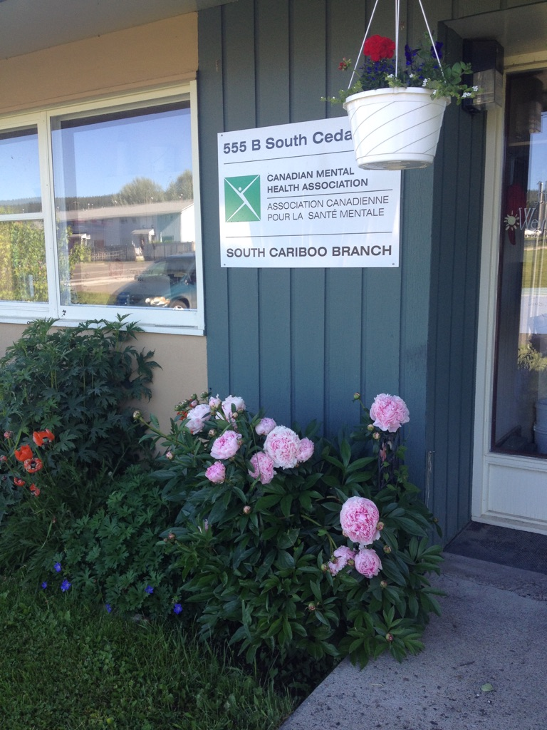

Agency Profile

Canadian Mental Health Association, South Cariboo Branch, is an autonomous, non-profit, charitable organization with ethical and legal responsibilities to the National and BC Divisions of CMHA. Our mandate emphasizes the importance of people with lived experience of mental illness being involved in the delivery of service and governance wherever possible.

Our Vision:

“Mentally Healthy People in a Healthy Society”

Our Mission:
Founded in 1918, The Canadian Mental Health Association (CMHA) is a national charity that helps maintain and improve mental health for all Canadians. As the nation-wide leader and champion for mental health, CMHA helps people access the community resources they need to build resilience and support recovery from mental illness.
In BC, mental health, substance use and addictive behaviour are within scope of the organization.
CMHA South Cariboo Branch believes in:

- Social justice
- Individual and collective responsibility
- Access to appropriate and adequate resources and supports
- Self-determination
- Maximum community inclusion
- Working collaboratively with our community partners

Geographic Catchment area:

The South Cariboo is a sub-region of the Cariboo Regional District in the Interior of British Columbia. Its main population center is the District Municipality of 100 Mile House, a community of approximately 2,000 residents. An additional 18,000 people live in the South Cariboo. The South Cariboo boundaries are roughly described as 70 Mile House in the South to Lac la Hache in the North, and the Fraser River to the West to Lac des Roches and Mahood Lake to the East. The region includes 100 Mile House and many smaller communities such as Forest Grove, Buffalo Creek, Lac la Hache, 108 Mile Ranch, Lone Butte, Sheridan Lake, Bridge Lake, and Watch Lake/Green Lake.

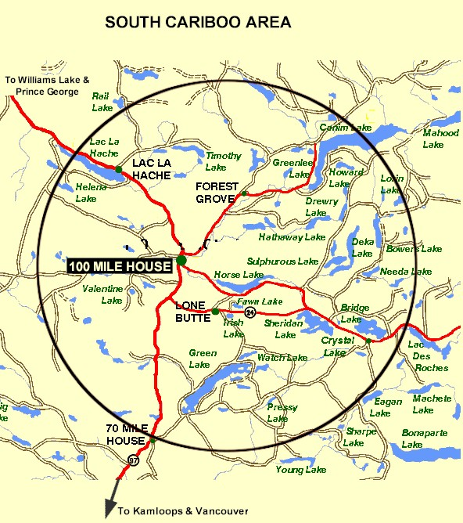

President’s Report:
Hello everyone and welcome!!
As the 2015-2016 year for the board draws to a close I feel both relieved and excited.
Over the past few months we have, with Susann's hard work, completed the application for accreditation with Imagine Canada. This process has helped us get all our ducks in a row and now we can say that we are doing everything above board and properly. The days of walking into Susann`s office and seeing it covered with lists and charts are finally coming to an end. I know we all appreciate all the hard work and dedication, not to mention the hours that she has given to this project.
We also were approached by the Womens Centre Board and asked if we would submit a proposal to have our board take over management of the Women’s Centre and for Susann to take on the role of being their Executive Director. The Board of the Women’s Centre decided to do this to bring them the stability and sustainability they needed. Our proposal was accepted and with the wonderful help of the Women`s Centre Board, I feel that we have a great working team and I see great things in the future!
Sadly we are saying goodbye to Jeannie Best and Cindi Thompson, two board members who have provided endless support and expertise to our board. We will certainly miss them and thank them for all their contributions as well as wishing them well in their future endeavors. Luckily for us we are welcoming two new board members and look forward to a great next year.
I would be remiss if I missed this opportunity to thank Susann and all her staff for all their hard work as well as the amazing team of clients that keep this place humming. It is always such a pleasure to come into the building and see all the activities!
Thank you to one and all for creating such an amazing space and here’s to the future and so much more
to come !!!
Liz Christensen, President/Chair

Executive Directors Report:
The June 30th, 2016 Annual General Meeting provides an opportunity for our members to gather together and take a moment to look back upon and celebrate what we have accomplished over this past very busy year. So much has happened this year and it has passed by so quickly. Some highlights of this past year:
A lot of time has been devoted to the work of preparing our branch to apply for accreditation with Imagine Canada. The branches of CMHA in BC are all independently incorporated and as the services they provide can differ from town to town, it was agreed that accreditation would be the best way to ensure that the work we do at the different branches and the way we do it is all based upon the same set of standards. All branches of CMHA in BC are required to become accredited by the end of this year. The Imagine Canada Standards program is focused in five areas: board governance, financial accountability and transparency, fundraising, staff management and volunteer involvement. In order to get our branch ready to apply for accreditation, we have been very busy writing policies and formalizing our processes to ensure they meet the standards and are developed in a way that is feasible and sustainable for an organization of our size and structure. Our application was submitted for the March intake deadline, and we have been through the first review round with very positive feedback. The second round of reviews will be completed by the end of September and hopefully at that time we will receive similar positive feedback and become accredited with Imagine Canada.
Last May the Executive Directors of CMHA branches in BC and CMHA BC went to the legislature and met with the MLAs to discuss mental health in BC and our vision for the future.
Our branch of CMHA and the other CMHA branches in BC received Gatekeepers Funding from CMHA BC via the Ministry of Health. This funding provided us with the opportunity to have Kathy provost, one of our staff members receive the training to become an ASIST and a SafeTALK facilitator, and provide these suicide prevention workshops in our area. Our goal is to train 200 people per year in suicide prevention for the next three years, and to continue to provide this training after that as needed. We are very happy to bring this important training to the South Cariboo, and to help increase our community’s capacity in this critical area.
Toward the end of this fiscal year we were invited by the Board of the Women’s Centre to present a proposal to them regarding our vision for the future of the Womens’ Centre. After much thought and discussion, we agreed to do so; our proposal included taking over the management of the Women’s Centre, with the Board of CMHA South Cariboo becoming the Board of the Women’s Centre and with myself becoming the Executive Director of both organizations. Our proposal was the one that was chosen by the Women`s Centre Board. I had to free up some of my time commitments to make this possible, so we have hired Mel Stoney as the Site Manager for our subsidized housing complex. Mel has many years of building management experience and he is a welcome addition to our staff.
I want to sincerely thank the CMHA South Cariboo Board of Directors and staff members for their continuing hard work and dedication: heroes all. They are a group of dedicated and compassionate people whose support and exemplary service to CMHA South Cariboo Branch accomplishes so much to improve the lives of the citizens of our community.
Thank you as well to our members – you are the heart of our organization.
I would also like to thank community agencies, community members and volunteers that have allowed us to promote mental health through awareness events and assisted us to achieve our fundraising goals over the past year. Events like Mental Health Week, Mental Illness Awareness Week and Beyond the Blues were all successful events that met our goals of increasing mental health awareness, reducing the stigma associated with mental illness and of raising the profile of CMHA’s work in the South Cariboo. This is an invaluable part of our work – locally, in BC and across Canada. We work collaboratively with other local agencies, and maintain a grassroots approach to meeting the needs of our community.
Susann Collins, Executive Director

History of Canadian Mental Health Association

CMHA National: One of Canada’s Oldest Non-Profits:
The Canadian Mental Health Association is one of the oldest national, charitable organizations in Canada and the oldest national mental health charity. Each year, CMHA divisions and branches across Canada provide service to more than 100,000 Canadians through the combined efforts of more than 10,000 volunteers and staff in locally run organizations in more than 120 communities. Visit CMHA National’s website for more information.
CMHA was founded in 1918 by Dr. Clarence M. Hincks, Dr. Charles K. Clarke and Clifford W. Beers as the Canadian National Committee for Mental Hygiene. The original goals of the organization centered on war recruits, mental examination of post-war immigrants, prevention, and support for adequate facilities and care for the treatment of mental illness.
Dr. Hincks became director of the association in 1924. He developed an interest in patients whose work and productive lives were hampered by what was then seen as malfunctions of the mind. He suffered from periodic bouts of depression all his life, so his empathy toward his fellow sufferers, coupled with a profound knowledge of medicine and early twentieth-century psychological developments in Europe revolutionized the conditions and treatment of mental health patients in Canada.
CMHA is uniquely positioned in Canada as a charity that brings together community-based experience and expertise on the prevention of mental illness and community supports for the mental well-being of all Canadians. We are not only unique in our mental health promotion approach but also in our ability to speak to issues spanning the broad range of mental disorders and the full spectrum of those affected from those at risk, to those newly diagnosed, to those who have been living with a psychiatric disability over the longer-term, as well as family, friends and community gatekeepers.
CMHA BC Division’s Beginnings
In 1952, with the assistance of Clarence M. Hincks, British Columbia saw the creation of a BC Division of CMHA. The office started with a federal mental health grant which was gradually diminished over three years as other sources of funding were found. CMHA volunteers became involved in the support of patients at Riverview Hospital and ran the thrift store. At one point, BC Division had employed more people with mental illness than any division in the country. Throughout its history, the division has advocated for changes to legislation and policy affecting people with a mental illness ensuring the availability of community alternatives, access to housing, and income supports. In its monitoring and systemic advocacy role, BC Division has played an important role in the reform of the mental health care system, as well as in community-based research and evaluation, employment supports, public education, and branch support. This history would not be complete if it did not also reflect the pride BC Division has felt being part of a network of CMHA branches in communities across BC whose grassroots involvement and direct services – such as housing, employment services, crisis lines, and support groups to name a few – have touched the lives of countless British Columbians. CMHA BC Division was officially incorporated on October 6, 1953.

CMHA South Cariboo Branch
CMHA in 100 Mile was started by a group of concerned individuals in the late 1980’s. The group’s early meetings took place in the Rosewood Building on Birch Avenue, and included individuals living with mental illness; their friends and family members; mental health service providers and local physicians. As mental health support services in the South Cariboo at that time were very limited, the initial goal for members was to begin to develop resources and a network of support - both for individuals living with a mental illness, and to those who were part of their lives. The branch was incorporated in June 1992. The branch’s early goals were to be actively involved in the development of psychiatric services to our community, and to find funds to develop a clubhouse or drop in center where people who live with mental illness could congregate, socialize and receive the help needed to live successfully in their homes and community. Since its inception, CMHA South Cariboo Branch has grown from a one staff office to a multi-program system. We continue to take pride in our identity as a grassroots organization that adapts to serve the need of our community.
Prevention is fundamental to all of the services we provide and is reflected through the work of the branch during Mental Health Week, Mental Illness Awareness Week, the ‘Give Hope’ Campaign, and through community information displays, health fairs and public awareness campaigns. It is also reflected in the services we provide to individuals who live with a serious and persistent mental illness. The South Cariboo Branch is proud to be among the 14 branches that make up Canadian Mental Health Association BC Division and one of 135 branches across Canada.

Philosophy and Principles of Service and Support:
CMHA South Cariboo Branch provides services that are person centered and adhere to the Framework for Support. The Framework is the central philosophy guiding the activities of CMHA. This philosophy holds that a mental health consumer (someone who uses mental health services) is at the center of any supportive mental health system. The Community Resource Base, as shown below, outlines a range of possible resources in addition to the formal mental health system which can provide support to a person with mental illness. Housing, income, work and education represent four basic elements of citizenship.

The Framework for Support
The Framework is the central philosophy guiding the activities of CMHA. This philosophy holds that the person experiencing mental illness is at the center of any supportive mental health system.
The Community Resource Base outlines a range of possible resources in addition to the formal mental health system which can provide support to a person with mental illness. Housing, income, work and education represent four basic elements of citizenship.
The ultimate goal of the Framework is to ensure that people with serious mental health problems live fulfilling lives in the community. The Framework for Support is referred to as the most comprehensive model for mental health planning by federal and provincial governments as well as by the Centre for Community Change in the US, and the Government of Ireland.

Community Awareness Events
Mental Health Week
CMHA’s Mental Health Week is an annual national event that takes place during the first week in May to encourage people from all walks of life to learn, talk, reflect and engage with others on all issues relating to mental health. CMHA Branches across the nation held special events to celebrate.
CMHA South Cariboo Branch held a series of client focused and mental health resource promotional events, including several fun filled events at the Peter Skene Ogden High School, a popular booth at our local annual Women’s Fair, and a celebratory barbeque held at our Clubhouse.

Mental Illness Awareness Week
Mental Illness Awareness Week (MIAW) is an annual national public education campaign designed to help open the eyes of Canadians to the reality of mental illness. The week was established in 1992 by the Canadian Psychiatric Association, and is now coordinated by the Canadian Alliance on Mental Illness and Mental Health (CAMIMH) in cooperation with all its member organizations and many other supporters across Canada. Campaign elements include: a grassroots public education initiative; a nationally-distributed poster and bookmark series; the annual Champions of Mental Health Awards event in Ottawa and an education initiative with federal Members of Parliament, both in their home ridings and on Parliament Hill.

Why Mental Illness Awareness Week?
For too long, Canadians with mental illnesses have been in the shadows. Too few Canadians know about the burden of mental illness on our society and too few sufferers seek help when they need it. Mental Illness Awareness Week seeks to raise awareness of the level of mental illness in Canada; to reduce negative stigma about mental illness amongst the general population and health care professionals; and to promote the positive effects of best practice in prevention, diagnosis and medical treatment.
Despite the fact that one in five Canadians is affected by mental illness, a persistent stigma prevents millions from getting the help they need. The continuing theme of Mental Illness Awareness Week—Face Mental Illness—is designed to change that.

Beyond the Blues Screening and Education Day is held annually in October during the first Thursday of Mental Illness Awareness Week. The South Cariboo Branch started participating in the 1990’s and continues to participate yearly. This year, in partnership with staff from other organizations in the community, the event included the Peter Skene Ogden Senior Secondary School, the Outback School and the Youth Zone.

Scholarship Report
This year we had many applicants for the CMHA-SCB $500.00 Scholarship. The Scholarship is designed to help a student pursuing a career related to mental health (such as psychiatry or a Community Mental Health Worker). We awarded the scholarship to Paige Hall this year, and we wish her all the best in her career path.

Operations Funding
BC Housing Management Commission provides funding for: Homes BC - Cariboo Trail Terrace Affordable Housing Program, Homeless Outreach Services, Homeless Outreach Subsidy and the Extreme Weather Response programs.

Interior Health Authority, Mental Health & Addictions Services provides the funding for services for people who live with serious and persistent mental illness. Our programs are rehabilitative in nature; recovery based, and focus on supporting and improving the quality of everyday living and on community inclusion. Programs and services include: Supported-Independent Living Outreach Life Skills Support, Acquired Brain Injury Support, Rent Subsidy programs, Emergency Home Support, Work Incentive Program and our Clubhouse program.
Grants:
United Way provided funding for the Emergency Transportation Program.
This past year The South Cariboo Health Foundation, the District of 100 Mile House and the CRD, the Canim Lake Truckers Association and others funded Soup de Tour. Soup de Tour is operated by a dedicated group of volunteers who work to make the soup and distribute it to people in need weekly. We are grateful for their contribution to food security in our community. Marnie Jensen continues to support the Soup Group in the role of Volunteer Coordinator. Thanks Marnie!

2015/16 Operations Budget:
Revenue :
I.HA.: $ 188,709.48
B.C. Housing-H.O.W/Subsidies: $ 250,133.82
Grants/United Way: $ 7,700.00
Fundraising and Donations: $ 32,686.59
Rental (CTT): $ 115,607.00
Rental Office Space: $ 3,100.00
Miscellaneous: $ 5,496.38

=================Total: $ 603,433.27
Nicole Bissat - Finance Coordinator

Program Reports

Supported Independent Living Program (SIL) (funded by Interior Health Authority):
The SIL program continues to provide support to clients to live independently in their community. The client, together with their health care team (consisting of doctors, psychiatrist, Interior Health case managers, and a CMHA SIL worker), identify their needs and a care plan is made that will support and facilitate independent living. The role of the SIL worker is to be encouraging and emotionally supportive while assisting the client to maximize their potential for more independent living. The SIL worker and the client go out in the community together, fostering independence, while assisting in areas such as life skills, budgeting, shopping, self-care, health and wellness.
Mental Health Outreach and Support Worker, Irene Spencer retired in April 2016. We bid Irene farewell with warm wishes for a happy retirement and thank her for her years of service! Angie Knutson is the new CMHA Outreach Worker for the South Cariboo Branch.
The Sunday Community Kitchen is a fun way for the SIL clients to interact together as a small group. The program supports clients in all aspects of meal preparation; from planning the food, to the cooking, and the clean- up.
Soup de Tour is another activity where two SIL clients and the SIL worker join the larger group of community volunteers to participate in the preparation of homemade soup. The soup is distributed to the Food Bank, Loaves and Fishes, Women’s Center, Family Enrichment Center and CMHA.
Angie Knutson-Mental Health Outreach and Support Worker

Activity and Drop-In Clubhouse Program (funded by Interior Health Authority):
The Activity/Clubhouse programs are designed to provide opportunities for members to congregate for social support, recreation, to improve their quality of life and to facilitate successful community engagement.
The Activity/Clubhouse members are involved in all aspects of the program operations. We provide a variety of leisure activities in order to encourage social relationships.
The Activity/Clubhouse program is all about choice, respect and education. The days of the week are used for different activities, and the clients are asked to participate in choosing them. We have an active recycling program which allows the group to make a charitable donation at Christmas time to the local Children’s Shoe box Program, as well as to fund our summer field trips.
We started an extensive gardening and healthy food program last year, and have continued with that by adding another raised garden bed and extending our in ground vegetable garden. We use the food for our daily lunch program and were able to eat from the garden until last November. The member’s find the gardening enjoyable and therapeutic and the food is a much needed bonus for everyone.
This year we have been fortunate enough to provide the members with laptop computers. Time is spent learning to use the internet, using online banking, email and social media. We will be offering ongoing education to help the member’s in becoming competent in the online world.
The Activity/Clubhouse program prides itself in helping the community with receiving, sorting and distributing charitable donations of household goods and furniture. Our members are instrumental in the delivery of this program with their ongoing labour and time, which is invaluable.
Our Activity/Clubhouse program offers the members an opportunity to build and maintain self-worth, purpose and confidence.
Kathy Provost - CMHA Activity Worker

Homeless Outreach Program (funded by BC Housing)
The Homeless Outreach Program helps break the cycle of homelessness by assisting people who are homeless or at risk of homelessness to access housing, and by connecting them to income assistance, health services, life skills training, crisis intervention, rent supplement funding and any other services they may need.
While there continues to be many individuals experiencing homelessness, for a significant number of these individuals this is due to lack of suitable and affordable housing for people living on a limited income. As well, I am seeing a significant increase in clients coming for support with financial issues (rent, utility), addictions, and mental health issues.
The number of people accessing the Homeless Outreach Program has increased, and at times is overwhelming to keep up.
I continue to see a large amount of individuals needing gas cards for medical appointments, job hunting, moving, etc. The funding for gas cards from United Way has helped many individuals meet their needs.
The Extreme Weather Emergency Shelter Program operated from Nov. 1, 2015 to April 30, 2016, and it was a busy winter.
Julie Pettigrew - Homeless Outreach Worker

Cariboo Trail Terrace – (Homes BC) Housing Report:
Cariboo Trail Terrace is a subsidized family housing development, funded through BC Housing and the community to serve qualified residents.
“Subsidized housing developments are for people with low to moderate incomes, including seniors, people with disabilities, individuals at risk of homelessness, women (with or without children) at risk of violence, Aboriginal people and low-income families.” (from BC Housing)
We received funding from BC Housing to replace the aging roof at Cariboo Trail Terrace, and it was replaced last fall. We were very happy to receive this generous funding for our much needed roof.
Things are going very well at Cariboo Trail Terrace, and we have, for the most part, good tenants who take care of their units. We have managed to avoid having units sit empty, and any repairs needing to be done were done quickly, allowing new tenants to move in without delay.
Susann Collins – Housing Manager

Soupe de Tour Report (funded by the South Cariboo Health Foundation, the Canim Lake Truckers Association, the District of 100 Mile House and the CRD)
Soupe de Tour is our local, mobile, volunteer run soup kitchen program. Our group of dedicated volunteers make soup weekly and give it out to local people in need.
In the past year, Soupe de Tour has worked on their goals of increasing our volunteer numbers, and increasing our yield of soup. We have been happy to see many new volunteers join us, with quite a few becoming regulars; it isn't unusual to have 18-20 people there. This gives us the ability to prepare and cool more soup. We meet weekly, and on average our output is 60 litres, or 250 servings of soup that goes out into our community each week to people in need. At the same time as we are working towards increasing our yield, local organizations are requesting larger amounts of soup; they are reporting to us that the number of their clients in need are growing.
Also, people were requesting that the Meals on Wheels program provide a soup entrée option and Soupe de Tour was asked if we would be willing to make and provide the soup for this. We decided that we would be willing as it is an opportunity to bring a small bit of income in to this program. The soup is available for purchase through Meals on Wheels and it sells for $4.00 per container. This is different from the soup that is given out weekly to people in need, which is always free.
In the past year we have provided over 12,500 servings of soup to people and organizations in our community. We do this with a very thoughtful, conscientious, hard-working group of volunteers.
Donations and ongoing fundraising is what allows us to keep Soupe de Tour operating. This past year we gratefully received generous donations from the South Cariboo Health Foundation, the Canim Lake Truckers Association, the District of 100 Mile House and the CRD, and donations from other organizations and individuals. As well, staff and clients from local organizations regularly come and help make the soup and we are very appreciative of this invaluable support as well. Thank you to everyone that made Soupe de Tour possible this past year.
Marnie Jensen – Soupe de Tour Volunteer Coordinator

Organizational and Reporting Structure 2015/2016

CMHA BOARD OF DIRECTORS

United Way Grant
Emergency Transportation (Grant)
EXECUTIVE DIRECTOR

FINANCIAL/ SUPPORT

BC Housing

Interior Health
Authority

Affordable Housing CTT

Homeless Outreach
and Supplements

Extreme Weather
Response
EWR
Activity/Drop In
Program - IHA

Supported-independent Living
Emergency Outreach. Various Clients & Subsidies

Work Incentive
Program.

BRANCH BOARD OF DIRECTORS 2015/2016

President/Chair: Liz Christensen
Vice Chair: Allie Blades
Treasurer: Jeanne Best
Secretary: Cindi Thompson and Ashley Pfeifer
Directors: Kitten Cadrin, Kimberly Vance Lundsbye

Board Committees
Governance: Jeanne Best
Finance: Jeanne Best
Fundraising: Kitten Cadrin, Allie Valiente and Kimberly Vance Lundsbye

