2016-2017 Annual Report

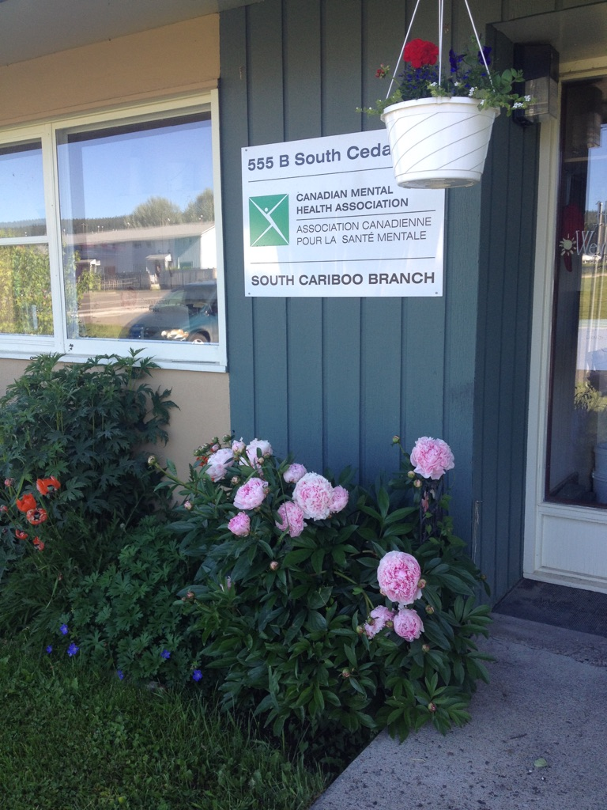

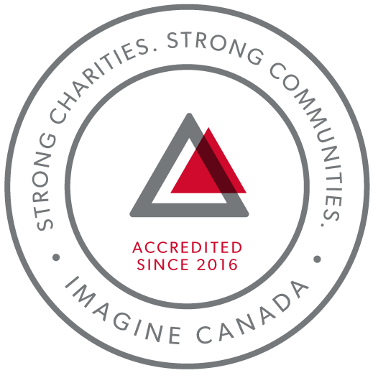
CMHA South Cariboo is an accredited organization through Imagine Canada’s Standards Program

Agency Profile
Canadian Mental Health Association, South Cariboo Branch, is an autonomous, non-profit, charitable organization with ethical and legal responsibilities to the National and BC Divisions of CMHA. Our mandate emphasizes the importance of people with lived experience of mental illness being involved in the delivery of service and governance wherever possible.

Our Vision: “Mentally Healthy People in a Healthy Society”

Our Mission: Founded in 1918, The Canadian Mental Health Association (CMHA) is a national charity that helps maintain and improve mental health for all Canadians. As the nation-wide leader and champion for mental health, CMHA helps people access the community resources they need to build resilience and support recovery from mental illness. In BC, mental health, substance use and addictive behaviour are within scope of the organization.

CMHA South Cariboo Branch believes in:
- Social justice
- Individual and collective responsibility
- Access to appropriate and adequate resources and supports
- Self-determination
- Maximum community inclusion
- Working collaboratively with our community partners

Geographic Catchment area:
The South Cariboo is a sub-region of the Cariboo Regional District in the Interior of British Columbia. Its main population center is the District Municipality of 100 Mile House, a community of approximately 2,000 residents. An additional 18,000 people live in the South Cariboo. The South Cariboo boundaries are roughly described as 70 Mile House in the South to Lac la Hache in the North, and the Fraser River to the West to Lac des Roches and Mahood Lake to the East. The region includes 100 Mile House and many smaller communities such as Forest Grove, Buffalo Creek, Lac la Hache, 108 Mile Ranch, Lone Butte, Sheridan Lake, Bridge Lake, and Watch Lake/Green Lake.

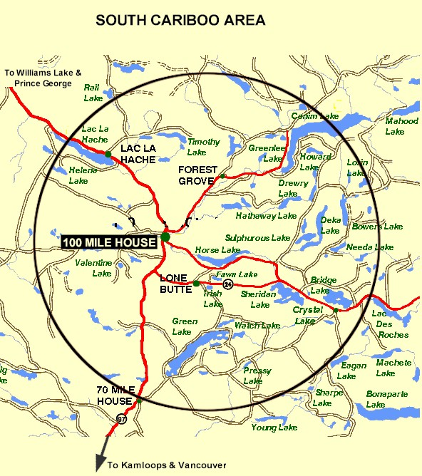

President’s Report:
Hello everyone and thank you for coming.
I cannot believe that another year has come and gone already! As the 2016-2017 year comes to a close, I would like to take this time to reflect on the high points that have kept life interesting for the board to say the least.
Completing the accreditation process with Imagine Canada was a huge accomplishment for CMHA. We now know what is expected of us and when. I know that Susann is working on a calendar for the board so that we can get things done in a timely manner. It has been a wild ride and a learning curve for each and every one of us.
Comedy night was a great success thanks to the hard work of all involved, and thanks to Kitten who heads our fundraising portion of the board. Another one is in the works for later this year.
With Roxy’s expertise we are close to finishing our board orientation binder which will be a great asset to the board.
I would like to take this opportunity to personally thank each and every person on the board for all their hard work and dedication.
All in all it has been a busy but productive year and I think that I can speak for all the board when I say that we are looking forward to the new adventures that next year will bring.
Liz Christensen, Board Chair

Executive Directors Report:
The June 20th, 2017 Annual General Meeting provides an opportunity for our members to gather together and take a moment to look back upon and celebrate what we have accomplished over this past very busy year. So much has happened this year and it has passed by so quickly. Some highlights of this past year:
After all the hard work we put into our application, we were accredited by Imagine Canada last fall, joining a growing community of more than 200 charitable and non-profit organizations dedicated to operational excellence. We are very proud of the accomplishment.
We acknowledge our first year of managing the 100 Mile House and District Women’s Centre. It has been a very busy year for me balancing the work of executive director for both organizations.
The provincial government announced that our proposal to bring more affordable housing to the South Cariboo was successful and that they are awarding us 1.5 million dollars. This is still a work in progress and there aspects of the project that have to be worked through.
I want to sincerely thank the CMHA South Cariboo board of directors and staff members for their continuing hard work and dedication: heroes all. They are a group of dedicated and compassionate people whose support and exemplary service to CMHA South Cariboo Branch accomplishes so much to improve the lives of the citizens of our community.
Thank you as well to our members – you are the heart of our organization and it is our honour to serve you.
I would also like to thank community agencies, community members and volunteers that have allowed us to promote mental health through awareness events over the past year. Events like Mental Health Week, Mental Illness Awareness Week and Beyond the Blues were all successful events that met our goals of increasing mental health awareness, reducing the stigma associated with mental illness and of raising the profile of CMHA’s work in the South Cariboo. This is an invaluable part of our work – locally, in BC and across Canada. We work collaboratively with other local agencies, and maintain a grassroots approach to meeting the needs of our community.
Susann Collins, Executive Director

History of the Canadian Mental Health Association

CMHA National: One of Canada’s Oldest Non-Profits
The Canadian Mental Health Association is one of the oldest national, charitable organizations in Canada and the oldest national mental health charity. Each year, CMHA divisions and branches across Canada provide service to more than 100,000 Canadians through the combined efforts of more than 10,000 volunteers and staff in locally run organizations across the country. Visit CMHA National’s website for more information.
CMHA was founded in 1918 by Dr. Clarence M. Hincks, Dr. Charles K. Clarke and Clifford W. Beers as the Canadian National Committee for Mental Hygiene. The original goals of the organization centered on war recruits, mental examination of post-war immigrants, prevention, and support for adequate facilities and care for the treatment of mental illness. Next year will mark CMHA’s 100 year.
CMHA is uniquely positioned in Canada as a charity that brings together community-based experience and expertise on the prevention of mental illness and community supports for the mental well-being of all Canadians. We are not only unique in our mental health promotion approach but also in our ability to speak to issues spanning the broad range of mental disorders and the full spectrum of those affected from those at risk, to those newly diagnosed, to those who have been living with a psychiatric disability over the longer-term, as well as family, friends and community gatekeepers.

CMHA South Cariboo Branch
CMHA in 100 Mile was started by a group of concerned individuals in the late 1980’s. The group’s early meetings took place in the Rosewood Building on Birch Avenue, and included individuals living with mental illness; their friends and family members; mental health service providers and local physicians. As mental health support services in the South Cariboo at that time were very limited, the initial goal for members was to begin to develop resources and a network of support - both for individuals living with a mental illness, and to those who were part of their lives. The branch was incorporated in June 1992. The branch’s early goals were to be actively involved in the development of psychiatric services to our community, and to find funds to develop a clubhouse or drop in center where people who live with mental illness could congregate, socialize and receive the help needed to live successfully in their homes and community. Since its inception, CMHA South Cariboo Branch has grown from a one staff office to a multi-program system. We continue to take pride in our identity as a grassroots organization that adapts to serve the need of our community.
Prevention is fundamental to all of the services we provide and is reflected through the work of the branch during Mental Health Week, Mental Illness Awareness Week and through community information displays, health fairs and public awareness campaigns. It is also reflected in the services we provide to individuals who live with a serious and persistent mental illness. The South Cariboo Branch is proud to be among the 14 branches that make up Canadian Mental Health Association BC Division and one of 87 branches across Canada.

The Framework for Support
The Framework is the central philosophy guiding the activities of CMHA. This philosophy holds that the person experiencing mental illness is at the center of any supportive mental health system.
The Community Resource Base outlines a range of possible resources in addition to the formal mental health system which can provide support to a person with mental illness. Housing, income, work and education represent four basic elements of citizenship.
The ultimate goal of the Framework is to ensure that people with serious mental health problems live fulfilling lives in the community. The Framework for Support is referred to as the most comprehensive model for mental health planning by federal and provincial governments as well as by the Centre for Community Change in the US, and the Government of Ireland.

Community Awareness Events

Mental Health Week
Mental Health Week is an annual national event that takes place during the first week in May to encourage people from all walks of life to learn, talk, reflect and engage with others on all issues relating to mental health. CMHA Branches across the nation held special events to celebrate.

Beyond the Blues Screening and Education Day
Beyond the Blues is held annually in October during the first Thursday of Mental Illness Awareness Week. The South Cariboo Branch started participating in the 1990’s and continues to participate yearly. This year, in partnership with staff from other organizations in the community, the event included the Peter Skene Ogden Senior Secondary School, the Outback School and the Youth Zone.

Scholarship Report

We provide a $500 Scholarship that is designed to help a student pursuing a career related to mental health (such as psychiatry or Community Mental Health Worker). We received two applications this year, but as the applicants were not pursuing a career in a related field, the scholarship was not awarded this year.

2016/17 Operations Budget

Revenue :
Contract income - IHA: $ 186,720.00
B.C. Housing-H.O.W/Subsidies: $ 260,190.00
Grants: $ 13,350.00
Fundraising and Donations: $ 12,904.00
Rental (CTT): $ 125,204.00
Management fees: $ 27,813.00
Miscellaneous: $ 6,540.00

=================Total: $ 634,999.00

Nicole Bissat - Finance Coordinator

Program Reports

Supported Independent Living Program (SIL) (funded by Interior Health Authority):
The Supported Independent Living (SIL) program supports clients to live independently in the community by providing emotional support, encouragement and life skills coaching in areas such as budgeting, nutrition, self-care and wellness. Clients are referred through Interior Health Authority Mental Health Services. A care plan is developed by the client and their Health Team, which can SIL worker, and other health care professionals. The SIL worker makes appointments with the client to help them with the identified goals as outlined in their plan. Care plans are adjusted as necessary according to what the individual needs.
During the 2016-2017 fiscal year the SIL worker and clients participated in the Soupe de Tour program, joining with the larger group of community volunteers every other week to make the soup that is distributed to the Food Bank, Loaves and Fishes emergency Food Bank, the Friendship Centre, the Women’s Center, Family Enrichment Center and CMHA.
The Sunday Community Kitchen is an opportunity for a small, fun, interactive social activity. This program supports clients in all aspects of meal preparation and healthy eating.
Two clients and I are using our SIL time to help out in the new Community Garden on First Avenue. This garden provides food for anyone in the community who is hungry. It was started by the Agriculture Enterprise Centre and the 100 Mile Food Security Society and is a worthwhile community venture.
Interior Health Mental Health Case managers meet with the SIL worker once a week to discuss the clients and the best way to support their needs. As well the SIL worker informs the Interior Health Team of any challenges the clients may be experiencing. This interaction leads to a good working relationship and clear communication for the team, the worker and the clients. The Case Managers also meet, together with the SIL worker and clients to review and update their care plan and goals. While some clients receive care from the SIL program indefinitely, with support, teaching and mentoring, clients are encouraged to maximize their potential for a more independent lifestyle.
Kathy Provost - Mental Health Outreach and Support Worker

Activity and Drop-In Clubhouse Program (funded by Interior Health Authority):
Members and staff work side by side in all activities of the Clubhouse, and our operations are based on client choice, respect and normalization. The Clubhouse focuses on the strengths, talents and abilities of our members and is designed to help them regain self-worth, purpose, confidence and a sense of belonging.
In our daily lunch program, members and staff work together to provide a nutritious meal, and daily chores are divided up to maintain a clean, safe environment.
Activities include baking, bowling, karaoke, board and card games, outings, a lot of gardening and meal planning, to name a few. We also provide transportation to and from 100 Mile Food Bank and Loaves n’ Fishes for those in need. Many of our activities are self-funded through bottle collections.
Activity/Clubhouse strives to improve the quality of life of its’ members and promote engagement with the community.
Marilyn Gallagher - Activity/Clubhouse Worker

Homeless Outreach Program (funded by BC Housing)
The Homeless Outreach Program helps break the cycle of homelessness by assisting people who are homeless or at risk, to access housing and by connecting them to income assistance, health services, life skills training, crisis intervention, rent/utility supplements and/or any other services they may need to be connected to.
With the housing crisis continuing, there is a lack of affordable and suitable housing, and more people are becoming homeless, couch surfing or having to find shelter elsewhere. It is difficult for these individuals to have the stability they need to better their life.
The Extreme Weather Emergency Shelter Program ran from November 1, 2016 to April 30, 2017, which helped a great number of people; I am extremely grateful that we have this program.
Julie Cheung - Homeless Outreach Program

Cariboo Trail Terrace - Housing Report (funded by BC Housing)
Cariboo Trail Terrace is our subsidized family housing development located at 910 Cariboo Trail.
Things are going very well at Cariboo Trail Terrace; we have good tenants who take care of their units. We have managed to avoid having units sit empty, and any repairs needing to be done were done quickly, allowing new tenants to move in without delay. In a few instances we chose to take the opportunity of a long term tenant moving out to repaint and/or replace flooring in units, and this did result in a small but necessary lapse in tenancy.
We had a flood in one unit at the end of January, but thankfully, due to our good insurance coverage this was not a crisis for us, and the repairs went smoothly.
Nicole Bissat – Housing Manager

Soupe de Tour Report (funded by the South Cariboo Health Foundation, the District of 100 Mile House and the CRD):
Soupe de Tour is our local, mobile, volunteer run soup kitchen program. Our group of dedicated volunteers makes soup weekly and it is given out for free to local people in need.
Soupe de Tour worked on their goals of increasing volunteer numbers, and increasing our yield of soup. We have been happy to see many new volunteers join us, with quite a few becoming regulars; it isn't unusual to have 18-20 people there. This gives us the ability to prepare and cool more soup. We meet weekly, and on average our output is 60 litres, or 250 servings of soup that goes out into our community each week to people in need. At the same time as we are working towards increasing our yield, local organizations are requesting larger amounts of soup; they are reporting to us that the number of their clients in need are growing.
In the past year we have provided over 12,500 servings of soup to people and organizations in our community. We do this with a very thoughtful, conscientious, hard-working group of volunteers.
Donations and ongoing fundraising is what allows us to keep Soupe de Tour operating. This past year we gratefully received generous donations from the South Cariboo Health Foundation, the District of 100 Mile House and the CRD, and donations from other organizations and individuals. As well, staff and clients from local organizations regularly come and help make the soup and we are very appreciative of this invaluable support as well. Thank you to everyone that made Soupe de Tour possible this past year.
Marnie Jensen – Soupe de Tour Volunteer Coordinator

Acquired Brain Injury program (funded by Interior Health Authority)
CMHA provides the Acquired Brain Injury (ABI) program in the South Cariboo, and continues to provide services to clients with an ABI. The client and his or her family, with their health care team of doctors, psychiatrist, Occupational Therapist, Interior Health case managers, and a support worker, develop a care plan to support and facilitate the safety, health and well-being of the client. The role of the support worker is to provide emotional, physical, and social support, assistance with life skills and education, and to encourage their clients in the direction of healthy choices and habits. We look to our community for programs that are suitable and serve to meet the needs of the clients, such as financial or recreational programs.
The support worker works one-to-one with the client, assisting them with a wide variety of day-to-day tasks and life skills, such as: budgeting, dietary planning, shopping, meeting financial obligations, time management, scheduling and attending medical appointments, keeping track of and following up on calendar events and responsibilities. In December 2016, Angie Knutson took over the position as the ABI Support Worker from Kathy Provost who continues to work for CMHA in a different role.
At the clients’ request, we are excited that we will be starting a support group for the local ABI clients in June 2017.
Angie Knutson- Acquired Brain Injury Support Worker

The Community Gatekeeper Program (led by the Canadian Mental Health Association, BC Division and funded by the Ministry of Health)
The Community Gatekeeper initiative has a provincial goal of training 20,000 British Columbians in suicide prevention over the next three years.
The initiative consists of two programs, ASIST and safeTALK. ASIST (Applied Suicide Intervention Training) is an internationally recognized and standardized two-day training designed to help caregivers learn suicide first aid intervention. safeTALK (suicide alertness for everyone) is the presentation of the basics for helping a person with thoughts of suicide get connected to the support they need. This is a half day program.
As the certified ASIST and safeTALK trainer for the CMHA South Cariboo Branch, I have completed 3 ASIST trainings and 3 safeTALKS in our first year.
The 3 target areas for the Gatekeeper initiative are: men in the 40-60 year age group, rural communities and First Nation communities. I am doing my best to reach these targets and I am confident that we will reach the numbers to fulfill our contract obligations for the initiative over the next two years.
Kathy Provost - Community Gatekeeper Trainer

Take a Break Support Group (funded by the Interior Health Authority)
Take a Break Support Group is part of the Interior Region Family Navigator Program. It is a support group designed for people caring for a youth/child or dependent adult up to age 25 who is struggling with mental illness and/or substance use issues.
CMHA South Cariboo’s Take a Break support group is an opportunity for caregivers to meet other caregivers, make connections, share experiences and learn or strengthen skills. Some of the topics we cover are:
• Mental Health Issues
• Substance use
• Strategies for wellness
• Boundary setting
• Communication skills

The group meets every second Tuesday in the Activity Room at CMHA from 9:15 – 11:15. We have a committed group of participants and I am hoping that we will reach greater numbers as the program continues over the next year.
Kathy Provost - Take a Break Support Group Facilitator

Our Board of Directors

President/Chair: Liz Christensen
Vice Chair: Allie Blades
Secretary Treasurer: Kira Mitchell
Directors: Kitten Cadrin, Kimberly Vance-Lundsbye and Roxy Barnes
Fundraising Committee: Kitten Cadrin, Kimberly Vance-Lundsbye and Allie Blades

