2017-2018 Annual Report

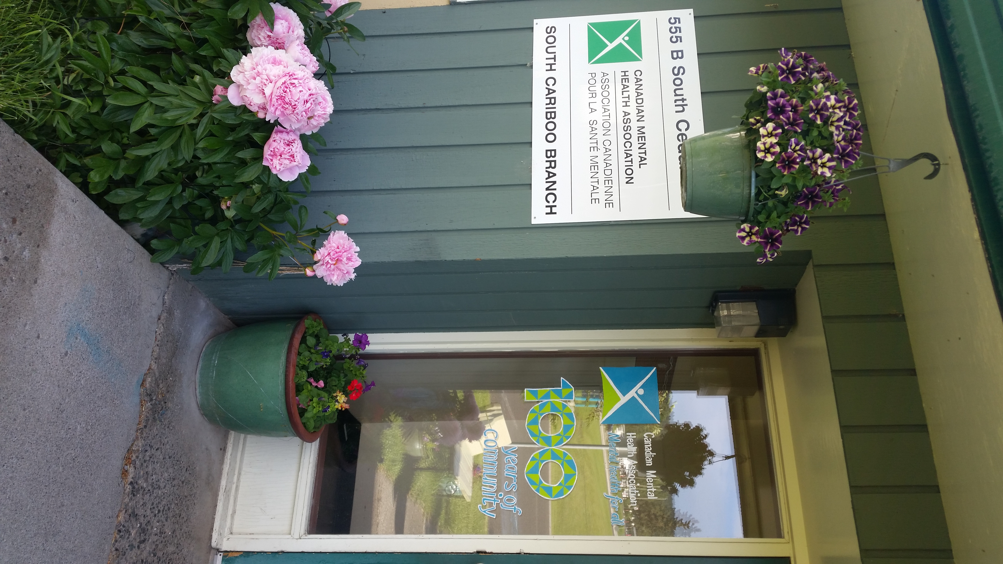

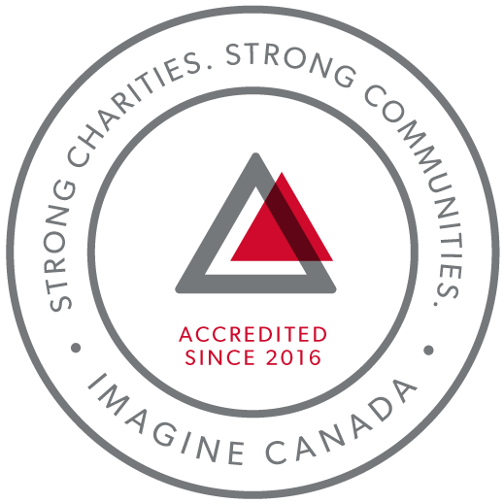
CMHA South Cariboo is an accredited organization through Imagine Canada’s Standards Program

Agency Profile
Canadian Mental Health Association, South Cariboo Branch, is an autonomous, non-profit, charitable organization with ethical and legal responsibilities to the National and BC Divisions of CMHA. Our mandate emphasizes the importance of people with lived experience of mental illness being involved in the delivery of service and governance wherever possible.

Our Vision: “Mentally Healthy People in a Healthy Society”

Our Mission: Founded in 1918, The Canadian Mental Health Association (CMHA) is a national charity that helps maintain and improve mental health for all Canadians. As the nation-wide leader and champion for mental health, CMHA helps people access the community resources they need to build resilience and support recovery from mental illness. In BC, mental health, substance use and addictive behaviour are within scope of the organization.

CMHA South Cariboo Branch believes in:
- Social justice
- Individual and collective responsibility
- Access to appropriate and adequate resources and supports
- Self-determination
- Maximum community inclusion
- Working collaboratively with our community partners

Geographic Catchment area:
The South Cariboo is a sub-region of the Cariboo Regional District in the Interior of British Columbia. Its main population center is the District Municipality of 100 Mile House, a community of approximately 2,000 residents. An additional 18,000 people live in the South Cariboo. The South Cariboo boundaries are roughly described as 70 Mile House in the South to Lac la Hache in the North, and the Fraser River to the West to Lac des Roches and Mahood Lake to the East. The region includes 100 Mile House and many smaller communities such as Forest Grove, Buffalo Creek, Lac la Hache, 108 Mile Ranch, Lone Butte, Sheridan Lake, Bridge Lake, and Watch Lake/Green Lake.

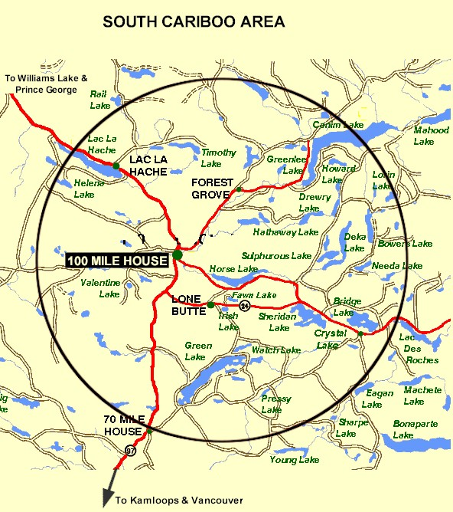

President’s Report:
Good evening to everyone! Thank you for coming and showing support for CMHA South Cariboo
Branch.
This past year has been challenging and has had a steep learning curve for the board, but I feel that
each and every single person has given their all for the benefit of the society. We are moving forward
with team building and we are able to discuss issues and come up with solutions that will help to make
the board much stronger. I appreciate all the talent that we have and look forward to adding even more
amazing people to our group!
We have many irons in the fire. One of the exciting programs we are looking into is new housing with a
private contractor and B.C. Housing. This will be an exciting adventure in the coming months and I
feel confident that the board will make good decisions.
I would like to thank the staff for always greeting the board members warmly when we enter the
building and I look forward to perhaps some team building in this area and for the staff to get to know
the board and to feel like they can approach us.
Lastly, I would like to specifically thank Susann for all her hard work.
Sincerely,
Elizabeth (Liz) Christensen, Board Chair

Executive Directors Report:
The June 19th, 2018 Annual General Meeting provides an opportunity for our members to gather together and take a moment to look back upon and celebrate what we have accomplished over this past very busy year. So much has happened this year and it has passed by so quickly. Some highlights of this past year:
In the aftermath of the wildfires of 2017, we experienced (and continue to experience) an increased demand for services and support. We applied to the Red Cross and the United Way for temporary wildfire recovery funding to provide us with the capacity to meet this increased demand. The Red Cross approved our funding request for two full time Navigator positions (one for CMHA and one for the Women’s Centre), and to put on two ASIST and two SafeTALK programs. The United Way approved our funding request for a full time receptionist for one year. At the end of this fiscal year we had hired the receptionist and we were in the process of hiring the two Navigators.
We had to shut down Soupe de Tour operations in May 2017 due to lack of funding, but we applied for BC Gaming for funding for Soupe de Tour and our application was approved. This will provide funding for one year. Soupe de Tour operations are scheduled to begin in May 2018.
We held our 2nd annual Comedy Night fundraiser in October, and we were pleased to have a local comedian join the line-up of comedians, and to have the Fennel Cup there to serve their delicious food. It was another successful event, and we are already looking forward to the next Comedy Night on October 13th.
We completed our second year of accreditation with Imagine Canada, following a successful annual accreditation compliance report. We are very proud to continue to be a part of this growing community of charitable and non-profit organizations dedicated to operational excellence.
We acknowledge our second year of managing the 100 Mile House and District Women’s Centre, and we are honoured to be a part of this important work.
I want to sincerely thank the CMHA South Cariboo board of directors and staff members for their continuing hard work: heroes all. They are a group of dedicated and compassionate people whose support and exemplary service to CMHA South Cariboo Branch accomplishes so much to improve the lives of the citizens of our community.
Thank you as well to our members – you are the heart of our organization and it is our honour to serve you.
I would also like to thank community agencies, community members and volunteers that have allowed us to promote mental health through awareness events over the past year. Events like Mental Health Week, Mental Illness Awareness Week and Beyond the Blues were all successful events that met our goals of increasing mental health awareness, reducing the stigma associated with mental illness and of raising the profile of CMHA’s work in the South Cariboo. This is an invaluable part of our work – locally, in BC and across Canada. We work collaboratively with other local agencies, and maintain a grassroots approach to meeting the needs of our community.
Susann Collins, Executive Director

History of the Canadian Mental Health Association

CMHA National: One of Canada’s Oldest Non-Profits
The Canadian Mental Health Association is one of the oldest national, charitable organizations in Canada and the oldest national mental health charity. Each year, CMHA divisions and branches across Canada provide service to more than 100,000 Canadians through the combined efforts of more than 10,000 volunteers and staff in locally run organizations across the country. Visit CMHA National’s website for more information.
CMHA was founded in 1918 by Dr. Clarence M. Hincks, Dr. Charles K. Clarke and Clifford W. Beers as the Canadian National Committee for Mental Hygiene. The original goals of the organization centered on war recruits, mental examination of post-war immigrants, prevention, and support for adequate facilities and care for the treatment of mental illness. Next year will mark CMHA’s 100 year.
CMHA is uniquely positioned in Canada as a charity that brings together community-based experience and expertise on the prevention of mental illness and community supports for the mental well-being of all Canadians. We are not only unique in our mental health promotion approach but also in our ability to speak to issues spanning the broad range of mental disorders and the full spectrum of those affected from those at risk, to those newly diagnosed, to those who have been living with a psychiatric disability over the longer-term, as well as family, friends and community gatekeepers.

CMHA South Cariboo Branch
CMHA in 100 Mile was started by a group of concerned individuals in the late 1980’s. The group’s early meetings took place in the Rosewood Building on Birch Avenue, and included individuals living with mental illness; their friends and family members; mental health service providers and local physicians. As mental health support services in the South Cariboo at that time were very limited, the initial goal for members was to begin to develop resources and a network of support - both for individuals living with a mental illness, and to those who were part of their lives. The branch was incorporated in June 1992. The branch’s early goals were to be actively involved in the development of psychiatric services to our community, and to find funds to develop a clubhouse or drop in center where people who live with mental illness could congregate, socialize and receive the help needed to live successfully in their homes and community. Since its inception, CMHA South Cariboo Branch has grown from a one staff office to a multi-program system. We continue to take pride in our identity as a grassroots organization that adapts to serve the need of our community.
Prevention is fundamental to all of the services we provide and is reflected through the work of the branch during Mental Health Week, Mental Illness Awareness Week and through community information displays, health fairs and public awareness campaigns. It is also reflected in the services we provide to individuals who live with a serious and persistent mental illness. The South Cariboo Branch is proud to be among the 14 branches that make up Canadian Mental Health Association BC Division and one of 87 branches across Canada.

The Framework for Support
The Framework is the central philosophy guiding the activities of CMHA. This philosophy holds that the person experiencing mental illness is at the center of any supportive mental health system.
The Community Resource Base outlines a range of possible resources in addition to the formal mental health system which can provide support to a person with mental illness. Housing, income, work and education represent four basic elements of citizenship.
The ultimate goal of the Framework is to ensure that people with serious mental health problems live fulfilling lives in the community. The Framework for Support is referred to as the most comprehensive model for mental health planning by federal and provincial governments as well as by the Centre for Community Change in the US, and the Government of Ireland.

Community Awareness Events

Mental Health Week
Mental Health Week is an annual national event that takes place during the first week in May to encourage people from all walks of life to learn, talk, reflect and engage with others on all issues relating to mental health. CMHA Branches across the nation held special events to celebrate.

Beyond the Blues Screening and Education Day
Beyond the Blues is held annually in October during the first Thursday of Mental Illness Awareness Week. The South Cariboo Branch started participating in the 1990’s and continues to participate yearly. This year, in partnership with staff from other organizations in the community, the event included the Peter Skene Ogden Senior Secondary School, the Outback School and the Youth Zone.

Scholarship Report

We provide a $500 Scholarship that is designed to help a student pursuing a career related to mental health (such as psychiatry or Community Mental Health Worker). We received two applications this year, but as the applicants were not pursuing a career in a related field, the scholarship was not awarded this year.

2017/18 Operations Budget

Revenue :
Contract income - IHA: $ 189,748.77
B.C. Housing-H.O.W/Subsidies: $ 246,690.67
Grants: $ 12,233.00
Fundraising and Donations: $ 15,363.89
Rental (CTT): $ 124,639.00
Interest Income: $ 3,763.21
Management fees: $ 38,345.04
Miscellaneous: $ 2,787.00

=================Total: $ 633,570.58

Nicole Bissat - Finance Coordinator

Program Reports

Supported Independent Living Program (funded by Interior Health Authority):
The Supported Independent Living Program (SIL) supports clients to live independently in the community by providing emotional support, encouragement and life skills coaching in areas such as budgeting, nutrition, self-care and wellness. Clients are referred through Interior Health Authority Mental Health Services. A care plan is developed by the client and their Health Team, which consists of the SIL Worker, and other health care professionals. The SIL worker makes appointments with the client to help them with the identified goals as outlined in their plan. Care plans are adjusted as necessary according to what the individual needs.
During the 2017-2018 year the SIL program has had significant growth. Our client base has more than doubled. We were able to provide more hours and a temporary part time SIL Worker with funds provided from Interior Health Mental Health Authority Wildfire funding.
This year the SIL Program worked in the CMHA Clubhouse kitchen once a week to make soup. We used donated fresh vegetables, dried beans and peas and other wonderful ingredients to create wholesome, hearty soups. The soup making was a good way to spend SIL time as we were able to talk and work collaboratively with each other and have some socialization amongst clients. The learning experience was rewarding for clients and the Activity program as we were able to provide a healthy addition to their weekly meals.
The Sunday Community Kitchen Program is an opportunity for a small, fun, interactive social activity. This program supports clients in all aspects of meal preparation and healthy eating. This is part of the SIL Program.
Interior Health Mental Health Case managers meet with the SIL worker once a week to discuss the clients and the best way to support their needs. As well the SIL worker informs the Interior Health Team of any challenges the clients may be experiencing. This interaction leads to a good working relationship and clear communication for the team, the worker and the clients. The Case Managers also meet, together with the SIL worker and clients to review and update their care plan and goals. While some clients receive care from the SIL program indefinitely, with support, teaching and mentoring, clients are encouraged to maximize their potential for a more independent lifestyle.
Kathy Provost - Mental Health Outreach and Support Worker

Activity and Drop-In Clubhouse Program (funded by Interior Health Authority):
The clubhouse programs are designed to provide opportunities for clients to gather for a meal, recreation, social support, as well as facilitate successful community engagement. The Clubhouse members are involved in all aspects of the program operations. Clubhouse members’ work with staff in preparing nutritious meal for lunch, and daily chores are divided up to maintain a clean and safe environment. The environment of the Clubhouse is focused on members having a sense of belonging, confidence, purpose, and to regain or maintain self-worth.
Activities include but not limited to: baking, bowling, karaoke, games, gardening, camping, outings, crafts, meal planning, budget planning, providing access to 100 Mile House Foodbank and Loaves N’ Fishes, and daily chat about day to day life or current events. We also collect bottles from local businesses to financially support our activities.
This year we saw spikes in referrals and in participation after the 2017 summer wild fires and evacuations here in the Cariboo. All the staff and members were effected either by being evacuated, or left behind on alert with limited resources (groceries and gas were hard to come by and expensive to purchase). With the 2018 summer season approaching, we are talking and mentally preparing for upcoming events. We are planning for the best, but preparing for potential wildfires and evacuations.
Activity/Clubhouse strives to improve the quality of life of members and promote engagement with each other and the community.
Angie Knutson - Activity/Clubhouse Worker

Homeless Outreach Program (funded by BC Housing)
The Homeless Outreach Program helps break the cycle of homelessness by assisting people who are homeless, or at risk of homelessness, access housing. Beyond this, we help people by connecting them to other resources such as income assistance, and health and employment services. In the 2017/2018 fiscal year, we worked with 1109 individuals. Of these individuals, 936 were current clients, 100 were new, and 73 were clients who reconnected with our services.
The Extreme Weather Emergency Shelter Program was open from November 1, 2017 to April 30, 2018. During those months, we provided 230 bed-stays.
The unit we rent at the Parkview Apartments is a wonderful resource for people who are working on a housing plan, and this unit is utilized nearly continuously throughout the year.
100 Mile House has an extremely low inventory of affordable and safe housing, and people often resort to temporary shelter solutions while they are looking for housing. As well, we are experiencing an increase in calls from people who have nowhere to go after their rental homes have been sold.
Marnie Jensen - Homeless Outreach Program

Cariboo Trail Terrace - Housing Report (funded by BC Housing)
Cariboo Trail Terrace is our subsidized family housing development located at 910 Cariboo Trail.
Things are going very well at Cariboo Trail Terrace; we have good tenants who take care of their units. We have managed to mostly avoid having units sit empty, and any repairs needing to be done were done quickly, allowing new tenants to move in without delay. In a few instances we chose to take the opportunity of a long term tenant moving out to repaint and/or replace flooring in units, and this did result in a small but necessary lapse in tenancy.
Nicole Bissat – Housing Manager

Soupe de Tour Report (funded by BC Housing, the District of 100 Mile House and the CRD)
We ran out of funding for Soupe de Tour and had to close the program down in May 2017. Gaming funding was applied for, and our application was approved, and we also received funding from the District of One Hundred Mile House and the CRD. Gaming funding, and funding from the District of 100 Mile House and the CRD is for one year; we will have to apply for it annually in order to have the funds to operate the program each year with no guarantee of it being approved each year.
Soupe de Tour operations are scheduled to start back up again on May 1st, 2018.

Acquired Brain Injury program (funded by Interior Health Authority)
CMHA provides the Acquired Brain Injury (ABI) program in the South Cariboo, and continues to provide services to clients with an ABI. The client and his or her family, with their health care team of doctors, psychiatrist, Occupational Therapist, Interior Health case managers, and a support worker, develop a care plan to support and facilitate the safety, health and well-being of the client. The role of the support worker is to provide emotional, physical, and social support, assistance with life skills and education, and to encourage their clients in the direction of healthy choices and habits. We look to our community for programs that are suitable and serve to meet the needs of the clients, such as financial or recreational programs.
The support worker works one-to-one with the client, assisting them with a wide variety of day-to-day tasks and life skills, such as: budgeting, dietary planning, shopping, meeting financial obligations, time management, scheduling and attending medical appointments, keeping track of and following up on calendar events and responsibilities.
Liz Jones and Melissa Campbell - Acquired Brain Injury Support Workers

The Community Gatekeeper Program (led by the CMHA BC Division and funded by the Ministry of Health)
The Community Gatekeeper initiative has a provincial goal of training 20,000 British Columbians in suicide prevention from February 1, 2016 to December 31, 2018.
The initiative consists of two programs, ASIST and safeTALK. ASIST (Applied Suicide Intervention Training) is an internationally recognized and standardized two-day training designed to help caregivers learn suicide first aid intervention. safeTALK (suicide alertness for everyone) is the presentation of the basics for helping a person with thoughts of suicide get connected to the support they need. This is a half day program.
The 3 target areas for the Gatekeeper initiative are: men in the 40-60 year age group, rural communities and First Nation communities.
Kathy Provost - Community Gatekeeper Trainer

Take a Break Support Group (funded by the Interior Health Authority)
Take a Break Support Group is part of the Interior Region Family Navigator Program. It is a support group designed for people caring for a youth/child or dependent adult up to age 25 who is struggling with mental illness and/or substance use issues.
CMHA South Cariboo’s Take a Break support group is an opportunity for caregivers to meet other caregivers, make connections, share experiences and learn or strengthen skills. Some of the topics we cover are:
• Mental Health Issues
• Substance use
• Strategies for wellness
• Boundary setting
• Communication skills
The group meets every second Tuesday in the Activity Room at CMHA from 9:15 – 11:15.
Kathy Provost - Take a Break Support Group Facilitator

Our Board of Directors

President/Chair: Liz Christensen
Vice Chair and Secretary: Kira Thomas
Directors: Kitten Cadrin, Kimberly Vance-Lundsbye and Allie Blades
Fundraising Committee: Kitten Cadrin, Kimberly Vance-Lundsbye and Allie Blades

