2018-2019 Annual Report

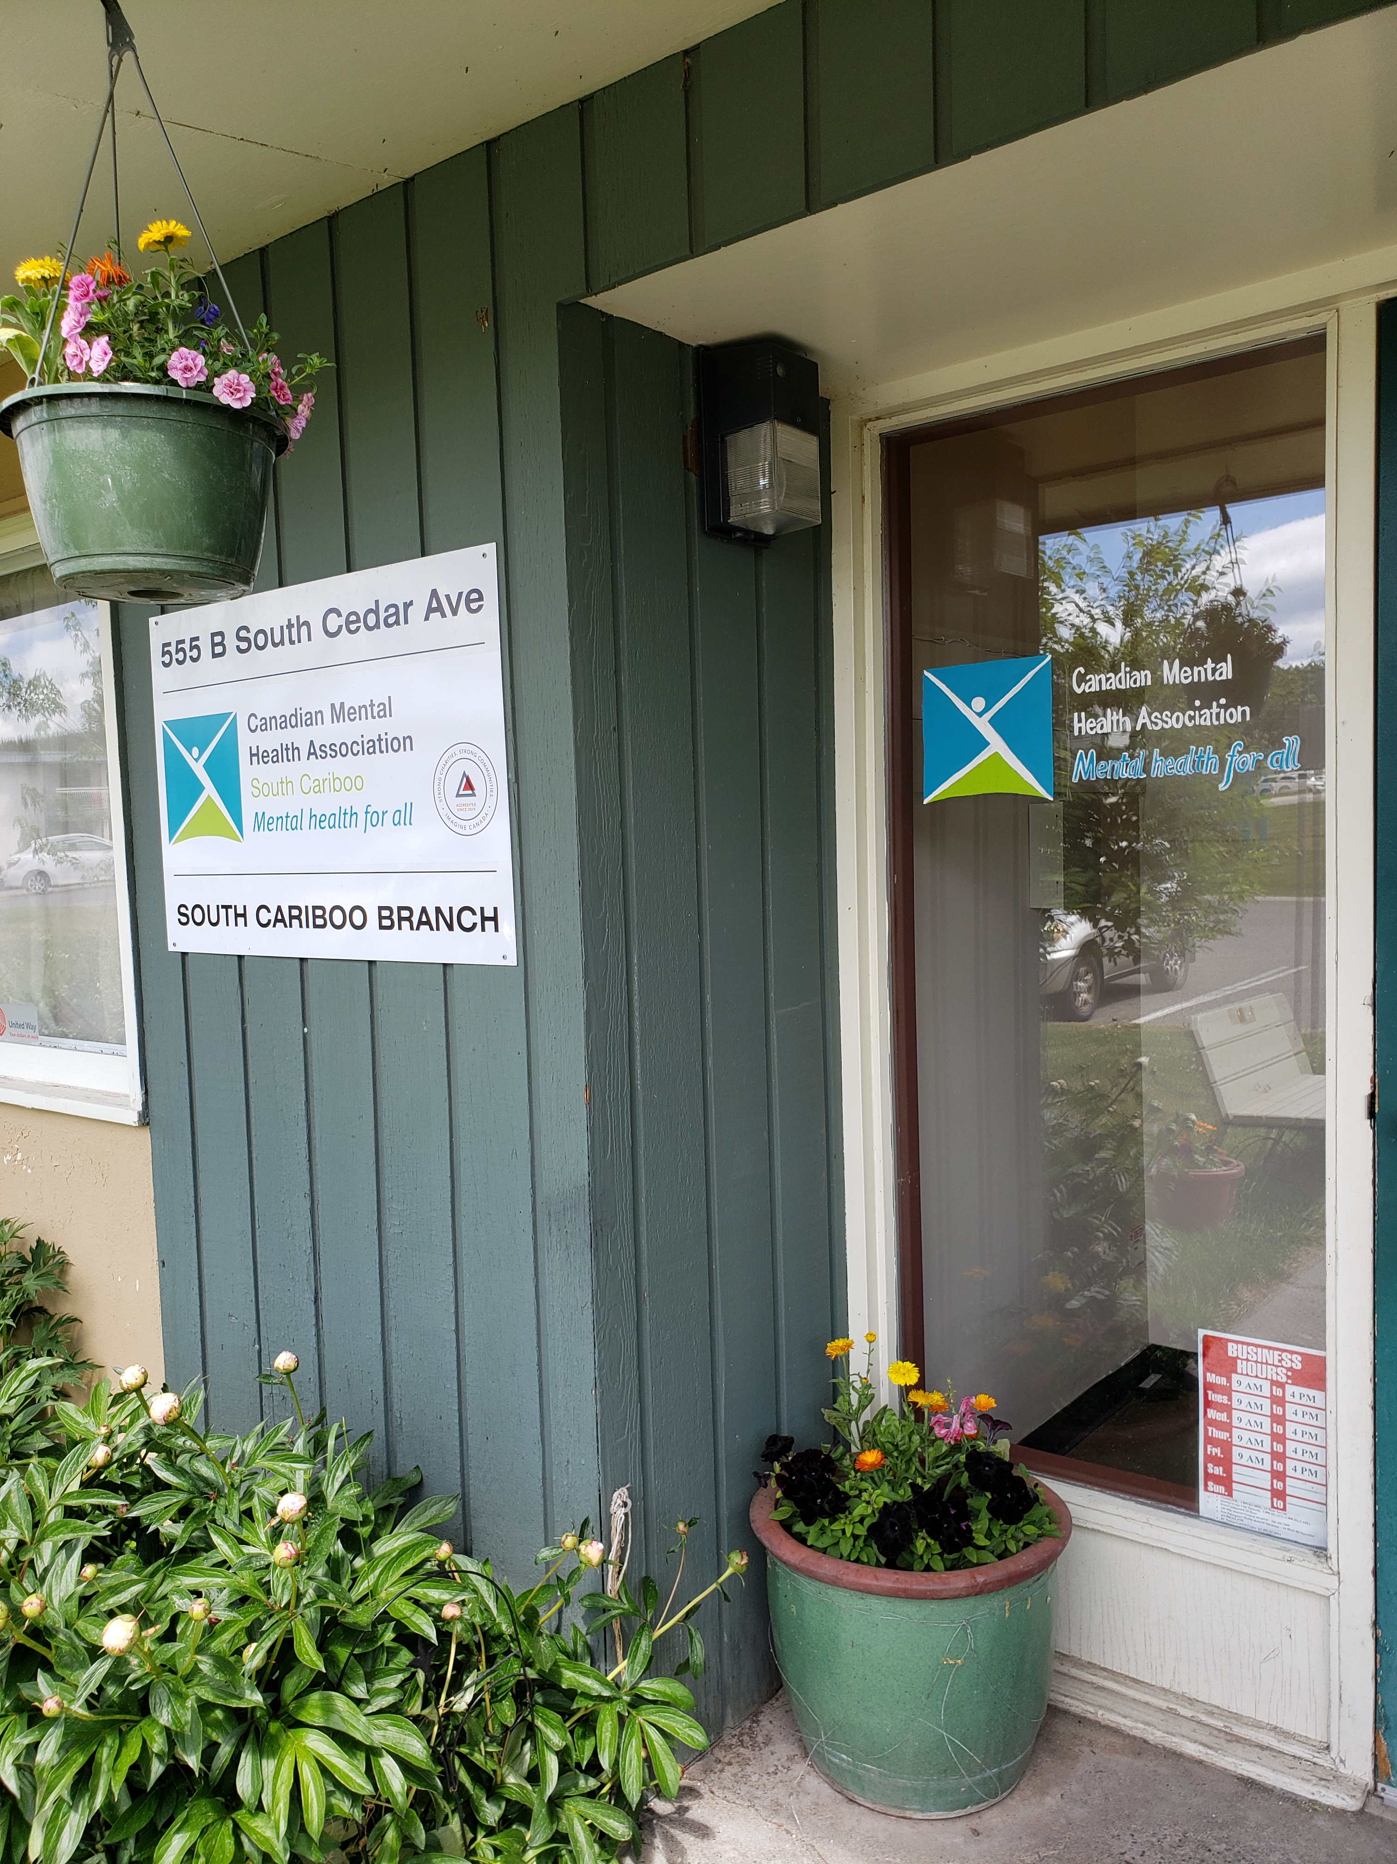

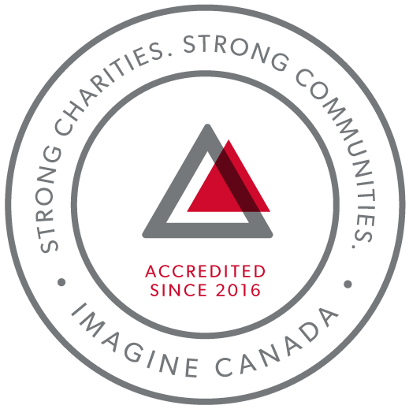
CMHA South Cariboo is an accredited organization through Imagine Canada’s Standards Program

Agency Profile
Canadian Mental Health Association, South Cariboo Branch, is an autonomous, non-profit, charitable organization with ethical and legal responsibilities to the National and BC Divisions of CMHA. Our mandate emphasizes the importance of people with lived experience of mental illness being involved in the delivery of service and governance wherever possible.

Our Vision: “Mentally Healthy People in a Healthy Society”

Our Mission:
Founded in 1918, The Canadian Mental Health Association (CMHA) is a national charity that helps maintain and improve mental health for all Canadians. As the nation-wide leader and champion for mental health, CMHA helps people access the community resources they need to build resilience and support recovery from mental illness. In BC, mental health, substance use and addictive behaviour are within scope of the organization.

CMHA South Cariboo Branch believes in:
- Social justice
- Individual and collective responsibility
- Access to appropriate and adequate resources and supports
- Self-determination
- Maximum community inclusion
- Working collaboratively with our community partners

Geographic Catchment area:
The South Cariboo is a sub-region of the Cariboo Regional District in the Interior of British Columbia. Its main population center is the District Municipality of 100 Mile House, a community of approximately 2,000 residents. An additional 18,000 people live in the South Cariboo. The South Cariboo boundaries are roughly described as 70 Mile House in the South to Lac la Hache in the North, and the Fraser River to the West to Lac des Roches and Mahood Lake to the East. The region includes 100 Mile House and many smaller communities such as Forest Grove, Buffalo Creek, Lac la Hache, 108 Mile Ranch, Lone Butte, Sheridan Lake, Bridge Lake, and Watch Lake/Green Lake.

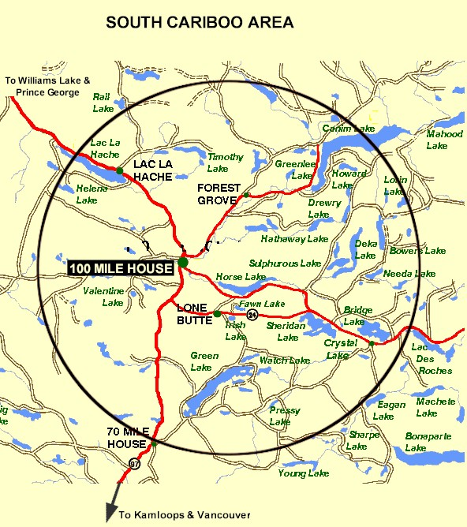

Board Chair’s Report:
So much has happened this year, yet it has gone by so fast. I can hardly believe we are approaching another AGM, as the last seems like only yesterday. Perhaps, this feeling is amplified by this being my first year as chair of this board. I have had a steep learning curve this year but am so grateful for all of the help from my fellow board members, from our Executive Director and from the staff. I couldn’t have managed without any of them this year.
This year, we welcomed two new board members, Rick Meyer and Kim Stokes. I am so appreciative of their contributions at the meetings and am looking forward to working with them in this next year on new projects and efforts.
This year has been one of embracing new opportunity while tying up loose ends on past opportunities. We were successful in entering discussions about a future transition housing project with BC Housing and were awarded two contracts that were in limbo after the closing of the 100 Mile House & District Women’s Centre Society – the Safehouse program and the Stopping the Violence counselling program.
My main focus this year has been working on healthy communication and a shared vision between board members, our Executive Director, our funders, and with our community. I feel we have achieved that – though it is always something that will need to be tended to and considered as we move forward.
This next year, I would like to see us bolster our board with additional directors, fundraising, and continue to explore the needs in our community related to mental health and wellness and the opportunities therein.
Kimberly Vance-Lundsbye, Board Chair

Executive Directors Report:
The June 4th, 2019 Annual General Meeting provides an opportunity for our members to gather together and take a moment to look back upon and celebrate what we have accomplished over this past very busy year. Here are some highlights:
Women’s Centre: 3 years ago, we agreed to take on the work of providing management and governance for the 100 Mile House & District Women’s Centre. We took this on as a temporary measure, understanding that we would need to take some time to explore our options and find the best way forward. We took this responsibility very seriously, gathering information, consulting with others that had navigated similar situations, and after considering everything, we concluded that an amalgamation of the two societies would not be feasible, and that continuing to manage and govern the Women’s Centre separately from CMHA as we had been doing, was not sustainable. The only other option left was to dissolve the Women’s Centre Society, and, where possible, to work to bring over to CMHA the Women’s Centre programs that fit with our vision and mission, in order to assure the continuance of these programs in 100 Mile House, and this is what we decided to do. The Women’s Centre’s STV Counselling program and the Safe House program were identified as programs that would fit with our mission and vision, and we worked with the funders to see if we could bring them over to CMHA, and we were successful in having both of these programs being awarded to CMHA. They are now up and running as CMHA programs in offices on the 2nd floor of the South Cariboo Business Centre (the green building) on Birch Avenue.
Wildfire Recovery: We continue to experience an increased demand for services and support in the aftermath of the wildfires of 2017 and 2018. This past fiscal year we applied for and received funding from the Red Cross to provide us with the capacity to meet this increased demand in the form of 2 Community Navigator positions, and the funding to provide ASIST and safeTALK suicide prevention workshops for our community. This year we applied again to the Red Cross for the funding to expand the Community Navigator program so that we could bring these services to outlying communities, for the funding to be extended for a 2nd year, and for 1 year of funding for our receptionist’s wages; we were recently informed that our application for this funding has been approved.
SIL Outreach and Activity/Clubhouse programs: The Red Cross has agreed to provide additional funding for these programs for 2 years to aid with wildfire recovery.
Soupe de Tour: Soupe de Tour, our mobile soup kitchen program received Gaming Branch funding this past year, allowing it to start operations again, and we have been informed that we will receive funding for this program for this upcoming year. For more information, please see the Soupe de Tour report in the Program Report section.
Fundraising: We held our 3rd^{d} annual Comedy Night fundraiser in October 2018; we were pleased to have a local comedian entertain us again this year, along with the headline comedian. We have decided to do something different this year for fundraising; instead we will be doing a ticket raffle that will have some great prizes, like a weekend at Sun Peaks.
Accreditation: We completed our third year of accreditation with Imagine Canada, following another successful annual accreditation compliance report. We are very proud to continue to be a part of this growing community of charitable and non-profit organizations dedicated to operational excellence.
I sincerely and gratefully thank the CMHA South Cariboo board of directors and staff members for their continuing hard work: they are heroes all. They are a group of dedicated and compassionate people whose support and exemplary service to CMHA South Cariboo Branch accomplishes so much to improve the lives of the citizens of our community.
Thank you as well to our members - you are the heart of our organization and it is our honour to serve you.
I would also like to thank community agencies, community members and volunteers that have allowed us to promote mental health in our community, joining us we work toward our goals of increasing mental health awareness, reducing the stigma associated with mental illness and raising the profile of CMHA’s work in the South Cariboo. This is an invaluable part of our work - locally, in BC and across Canada.
Susann Collins, Executive Director

History of the Canadian Mental Health Association

CMHA National: One of Canada’s Oldest Non-Profits
The Canadian Mental Health Association is one of the oldest national, charitable organizations in Canada and the oldest national mental health charity. Each year, CMHA divisions and branches across Canada provide service to more than 1.3 million Canadians through the combined efforts of more than 10,000 volunteers and staff in locally run organizations across the country. Visit CMHA National’s website for more information.
CMHA was founded in 1918 by Dr. Clarence M. Hincks, Dr. Charles K. Clarke and Clifford W. Beers as the Canadian National Committee for Mental Hygiene. The original goals of the organization centered on war recruits, mental examination of post-war immigrants, prevention, and support for adequate facilities and care for the treatment of mental illness.
CMHA is uniquely positioned in Canada as a charity that brings together community-based experience and expertise on the prevention of mental illness and community supports for the mental well-being of all Canadians. We are not only unique in our mental health promotion approach but also in our ability to speak to issues spanning the broad range of mental disorders and the full spectrum of those affected from those at risk, to those newly diagnosed, to those who have been living with a psychiatric disability over the longer-term, as well as family, friends and community gatekeepers.

CMHA South Cariboo Branch
CMHA in 100 Mile was started by a group of concerned individuals in the late 1980’s. The group’s early meetings took place in the Rosewood Building on Birch Avenue, and included individuals living with mental illness; their friends and family members; mental health service providers and local physicians. As mental health support services in the South Cariboo at that time were very limited, the initial goal for members was to begin to develop resources and a network of support - both for individuals living with a mental illness, and to those who were part of their lives. The branch was incorporated in June 1992. The branch’s early goals were to be actively involved in the development of psychiatric services to our community, and to find funds to develop a clubhouse or drop in center where people who live with mental illness could congregate, socialize and receive the help needed to live successfully in their homes and community. Since its inception, CMHA South Cariboo Branch has grown from a one staff office to a multi-program system. We continue to take pride in our identity as a grassroots organization that adapts to serve the need of our community.
Prevention is fundamental to all of the services we provide and is reflected through the work of the branch during Mental Health Week, Mental Illness Awareness Week and through community information displays, health fairs and public awareness campaigns. It is also reflected in the services we provide to individuals who live with a serious and persistent mental illness. The South Cariboo Branch is proud to be among the 14 branches that make up Canadian Mental Health Association BC Division and one of 87 branches across Canada.

The Framework for Support
The Framework is the central philosophy guiding the activities of CMHA. This philosophy holds that the person experiencing mental illness is at the center of any supportive mental health system.
The Community Resource Base outlines a range of possible resources in addition to the formal mental health system which can provide support to a person with mental illness. Housing, income, work and education represent four basic elements of citizenship.
The ultimate goal of the Framework is to ensure that people with serious mental health problems live fulfilling lives in the community. The Framework for Support is referred to as the most comprehensive model for mental health planning by federal and provincial governments as well as by the Centre for Community Change in the US, and the Government of Ireland.

Community Awareness Events

Mental Health Week
Mental Health Week is an annual national event that takes place during the first week in May to encourage people from all walks of life to learn, talk, reflect and engage with others on all issues relating to mental health. CMHA Branches across the nation held special events to celebrate.

Beyond the Blues Screening and Education Day
Beyond the Blues is held annually in October during the first Thursday of Mental Illness Awareness Week. The South Cariboo Branch started participating in the 1990’s and continues to participate yearly. This year, in partnership with staff from other organizations in the community, the event included the Peter Skene Ogden Senior Secondary School, the Outback School and the Youth Zone.

Scholarship Report

We provide a $500 Scholarship that is designed to help a student pursuing a career related to mental health (such as psychiatry or Community Mental Health Worker) when we receive applications that meet this criterion. The scholarship was awarded this year to 2 students.

2018/19 Operations Budget

Revenue :
Contract income - IHA: $ 240,045.76
B.C. Housing-H.O.W/Subsidies: $ 238,297.08
Grants: $ 159,904.47
Fundraising and Donations: $ 8,357.45
Rental (CTT): $ 137,904.00
Interest Income: $ 5,085.80
Management fees: $ 43,956.00
Miscellaneous: $ 2,977.00

=================Total: $ 792,571.56
Nicole Bissat - Finance Coordinator

Program Reports

Supported Independent Living Program (funded by Interior Health Authority):
The Supported Independent Living Program (SIL) supports clients to live independently in the community by providing life skills coaching around budgeting, nutrition, shopping, cooking, and self-care. SIL workers also provide emotional support and encourage healthy lifestyles. Clients are referred to Canadian Mental Health Association (CMHA) from Interior Health Authority Mental Health Services (IH) to connect with programs and services. A care plan is developed by the client, IH Case Manager, Psychiatrist, Doctor, Canadian Mental Health’s Outreach worker, and other health care professionals. CMHA SIL Outreach Worker makes appointments with the client to assist them with the identified goals as outlined in their plan. The SIL Worker meets with IH Managers once a week to discuss the clients and their needs.
Care plans are adjusted as necessary, and typically, once a year the client and their team meet to re-evaluate goals once a year. While some clients receive care from SIL program indefinitely, with support, teaching and mentoring clients are encouraged to maximize their potential for a more independent lifestyle.
In 2018-2019 the SIL program stayed busy and full after the year before doubling the number of clients needing services. We were able to continue providing more hours and a temporary part-time SIL Worker with funds provided by the Red Cross Wildfire Relief funds. The last two summers have been very smoky and triggering for clients who went through the evacuations in 2017 forest fire season in the Cariboo.
The SIL worker and clients continue to support the “Soup De Tour” project by joining a volunteer group in making a large quantity of hearty nutritious soup that gets distributed to non- profit organizations in our community. This is an opportunity for clients to meet and work with people from other community agencies.
On Sunday’s SIL clients have Community Kitchen which provides opportunity for fun, interactive social activity while making a meal together. Working on cooking skills with emphasis on healthy eating and living. In addition, we are going as a group to plant vegetables at the Community Garden in 100 Mile House. The Agriculture Enterprise Center and 100 Mile Food Security Society started this project and the idea is that anyone who is hungry can help themselves to the produce.
Angie Knutson - SIL Outreach Worker

Activity/Clubhouse Program (funded by Interior Health Authority):
The Clubhouse is designed to provide opportunities for clients to get together for social support, recreation, building community and improving their quality of life. The programming is built around these goals, and activities are created to build life skills that reflect these goals. We have been grateful for additional funding received from the Red Cross to allow an extra hour per day for prep time for our Clubhouse Program.
The Clubhouse members are involved in all aspects of program operations, planning, offering suggestions or ideas for projects/ activities and working together cooking lunches and tidying up. We provide opportunities for leisure activities such as walking club, birthday celebrations, and gardening, in order to encourage the development of social relationships. The Clubhouse is all about choice, mutual respect and education. An important part of the program is in working together to prepare a nutritious lunch for Clubhouse members. Chores are divided up and everyone works together; both members and staff. Daily activities include board and card games, karaoke, crafts, outside games such as croquet and frisbee, walk-a-bouts to explore events and services in the community (or just plain walks), and daily chats about the issues of day to day life.
This year we continued to develop a vegetable garden with raised beds and have been actively growing our own food. That food has even made its way into the lunch program. Frozen bounty from last year’s crop is still being used. Working with our hands in the earth is a powerful contributor to a positive outlook on life and the clients enjoy seeing the fruits of their labours.
We also accept donations of cans and bottles, and plans are to donate most of the proceeds for Christmas gifts for children. In response to the anxiety surrounding the recent wildfires, a program called Pioneer Days was started to address fears around this issue, by empowering clients with knowledge and skills that our ancestors had and have been lost to many of us. Once a week we gathered and focused on learning about which plants are edible in the Cariboo region, ways to heat and light up a home without electricity. We also learned how to purify water and build emergency shelter in the forest if you get lost while hiking.
Time spent in the Clubhouse is designed to help members gain and/or regain self-worth, purpose and build the confidence necessary to living independently and managing their own wellness.
Angie Knutson - Activity/Clubhouse Worker

Homeless Outreach Program (funded by BC Housing)
The Homeless Outreach Program helps break the cycle of homelessness by assisting people who are homeless, or at risk of homelessness; we help people access housing, or work with landlords to maintain housing. Beyond this, we help people by connecting them to other resources such as income assistance, and health and employment services. In the 2018-2019 fiscal year, we worked with 1267 individuals. Of these individuals, 1106 were current clients, 86 were new, and 75 were clients who reconnected with our services.
The Extreme Weather Emergency Shelter Program was open from November 1, 2018 to April 30, 2019. During those months we provided 437 bed-stays, close to double what we provided the previous year.
The unit we rent at the Parkview Apartments is a wonderful resource for people who are working on a housing plan, and it is utilized nearly continuously throughout the year. All of the clients we sheltered at our Parkview Apartments unit were able to successfully transition to their own rental accommodations.
100 Mile House continues to have an extremely low inventory of affordable and safe housing, and people often resort to temporary shelter solutions while they look for housing. Many of the short-term options that people accessed in the past are no longer available or have become unaffordable, increasing the demand for supports.
Marnie Jensen - Homeless Outreach Worker

Cariboo Trail Terrace - Housing Report (funded by BC Housing)
Cariboo Trail Terrace is our subsidized family housing development located at 910 Cariboo Trail. Currently, all units are occupied with a combination of 1 Low-End Market Unit and 24 Rent Geared to Income Units. As there is a housing crisis in this area, there is a long wait list for all of the units.
Things are going very well at Cariboo Trail Terrace; we have good tenants who take care of their units. We have managed to mostly avoid having units sit empty, and any repairs needing to be done were done quickly, allowing new tenants to move in without delay. In a few instances we chose to take the opportunity of a long- term tenant moving out to repaint and/or replace flooring in units, and this did result in a small but necessary lapse in tenancy. We have decided to replace the old, worn carpets as needed with a vinyl plank flooring, which is more expensive, but is also more durable, easy to clean and waterproof.
In January we had a flood in one of the units which spread downstairs to the Common Area. This was covered under our insurance and the repairs are almost complete.
Nicole Bissat - Housing Manager

Soupe de Tour Report (funded by BC Gaming, the District of 100 Mile House and the CRD):
In 2018, our Soupe de Tour program received a Gaming Grant as well as funding from the District of 100 Mile and the CRD, and this allowed us to start cooking again, after a year-long break.
Each Tuesday, ten to twenty dedicated volunteers meet at the Lodge Kitchen to prepare the soup of the day. We cook in the morning, break for lunch at noon, and cool soup and clean the kitchen in the afternoon.
Since our start in May of last year, we have cooked nearly every week, and have given out over 10,000 servings of soup. Some of this soup is served fresh, but the majority is given out frozen to the clients of organizations in town.
The Soup de Tour program received funding from the District of 100 Mile House and the CRD for this year, and a Gaming Grant for this year; however, the Gaming funding is lower than expected and we will have to make adjustments to our program. We will likely take a break from soup production for the summer and begin again in the fall.
Marnie Jensen - Soupe de Tour Coordinator

Acquired Brain Injury program (funded by Interior Health Authority)
CMHA provides the Acquired Brain Injury (ABI) program in the South Cariboo. The ABI Life Skills Worker supports clients and their families, and works collaboratively with the client’s health care team that can include the client’s doctor, psychiatrist, occupational therapist, and Interior Health case manager to develop and facilitate a care plan. The role of the Life Skills Worker is to provide emotional, physical, and social support, and assistance with life skills. The Life Skills Worker works one-to-one with clients, assisting them with a wide variety of day-to-day tasks such as: budgeting, dietary planning, shopping, meeting financial obligations, time management, scheduling and attending medical appointments, and keeping track of calendar events and responsibilities. The ABI program also helps clients to connect to community programs that serve to meet their needs, such as financial or recreational programs. The ABI Group started up again in November 2018 and meets once a month. The ABI Group provides clients with a supportive social environment, resources, and discussion around living with an ABI.
Melissa Campbell - Acquired Brain Injury Support Worker

Receptionist (funded by United Way)
During March of 2018, a reception role had been created with the help of Red Cross funding for a new member of support staff. A front reception area had been created providing a welcoming entrance to receive visitors and clients, unique to their individual needs.
Telephone contacts were collected from July 2018 to March 2019. During this time, there were 1,455 calls for staff, housing inquiries and redirected calls to other local health care agencies. In addition to receiving calls, services extended to walk-in visitors requiring additional wellness services, program and community information inquiries.
The role created enables balance with additional help for staff and care recipients with the opportunity for a better outcome for the person needing care while demonstrating sensitivity to concerns and needs in the delivery of CMHA services.
Pamela Glossop – Receptionist

Community Navigator program (funded by the Canadian Red Cross)
The Community Navigator program was established to help support individuals in collaboration with various community agencies and professionals, to provide emergency and ongoing relief to marginalized people experiencing complex challenges, including poverty, mental health issues and geographic isolation, whose vulnerabilities have been compounded by the ongoing impacts of the 2017 and 2018 wildfires.
The program assists individuals and families in 100 Mile House and the surrounding areas to meet essential needs, navigate local, provincial and federal support services and resources they require to recover from trauma in the aftermath of the wildfires. The Community Navigator Program will take individuals where they need to go to be connected in person or in a manner suited to the client’s individual needs and circumstances by providing a range of information and support according to individual needs and circumstances. These services are also offered in remote communities such as 70 Mile, Forest Grove, Lac La Hache.
In the 2018-2019 fiscal year; we worked with 88 unique individuals, 1214 current, new, returned or reconnected clients, 386 referrals went in and out of the program, 913 services were accessed, and 1673 contacts were made.
Leah Sinal - Community Navigator

The Community Gatekeeper Program (led by the CMHA BC Division, and funded by the Ministry of Health, ending December 2018)
The Community Gatekeeper initiative has a provincial goal of training 20,000 British Columbians in suicide prevention from February 1, 2016 to December 31, 2018.
The initiative consists of two programs, ASIST and safeTALK. ASIST (Applied Suicide Intervention Training) is an internationally recognized and standardized two-day training designed to help caregivers learn suicide first aid intervention. safeTALK (suicide alertness for everyone) is the presentation of the basics for helping a person with thoughts of suicide get connected to the support they need. This is a half day program.
The 3 target areas for the Gatekeeper initiative are: men in the 40-60 year age group, rural communities and First Nation communities.
Kathy Provost - Community Gatekeeper Trainer

Take a Break Support Group (funded by the Interior Health Authority)
Take a Break Support Group is part of the Interior Region Family Navigator Program. It is a support group designed for people caring for a youth/child or dependent adult up to age 25 who is struggling with mental illness and/or substance use issues.
CMHA South Cariboo’s Take a Break support group is an opportunity for caregivers to meet other caregivers, make connections, share experiences and learn or strengthen skills. Some of the topics we cover are: mental health Issues, substance use, strategies for wellness, boundary setting, communication skills.
Kathy Provost - Take a Break Support Group Facilitator

Our Board of Directors

President/Chair: Kimberly Vance Lundsbye
Vice Chair and Secretary: Kira Thomas
Directors: Kitten Cadrin, Rick Meyer, Kim Stokes and Allie Blades
Fundraising Committee: Kitten Cadrin, Kim Stokes and Allie Blades

