2019-2020 Annual Report

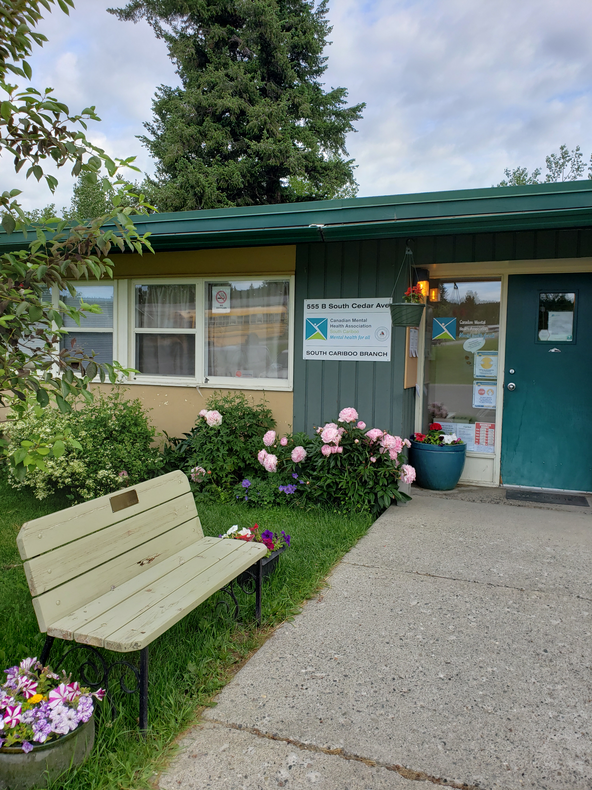

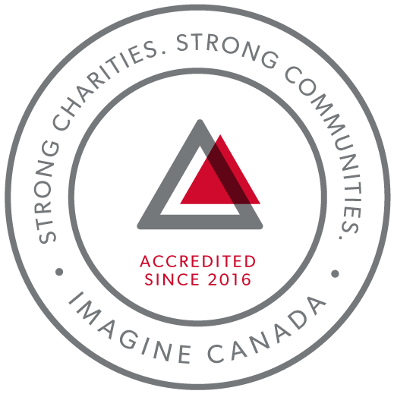
CMHA South Cariboo is an accredited organization through Imagine Canada’s Standards Program
Agency Profile
Canadian Mental Health Association, South Cariboo Branch, is an autonomous, non-profit, charitable organization with ethical and legal responsibilities to the National and BC Divisions of CMHA. Our mandate emphasizes the importance of people with lived experience of mental illness being involved in the delivery of service and governance wherever possible.

Our Vision: “Mentally Healthy People in a Healthy Society”

Our Mission:
Founded in 1918, The Canadian Mental Health Association (CMHA) is a national charity that helps maintain and improve mental health for all Canadians. As the nation-wide leader and champion for mental health, CMHA helps people access the community resources they need to build resilience and support recovery from mental illness. In BC, mental health, substance use and addictive behaviour are within scope of the organization.

CMHA South Cariboo Branch believes in:
- Social justice
- Individual and collective responsibility
- Access to appropriate and adequate resources and supports
- Self-determination
- Maximum community inclusion
- Working collaboratively with our community partners

Geographic Catchment area:
The South Cariboo is a sub-region of the Cariboo Regional District in the Interior of British Columbia. Its main population center is the District Municipality of 100 Mile House, a community of approximately 2,000 residents. An additional 18,000 people live in the South Cariboo. The South Cariboo boundaries are roughly described as 70 Mile House in the South to Lac la Hache in the North, and the Fraser River to the West to Lac des Roches and Mahood Lake to the East. The region includes 100 Mile House and many smaller communities such as Forest Grove, Buffalo Creek, Lac la Hache, 108 Mile Ranch, Lone Butte, Sheridan Lake, Bridge Lake, and Watch Lake/Green Lake.

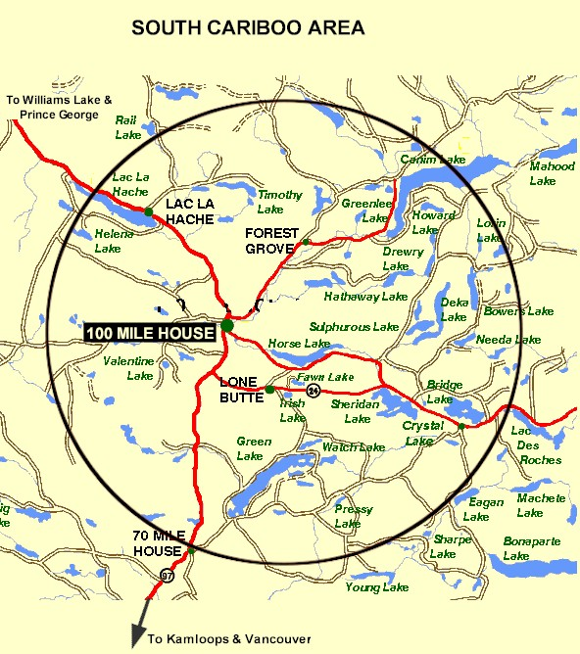

Board Chair’s Report:
This past year has been a smooth one from a board perspective. I would like to recognize the hard work that our Executive Director, Susann Collins, and staff do to make it feel that way.
At a board level, we tightened up our meeting schedule this year with bi-monthly meetings. We considered our board capacity often when making decisions around fundraising, communication, and new endeavors. As a result, much of the work that a working board may be involved in has landed on the desks of others. I acknowledge and have a deep appreciation for that.
Our branch reminds me of the “little engine that could”. We may be a small chapter of a large organization, but I am often amazed at the breadth and quality of services the staff provides in the community. This year saw the incorporation of many services previously offered via the 100 Mile House Women’s Centre Society, with staff following their employment under a new umbrella (and office space). We continue to grow with new funding opportunities and have managed to maintain a variety of contracts allowing us to continue to serve the community. This would not be possible without dedicated and capable staff proving these indispensable services and without an Executive Director taking care of the funding requirements so astutely.
I also want to express how proud I am of our branch for continuing to provide services to the community during this Covid-19 situation and for doing so in a way that considered the safety and wellness of the staff. I believe flexibility in service delivery and a willingness to adapt to meet the needs of both the clients and the staff is imperative to a healthy non-profit organization. I support any and all steps the branch takes that make the services we provide more inclusive and that reduce barriers to service provision for all involved. If there is anything we can learn from this unexpected situation, it is that change is hard, but we can adapt, and that the creativity that derives out of necessity when our routines are broken can lead to not only new ways of operating but better ways.
This next year, I intend to focus on board recruitment and development so we can increase our capacity to be of greater assistance to the branch going forward. I am looking forward to new opportunities that come our way and new voices to be heard at our table.
Kimberly Vance-Lundsbye, Board Chair

Executive Directors Report:
The June 23rd, 2020 Annual General Meeting provides an opportunity for our members to gather together and take a moment to look back upon, and celebrate, what we have accomplished over this past very busy year. Here are some highlights:
COVID-19: With the onset of the pandemic at the end of this reporting period we closed our doors to the public in order to comply with physical distancing requirements and do our part in keeping our staff and the public safe. We managed to find ways to continue providing services in all of our programs except Soupe de Tour; for most of us that meant shifting to working from home, or a combination of working at home and at the CMHA building, connecting with the people we serve through phone calls, email or texting. Some of the people we serve do not have phones or computers, so our staff made sure they were available to provide the support or services these people needed by meeting with them outdoors (at a distance of at least 2 metres). I am so proud of my staff, and grateful for their dedication to the people we serve. Thank you for all you do every single day, and also through the difficult times this pandemic presented us with.
Stopping the Violence (S.T.V.) Counselling Program and the Safe House Program: With the dissolution of the 100 Mile House Women’s Centre Society, we applied for and were awarded the STV Counselling program and the Safe House program, programs that were previously with the Women’s Centre. We set these programs up in offices in the South Cariboo Business Centre (the green building) on Birch to provide more private and discreet access to them.
Wildfire Recovery: We continue to experience an increased demand for services and support in the aftermath of the wildfires of 2017 and 2018, and the mill closures and curtailments, and the Red Cross has approved the funding for our Community Navigator and Reception until March 2021. BC Gaming also approved partial funding for the Community Navigator program for a year, and we will continue to apply to Community Gaming annually for this program.
Fundraising: We held our first ticket raffle fundraising event this past year, thanks to the hard work and dedication of Kitten Cadrin, fundraiser extraordinaire on our board. Prizes were 3 nights at Sun Peaks, $300 in gifts card from Safeway and Save on Foods, and a cord of firewood. After expenses we raised $4,695.
Accreditation: We completed our fourth year of accreditation with Imagine Canada, following another successful annual accreditation compliance report. We are very proud to continue to be a part of this growing community of charitable and non-profit organizations dedicated to operational excellence.
I sincerely and gratefully thank the CMHA South Cariboo board of directors and staff members for their continuing hard work: they are heroes all. They are a group of dedicated and compassionate people whose support and exemplary service to CMHA South Cariboo Branch accomplishes so much to improve the lives of the citizens of our community.
Thank you as well to our members - you are the heart of our organization and it is our honour to serve you.
I would also like to thank community agencies, community members and volunteers that have allowed us to promote mental health in our community, joining us we work toward our goals of increasing mental health awareness, reducing the stigma associated with mental illness and raising the profile of CMHA’s work in the South Cariboo. This is an invaluable part of our work - locally, in BC and across Canada.
Susann Collins, Executive Director

History of the Canadian Mental Health Association

CMHA National: One of Canada’s Oldest Non-Profits
The Canadian Mental Health Association is one of the oldest national, charitable organizations in Canada and the oldest national mental health charity. Each year, CMHA divisions and branches across Canada provide service to more than 1.3 million Canadians through the combined efforts of more than 10,000 volunteers and staff in locally run organizations across the country. Visit CMHA National’s website for more information.
CMHA was founded in 1918 by Dr. Clarence M. Hincks, Dr. Charles K. Clarke and Clifford W. Beers as the Canadian National Committee for Mental Hygiene. The original goals of the organization centered on war recruits, mental examination of post-war immigrants, prevention, and support for adequate facilities and care for the treatment of mental illness.
CMHA is uniquely positioned in Canada as a charity that brings together community-based experience and expertise on the prevention of mental illness and community supports for the mental well-being of all Canadians. We are not only unique in our mental health promotion approach but also in our ability to speak to issues spanning the broad range of mental disorders and the full spectrum of those affected from those at risk, to those newly diagnosed, to those who have been living with a psychiatric disability over the longer-term, as well as family, friends and community gatekeepers.

CMHA South Cariboo Branch
CMHA in 100 Mile was started by a group of concerned individuals in the late 1980’s. The group’s early meetings took place in the Rosewood Building on Birch Avenue, and included individuals living with mental illness; their friends and family members; mental health service providers and local physicians. As mental health support services in the South Cariboo at that time were very limited, the initial goal for members was to begin to develop resources and a network of support - both for individuals living with a mental illness, and to those who were part of their lives. The branch was incorporated in June 1992. The branch’s early goals were to be actively involved in the development of psychiatric services to our community, and to find funds to develop a clubhouse or drop in center where people who live with mental illness could congregate, socialize and receive the help needed to live successfully in their homes and community. Since its inception, CMHA South Cariboo Branch has grown from a one staff office to a multi-program system. We continue to take pride in our identity as a grassroots organization that adapts to serve the need of our community.
Prevention is fundamental to all of the services we provide and is reflected through the work of the branch during Mental Health Week, Mental Illness Awareness Week and through community information displays, health fairs and public awareness campaigns. It is also reflected in the services we provide to individuals who live with a serious and persistent mental illness. The South Cariboo Branch is proud to be among the 15 branches that make up Canadian Mental Health Association BC Division, and one of over 100 local, provincial, and national locations across Canada.

The Framework for Support
The Framework is the central philosophy guiding the activities of CMHA. This philosophy holds that the person experiencing mental illness is at the center of any supportive mental health system.
The Community Resource Base outlines a range of possible resources in addition to the formal mental health system which can provide support to a person with mental illness. Housing, income, work and education represent four basic elements of citizenship.
The ultimate goal of the Framework is to ensure that people with serious mental health problems live fulfilling lives in the community. The Framework for Support is referred to as the most comprehensive model for mental health planning by federal and provincial governments as well as by the Centre for Community Change in the US, and the Government of Ireland.

Community Awareness Events

Mental Health Week
Mental Health Week is an annual national event that takes place during the first week in May to encourage people from all walks of life to learn, talk, reflect and engage with others on all issues relating to mental health. CMHA Branches across the nation hold special events to celebrate.

Beyond the Blues Screening and Education Day
Beyond the Blues is held annually in October during the first Thursday of Mental Illness Awareness Week. The South Cariboo Branch started participating in the 1990’s and continues to participate yearly. This year, in partnership with staff from other organizations in the community, the event included the Peter Skene Ogden Senior Secondary School, the Outback School and the Youth Zone.

Scholarship Report

We provide a $500 Scholarship that is designed to help a student pursuing a career related to mental health (such as psychiatry or Community Mental Health Worker) when we receive applications that meet this criterion. The scholarship was awarded this year.

2019/20 Operations Budget

Revenue :
Contract income - IHA: $ 193,703.03
B.C. Housing-H.O.W/Subsidies: $ 289,265.01
Grants: $ 210,253.51
Fundraising and Donations: $ 22,232.04
Rental (CTT): $ 153,517.00
Interest Income: $ 6,254.40
Management fees: $ 2,461.80
Miscellaneous: $ 2,721.76
Contract income - STV: $ 82,762.04

=================Total: $ 963,170.59

Nicole Bissat - Finance Coordinator

Program Reports

Supported Independent Living Program (funded by Interior Health Authority and the Red Cross):
The staff of the Supported Independent Living Program (SIL program) support clients to live independently in the community by providing life skills coaching around budgeting, nutrition, shopping, cooking, and self-care. SIL workers also provide emotional support and encourage healthy lifestyles. Clients are referred to Canadian Mental Health Association (CMHA) from Interior Health Authority Mental Health and Substance Use Services (IH) to connect with programs, services and supports. A care plan is developed by the client, IH case manager, psychiatrist, doctor, CMHA’s SIL outreach worker, and other health care professionals. The CMHA SIL outreach worker makes appointments with the client to assist them with the identified goals as outlined in their plan. The SIL worker meets with IH managers as needed to discuss the clients and their needs.
Care plans are adjusted as necessary, and typically once a year the client and their team meet to re-evaluate goals. While some clients receive care from SIL program indefinitely, clients are encouraged to maximize their potential for a more independent lifestyle.
In 2019-2020, the SIL program was busy and well-used. We were able to continue providing more hours and a part-time SIL worker with funds provided by the Red Cross Wildfire Relief funds.
The SIL worker and clients continue to support the “Soup De Tour” project by joining a volunteer group in making a large quantity of hearty nutritious soup that gets distributed to non-profit organizations in our community, who, in turn distribute the soup to people in need. This is an opportunity for clients to meet and work with people from other community agencies. Unfortunately, the Soup De Tour program had to be temporarily shut down during the COVID-19 pandemic, towards the end of the reporting period.
On Sundays, SIL clients have Community Kitchen which provides opportunity for fun, interactive social activity while making a meal together, working on cooking skills with emphasis on healthy eating and living. In addition, we are going as a group to plant vegetables at both the CMHA garden and the Community Garden in 100 Mile House.
Towards the end of the reporting period, the onset of COVID-19 began to affect the way we worked with clients (i.e. distancing, disinfecting, and not being able to enter the hospital with clients). As of March 23, the staff at CMHA South Cariboo were requested to work from home, having staff rotate using the office with no more than two staff members in the building at a time, and with no transporting of clients. This has been challenging for many clients who rely on our services, many of whom already struggle with anxiety, and were just overcoming the stresses of the 2017 wildfires. Contact and support was maintained with clients through regular phone calls throughout the pandemic to prevent isolation.
Cindy Faulkner and Reimo Paivinen - SIL Outreach Workers

Activity/Clubhouse Program (funded by Interior Health Authority and the Red Cross):
The Clubhouse program is designed to provide opportunities for clients to get together for social support, recreation, building community and improving their quality of life. The programming is built around these goals, and activities are created to build life skills that reflect these goals. We have been grateful for additional funding received from the Red Cross to allow an extra hour per day for prep time for our Clubhouse Program. This gives staff more time for office and administrative work.
The Clubhouse members are involved in all aspects of program operations, planning, offering suggestions or ideas for projects/activities and working together cooking lunches and tidying up. We provide opportunities for leisure activities such as walking club, birthday celebrations, and gardening to encourage the development of social relationships. The Clubhouse is all about choice, mutual respect and education. An important part of the program is in working together to prepare a nutritious lunch for Clubhouse members; chores are divided up and everyone works together. Daily activities include board and card games, karaoke, crafts, outside games such as croquet and frisbee, walk-a-bouts to explore events and services in the community (or just plain walks), and daily chats about the issues of day to day life.
This year we continued to develop a vegetable garden with raised beds and have been actively growing our own food. That food has even made its way into the lunch program. Working with our hands in the earth is a powerful contributor to a positive outlook on life and the clients enjoy seeing the fruits of their labours.
We also accept donations of cans and bottles, and plans are to donate most of the proceeds for Christmas gifts for children. Time spent in the Clubhouse is designed to help members gain a sense of self-worth and purpose, and to build the confidence necessary to living independently and managing their own wellness.
The restrictions surrounding the COVID-19 pandemic necessitated changing our program format towards the tail end of this reporting period. Services are still being provided to our clients and new ways of staying in touch have developed. Lunches are provided daily in separate bags for clients to pick up in a staggered order to stay with physical distancing guidelines. We talk to clients at a distance outside for short periods of time, one client at a time, while they pick up their lunches. Telephone check-ins are done regularly for those participants who are too far away to drop by for a lunch. This connection has been an important touchstone for our clients.
Janet Bellamy and Tammy Martens - Activity/Clubhouse Workers

Homeless Outreach Program (funded by BC Housing)
The Homeless Outreach Program helps break the cycle of homelessness by assisting people who are homeless or at risk of homelessness; we help people access housing or work with landlords to maintain housing. Beyond this, we help people by connecting them to other resources such as income assistance, and health and employment services. In the 2019-2020 fiscal year, we provided over 2800 services to 1271 individuals. Of these individuals, 1101 were current clients, 110 were new, and 60 were clients who reconnected with our services.
The Extreme Weather Response Shelter Program was open from November 1, 2019 to April 30, 2020. During those months we provided 507 bed-stays, a 10% increase over the previous year.
The Homeless Outreach unit at Parkview Apartments is a resource for people who are working on a housing plan, and it is utilized continuously throughout the year. All of the clients we sheltered at our Parkview Apartments unit were able to successfully transition to their own rental accommodations.
Due to COVID-19, BC Housing extended our funding for shelter beds through June 2020. This extension has allowed us to shelter people who needed to self-isolate but were unable to return home or find other shelter options because of the pandemic restrictions.
The Homeless Outreach Program was able to seamlessly transition to working from home, while also providing office hours for those who are unable to communicate through phone or computer. When in-person meetings were necessary, we were able to meet outside to maintain physical distancing. In this way, we’ve been able to continue to provide the same services to our clients and follow safety guidelines.
Marnie Jensen - Homeless Outreach Worker

Cariboo Trail Terrace - Housing Report (funded by BC Housing)
Cariboo Trail Terrace is our subsidized family housing development located at 910 Cariboo Trail. Currently, all units are occupied with a combination of 2 Low-End Market Units and 23 Rent Geared to Income Units. As there is a housing crisis in this area, there is a long wait list for all units.
Things are going very well at Cariboo Trail Terrace; we have good tenants who take care of their units. We have continued to replace old, worn carpets with vinyl plank flooring in a few of the units this year, resulting in a higher cost, but a more durable, waterproof and easy to clean floor. In order to do this, some units were vacant for a month, but this should mean shorter vacancy times for repairs in the future. There were no major repairs needed this year, but we did manage to replace the old fence by the cemetery with a new chain link fence, and hope to continue replacing fence panels as needed. We also managed to move some of our over-housed tenants into smaller units appropriate for their family size.
BC Housing has informed us they will be supplying Cariboo Trail Terrace with a water treatment system. This is great news as we have noticed since the District of 100 Mile House changed their water source there has been an increase in hot water tank and boiler issues because of the mineral content in the water. The system will be located where the water comes into the property and will be serviced monthly by the company that supplied it, paid for by BC Housing for the first few years, then as a new budget item on our contract after that.
Nicole Bissat - Housing Manager

Soupe de Tour Report (funded by BC Gaming, the District of 100 Mile House and the CRD):
In 2019, our Soupe de Tour program was funded again by a Community Gaming Grant as well as funding from the District of 100 Mile and the CRD, and this allowed us to continue making soup for another year.
Ten to twenty dedicated volunteers meet at the Lodge Kitchen on Tuesdays to prepare about 200 servings of the soup of the day. They cook in the morning, break for lunch at noon, and cool soup and clean the kitchen in the afternoon. Some of this soup is immediately taken to several local organizations where it is served fresh, but the majority is given out frozen to the clients of organizations in town.
Soup was made nearly every week this past year until the physical distancing requirements of the COVID-19 pandemic came into effect. We were unable to continue to make the soup and meet these requirements, so we had to temporarily shut down Soupe de Tour operations. The Lodge Kitchen, where the soup is made, is now closed for renovations for an unknown period of time. We are currently looking into other options for making the soup.
Marnie Jensen, Leah Sinal and Tammy Martens - Soupe de Tour Coordinators

Acquired Brain Injury Program (funded by Interior Health Authority)
The Acquired Brain Injury (ABI) program has been designed to provide support and encouragement for survivors of illnesses or injuries resulting in brain injuries that make it more difficult to live independently. The ABI program is administered through Interior Health out of Kamloops which provides oversight, referrals, and resources for all the ABI workers in the region.
Some of the ways that support can be given include helping program participants to make and attend appointments, shop for themselves, access needed government or other services or resources, and practical life skills necessary to successfully live on their own. Life skills include cooking, budgeting, coping with stress, developing social skills and decision making; the needs are as individual as the people concerned.
It has been a good year for the ABI program, with some important successes being achieved by the participants in the program. Recently the ABI program caseload increased from 6 people to 8 with two new referrals.
With the COVID-19 physical distancing requirements the ABI program continued to provide services as before but shifting to mainly providing services by phone and computer. Some participants have limited family support but either distance or illness has changed their availability for the family member needing support. During the pandemic, the ABI program support has become even more vital to helping people to be able to continue living successfully on their own.
Janet Bellamy - Acquired Brain Injury Support Worker

Receptionist (funded by the Red Cross)
Over the past year, the receptionist role provided service to the community from Red Cross Funding. Between April 1, 2019 to March 31, 2020 - 2,259 front desk calls were received, marking an approximate increase of 800 calls from 2018-2019. With the addition of the Stopping the Violence Program and Safe House Program, the receptionist role now provides support for 10 programs. The role also expanded to include community wellness awareness events in support of the 2017 wildfire resiliency funds. Between June to November 2019, the role was responsible for event planning activities in various South Cariboo communities to support residents dealing with stress or trauma from previous years while anticipating upcoming wildfire alerts and evacuations. The purpose of these collaborative community events was to promote the mental health and well-being of our residents, support their resiliency and preparedness, and also included working with the CMHA Community Navigator and the United Way Community Wellness Coordinator for 100 Mile House and region.
Recently, with COVID-19 restrictions being implemented province-wide, all staff were sent to work-from-home, requiring a sudden need to deliver services remotely and adapt work schedules rapidly to ensure continuity of mental health support. A spike in callers with uncertainty of where to get supports and information was deemed a priority from CMHA SCB for additional local and government help.
The receptionist role continues to be responsive in supporting staff to increase effectiveness; screening all telephone calls and visitors, helping keep the office organized, inventory control, keeping each other up to date, anticipating needs, and showing initiative by furthering professional development. The time invested in training and developing the role has benefited the branch by creating connections and enabling opportunities for clients when reaching out for quality information and referral services, making a positive difference for the clients, staff, community and mental health services.
Pamela Glossop - Receptionist

Community Navigator Program (funded by the Canadian Red Cross)
The Community Navigator program was established to help support individuals, in collaboration with various community agencies and professionals, to provide emergency and ongoing relief to marginalized people experiencing complex challenges, including poverty, mental health issues and geographic isolation, whose vulnerabilities have been compounded by the ongoing impacts of the 2017 and 2018 wildfires.
The program assists individuals and families in 100 Mile House and the surrounding areas to meet essential needs, navigate the local, provincial, and federal support services and resources they require to recover from trauma in the aftermath of the wildfires. The Community Navigator Program provides a range of information and support according to individual needs and circumstances. These services are also offered through outreach in other communities, such as 70 Mile, Forest Grove, Lac La Hache.
In the 2019-2020 fiscal year we worked with 1234 clients; 304 of these were new clients. 426 referrals went in and out of the program, 2607 services were accessed, and 3098 contacts were made.
Leah Sinal - Community Navigator

Safe House Program (funded by BC Housing)
The Safe House Program contract was awarded by BC Housing to CMHA South Cariboo following the closure of the 100 Mile House & District Women’s Centre on March 31, 2019. The Women’s Centre Safe House Coordinators were retained, allowing for a seamless transition with no gaps in service.
The Safe House program helps break the cycle of domestic violence by assisting women and children who are fleeing abuse. The Safe House program provides emergency safe housing, groceries, emotional support, safety planning, referrals and transportation to longer term transition houses, and referrals to counselling services, legal aid and other community resources, according to the needs of the individual woman.
A Safe House Coordinator is available 24 hours per day, every day of the year.
Safe House Coordinators offer women the information needed to make informed decisions. During the previous 2018/2019 fiscal year 34 women and 7 children were supported. In the 2019/2020 fiscal year 39 women and 4 children were supported, and 12 enquiries from other agencies about services available were responded to. The past year has highlighted the need for first and second stage housing in the 100 Mile area as women with jobs and/or children in school are often reluctant to take their children out of their school and away from their friends and go to another town for longer-term safe housing.
COVID-19 physical distancing protocols have presented some challenges to the Safe House Program in that Safe House Coordinators could not transport women to appointments, grocery shopping or to Williams Lake facilities and also meet physical distancing requirements, and bus service is limited. The RCMP assisted by providing emergency transport locally. Isolation protocols and being unable to provide the usual face-to-face emotional support and contact has also proved to be stressful for some clients. In recent weeks there has been an upsurge in calls and Safe House intakes in 100 Mile House. Other areas have also seen an increase in demand for services.
Roxanne Salinas and Hayley Emmerson - Safe House Coordinators

Stopping the Violence (S.T.V.) Program (funded by the Ministry of Public Safety and Solicitor General and the Red Cross)
The S.T.V. Program offers essential counselling services to women. Since the S.T.V. Counselling, and S.T.V. Counselling Assistant have moved from the Women Centre Society to the Canadian Mental Health Association (C.M.H.A.), we continue to offer counselling, intake and outreach services. The new private and confidential counselling environment offers stream-lined counselling and support services, addressing violence and abuse, childhood abuse and sexual assault through 1-1 or group counselling sessions.
An open house was held to formally open the program as a new CMHA program, with food, conversation and information provided to all attendees.
Generous donations from businesses in the community allowed us to provide clothing as well as self-care holiday and birthday presents to the women served.
In 2019-2020 the STV Counselling Program had 1044 contacts, 300 scheduled sessions, 700 support follow up contacts and 77 intakes. 23 women were supported through outreach.
Kalika Moody S.T.V. Counsellor and Tshidi Machete S.T.V. Counselling Assistant

Our Board of Directors

President/Chair: Kimberly Vance Lundsbye
Vice Chair: Kitten Cadrin
Secretary and Treasurer: Marna Forsyth
Fundraising Committee: Kitten Cadrin, Kim Stokes
Directors: Kira Thomas, Rick Meyers, Carey Davidson

