2020-2021 Annual Report

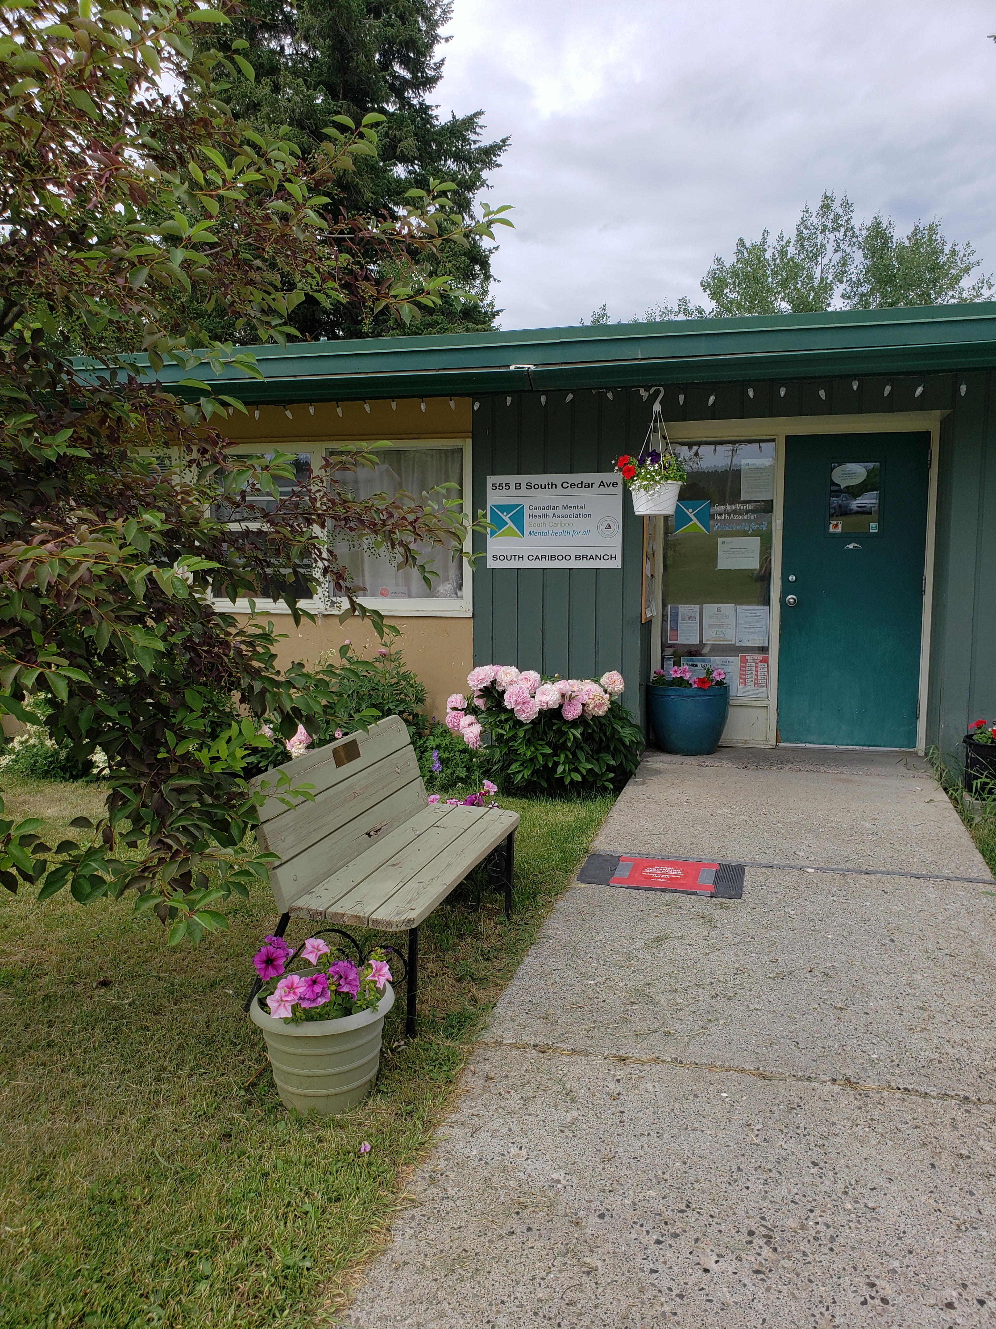

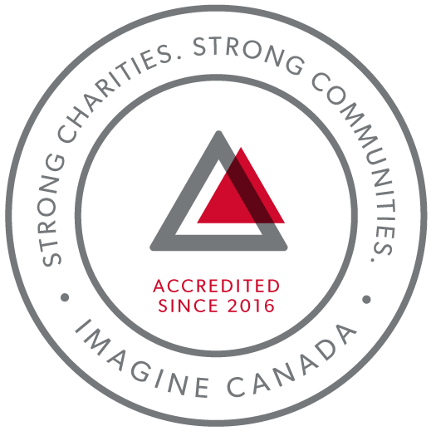
CMHA South Cariboo is an accredited organization through Imagine Canada’s Standards Program
Agency Profile
Canadian Mental Health Association, South Cariboo Branch, is an autonomous, non-profit, charitable organization with ethical and legal responsibilities to the National and BC Divisions of CMHA. Our mandate emphasizes the importance of people with lived experience of mental illness being involved in the delivery of service and governance wherever possible.

Our Vision: “Mentally Healthy People in a Healthy Society”

Our Mission:
Founded in 1918, The Canadian Mental Health Association (CMHA) is a national charity that helps maintain and improve mental health for all Canadians. As the nation-wide leader and champion for mental health, CMHA helps people access the community resources they need to build resilience and support recovery from mental illness. In BC, mental health, substance use and addictive behaviour are within scope of the organization.

CMHA South Cariboo Branch believes in:
- Social justice
- Individual and collective responsibility
- Access to appropriate and adequate resources and supports
- Self-determination
- Maximum community inclusion
- Working collaboratively with our community partners

Geographic Catchment area:
The South Cariboo is a sub-region of the Cariboo Regional District in the interior of British Columbia. Its main population center is the District Municipality of 100 Mile House, a community of approximately 2,000 residents. An additional 18,000 people live in the South Cariboo. The South Cariboo boundaries are roughly described as 70 Mile House in the South to Lac la Hache in the North, and the Fraser River to the West to Lac des Roches and Mahood Lake to the East. The region includes 100 Mile House and many smaller communities such as Forest Grove, Buffalo Creek, Lac la Hache, 108 Mile Ranch, Lone Butte, Sheridan Lake, Bridge Lake, and Watch Lake/Green Lake.

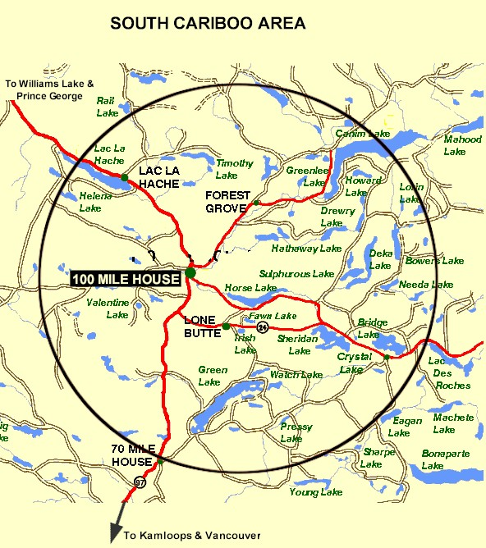

Board Chair’s Report:
The 2020/2021 year has not been short of challenges. In some ways, this year has gone by very quickly as it has felt a bit like the movie Groundhog Day. The only thing that has remained consistent has been the notion that nothing is certain. I am keenly aware of how difficult it is to provide crisis work for others while also experiencing many of the same stressors as those we help. I am proud of the work everyone has done at our local CMHA branch to carry forth with providing diverse and quality mental health and wellness services for people in the South Cariboo. As a board, we supported strategies to care for staff so they can care for others. We put employee safety, physical and emotional, at the forefront of all our decision making and took a stance early to look beyond what has been done before and what is being done to meet unprecedented needs during exceptional times. As we go forward into a new year, I hope to not forget the ground we have made in this direction.
Kimberly Vance-Lundsbye, Board Chair

Executive Directors Report:
The June 29th, 2021 Annual General Meeting provides an opportunity for our members to take a moment to look back upon and celebrate what we have accomplished over this past very busy year.
COVID-19: While we closed our doors to the public in order to comply with physical distancing requirements and do our part to keep staff and the public safe, we found ways to continue providing services in all of our programs except Soupe de Tour. At times that meant shifting to working from home, or a combination of working at home and at CMHA, connecting with the people we serve by meeting them outside, going for walks with them, or booking time in one of the big rooms we have access to when meeting inside was necessary. When meeting in person was not necessary, service was provided through phone calls, email, Zoom meetings or texting.
I am so proud of our staff, and grateful for their hard work and dedication throughout the pandemic and the challenging times it has presented us with. Thank you for all you do every single day.
It has been a long year; a hard one for many, and we look forward to the unfolding of our new normal as restrictions lift.
Accreditation: In 2020-2021 we completed our fifth year of accreditation with Imagine Canada. Due to the pandemic, Imagine Canada granted annual accreditation to all current accredited organizations without requiring the annual compliance report. We are very proud to continue to be a part of this growing community of charitable and non-profit organizations dedicated to operational excellence.
I sincerely and gratefully thank the CMHA South Cariboo board of directors and staff members for their continuing hard work: they are heroes all. They are a group of dedicated and compassionate people whose support and exemplary service to CMHA South Cariboo Branch accomplishes so much to improve the lives of the citizens of our community.
Thank you to the people we serve; you are the heart of our organization and it is our honour to serve you.
Thank you as well to our members; your ongoing support is very important to us.
I would also like to thank community agencies, community members and volunteers that have allowed us to promote mental health in our community, joining us we work toward our goals of increasing mental health awareness, reducing the stigma associated with mental illness and raising the profile of CMHA’s work in the South Cariboo. This is an invaluable part of our work; locally, in BC and across Canada.
Susann Collins, Executive Director

History of the Canadian Mental Health Association

CMHA National: One of Canada’s Oldest Non-Profits
The Canadian Mental Health Association is one of the oldest national, charitable organizations in Canada and the oldest national mental health charity. Each year, CMHA divisions and branches across Canada provide service to more than 1.3 million Canadians through the combined efforts of more than 10,000 volunteers and staff in locally run organizations across the country. Visit CMHA National’s website for more information.
CMHA was founded in 1918 by Dr. Clarence M. Hincks, Dr. Charles K. Clarke and Clifford W. Beers as the Canadian National Committee for Mental Hygiene. The original goals of the organization centered on war recruits, mental examination of post-war immigrants, prevention, and support for adequate facilities and care for the treatment of mental illness.
CMHA is uniquely positioned in Canada as a charity that brings together community-based experience and expertise on the prevention of mental illness and community supports for the mental well-being of all Canadians. We are not only unique in our mental health promotion approach but also in our ability to speak to issues spanning the broad range of mental disorders and the full spectrum of those affected from those at risk, to those newly diagnosed, to those who have been living with a psychiatric disability over the longer-term, as well as family, friends and community gatekeepers.

CMHA South Cariboo Branch
CMHA in 100 Mile was started by a group of concerned individuals in the late 1980’s. The group’s early meetings took place in the Rosewood Building on Birch Avenue, and included individuals living with mental illness; their friends and family members; mental health service providers and local physicians. As mental health support services in the South Cariboo at that time were very limited, the initial goal for members was to begin to develop resources and a network of support - both for individuals living with a mental illness, and to those who were part of their lives. The branch was incorporated in June 1992. The branch’s early goals were to be actively involved in the development of psychiatric services to our community, and to find funds to develop a clubhouse or drop-in center where people who live with mental illness could congregate, socialize and receive the help needed to live successfully in their homes and community. Since its inception, CMHA South Cariboo Branch has grown from a one staff office to a multi-program system. We continue to take pride in our identity as a grassroots organization that adapts to serve the need of our community.
Prevention is fundamental to all of the services we provide and is reflected through the work of the branch during Mental Health Week, Mental Illness Awareness Week and through community information displays, health fairs and public awareness campaigns. It is also reflected in the services we provide to individuals who live with a serious and persistent mental illness. The South Cariboo Branch is proud to be among the 14 branches that make up Canadian Mental Health Association BC Division, and one of over 75 branches/regions across Canada.

The Framework for Support
The Framework is the central philosophy guiding the activities of CMHA. This philosophy holds that the person experiencing mental illness is at the center of any supportive mental health system.
The Community Resource Base outlines a range of possible resources in addition to the formal mental health system which can provide support to a person with mental illness. Housing, income, work and education represent four basic elements of citizenship.
The ultimate goal of the Framework is to ensure that people with serious mental health problems live fulfilling lives in the community. The Framework for Support is referred to as the most comprehensive model for mental health planning by federal and provincial governments as well as by the Centre for Community Change in the US, and the Government of Ireland.

Scholarship Report

We provide a $500 Scholarship that is designed to help a student pursuing a career related to mental health (such as psychiatry or Community Mental Health Worker) when we receive applications that meet this criterion. The scholarship was awarded this year to 2 students.

Community Awareness Events

This past year, in order to comply with provincial restrictions in place due to the COVID-19 pandemic, we did not participate in face-to-face community awareness events.

2020/21 Operations Budget

Revenue :
Contract income - IHA: $ 191,201.40
B.C. Housing-H.O.W/Subsidies: $ 471,619.32
Grants: $ 226, 372.31
Fundraising and Donations: $ 3,286.01
Rental (CTT): $ 159,673.00
Interest Income: $ 5,572.44
Legal Service Contract Income: $ 16,019.04
Miscellaneous: $ 2,785.00
COVID Relief $ 48,748.61
Contract income - STV: $ 93,303.57

=================Total: $1,218,580.70
Nicole Bissat - Finance Coordinator

Program Reports

Supported Independent Living Program (funded by Interior Health Authority and the Red Cross)
The Supported Independent Living (SIL) Program supports clients to live independently in the community by providing emotional support, encouragement, and life skills coaching in areas such as budgeting, nutrition, self-care and wellness. Clients are referred through Interior Health Mental Health and Substance Use Services. A care plan is developed by the client and their Health Team, which can consist of Interior Health Case Managers, Psychiatrist, Doctor, Canadian Mental Health SIL Worker and other health care professionals. The SIL Worker makes appointments with the client to help them with the identified goals as outlined in their plan. Care plans are adjusted as necessary according to what the individual needs.
During this year, the program made adjustments to comply with the new and changing government regulations brought on by the COVID 19 pandemic. Our CMHA van was outfitted with a Plexiglas style COVID 19 shield. With masks and proper sanitizing, this enabled us to safely transport clients so that they could complete their necessary tasks and appointments. All SIL business had to be completed outside of the office as it was not open to the public. Despite the many challenges we have been able to serve our clients successfully. Client numbers are growing again, and we are looking forward to reopening our doors in the near future.
Kathy Provost and Cindy Faulkner - SIL Outreach Workers

Activity/Clubhouse Program (funded by Interior Health Authority and the Red Cross)
The focus of the Clubhouse program is to encourage social connection and peer support through preparing and sharing a meal together, recreation such as outings, picnics, gardening, etc. Prior to the onset of COVID-19, the members were encouraged to participate in all areas of the program, such as planning, preparing and cleanup of the lunches, planning the garden, as well as what outings and activities were chosen.
The 2020-21 fiscal year has been a challenging one for the Clubhouse activities. With the pandemic preventing us from gathering in the building, the social gathering became a takeout lunch with workers doing a check in with clients when they came to pick up their lunches.
The isolation and missing the social meal together were difficult for many clients, but so was the fear of COVID-19. Clients were very cautious while coming to pick up their lunches, wearing their masks and keeping their distance.
In keeping with our commitment to recognize and share major holidays such as Thanksgiving and Christmas etc., a full course hot meal was prepared in takeout containers for our clients on these occasions. This brought on much pride since all of the vegetables (potatoes, carrots, brussels sprouts and peas) for our meals were grown ourselves in the CMHA garden out front. The turkeys were donated.
In the past few weeks as the provincial guidelines began to lift, I began serving a sit-down lunch outdoors, with clients physically distanced at the table out back. We BBQ hot dogs or burgers about once a week, and soup and sandwich, spaghetti, pizza or chili, etc., on other days.
Interior Health has sent several new referrals to the Clubhouse program, mostly due to social isolation. It has been heartwarming to see these new members join in on conversation, helping others with their tea and coffee, being the first to come and the last to leave. Many of them say it is their only “real” meal in their day. Budgeting is also a challenge as the cost of groceries is ever rising.
We have a really fun group right now, with a few of them being real wise cracks; the jokes and laughter have been flowing freely. Although we are not yet gathering indoors, I feel that our outdoor visits while sharing a meal together, are definitely very therapeutic. We are grateful.
Cindy Faulkner - Clubhouse/Activity Worker

Homeless Outreach Program (funded by BC Housing)
The Homeless Outreach Program helps break the cycle of homelessness by assisting people who are homeless, or at risk of homelessness.
In the 2020-2021 fiscal year, we provided over 3100 services to 1365 individuals. Of these individuals, 1140 were current clients, 174 were new, and 51 were clients who reconnected with our services.
The Homeless Outreach Program provided 350 bed stays to homeless individuals. This is a decrease over last year, a fact that I think can be attributed to the increasing needs of those active in addictions in our community. While having a shelter option is helpful, we are seeing more people who cannot meet the requirements to stay in our high-barrier shelters. At least 28 hard to house individuals were turned away from our shelters or had their shelter stay terminated because their needs exceeded what we are able to provide.
In response to COVID-19, BC Housing extended our shelter supports and we had a hotel shelter space all year. Because of this extension, we supported 15 people who needed to self-isolate due to COVID-19.
Early in 2021, a COVID-19 outbreak restricted people living at Canim Lake Reserve from leaving their community. The Homeless Outreach Program coordinated with Interior Health and First Nations Health Authority to help support the 25 people required to self-isolate outside of their community. This support included coordinating hotel rooms, purchasing and delivering food, medications, and clothing, and other items to help people remain in isolation for as long as required.
Marnie Jensen - Homeless Outreach Worker

Cariboo Trail Terrace - Housing (funded by BC Housing)
Cariboo Trail Terrace is our 25-unit subsidized family housing development located at 910 Cariboo Trail. Currently, all units are occupied, with a combination of 2 Low-End Market Units and 23 Rent Geared to Income Units. As there is a housing crisis in this area, there is a long wait list for all units.
Things are going very well at Cariboo Trail Terrace; we have good tenants who take care of their units. We did not have any major unit repairs of note as there were no vacancies during the year. We did order some fence panels last spring, but by the time they arrived the ground was frozen, so the job was completed this spring.
In the beginning of March 2021 our boiler system broke down. The system was outdated, but the poor water quality in 100 Mile House contributed to the deterioration. We were able to get BC Housing to fund a brand-new high efficiency boiler system which was installed on March 20, 2021. We are still waiting to hear when the new water treatment system will be installed as it was delayed due to COVID-19.
As part of the Energy Conservation Assistance Program (ECAP) we have been able to receive a few high efficiency fridges as well as furnaces for a some of the units! This is great news as the furnaces are at the age where we will have to start replacing, so any that can be replaced free of charge, will help us and being energy efficient will reduce the cost for the tenants.
Nicole Bissat - Housing Manager

Acquired Brain Injury Program (funded by Interior Health Authority)
The Acquired Brain Injury (ABI) program provides support and encouragement for survivors of illnesses or injuries resulting in brain injuries that make it more difficult to live independently. It is an outreach program that helps equip clients for successful independent living. The ABI program is administered through Interior Health out of Kamloops which provides oversight, referrals, and resources for all the ABI workers in the region. The ABI program caseload currently stands at 7 with several possible new referrals pending.
Some of the ways that support can be given include helping program participants to make and attend appointments, shop for themselves, access needed government or other services or resources, and learn and practice life skills necessary to successfully live on their own. Life skills include cooking, budgeting, coping with stress, developing social skills and decision making; the needs are as individual as the people concerned.
It has been a challenging year for the ABI program. With the COVID-19 protocols for service the ABI program continued to provide assistance, but physical distancing and limited personal contact except outdoors, made service provision a little more difficult. However, during the pandemic, the ABI program has become even more vital in helping people to be able to continue living successfully on their own. Despite the limitations to the program during the pandemic, helping people access services and figuring out how to make things work to get what they need has been an important point of contact and support.
Despite the limitations, some important successes have been achieved by the participants in the program. Lack of transportation options have meant some clients needed to be more proactive and resourceful to be able to get around. This has been beneficial for the goal of living independently. Two people were dismissed from the program as they were no longer in need of the support offered and are managing well on their own.
I am looking forward to the year ahead, to getting back to some semblance of normalcy and to continuing to walk alongside people who are invested in making their lives work better, despite the setbacks of their injuries and the challenges of everyday life.
Janet Bellamy - Acquired Brain Injury Support Worker

Receptionist (funded by the Red Cross and other funders)
The key responsibilities of the receptionist role are to:
- receive visitors
- provide information and support in crisis situations by connecting people to appropriate staff
- act as a safety check-in person for staff working in the community
- answer the telephone and direct to appropriate persons
- type and create documents, reports and minutes
- receive rent payments, issue receipts
- maintain records and prepare summary reports

The receptionist's role has also expanded to include scheduling for the organization, and during COVID-19, ensuring staff and visitor entry checks, and COVID-19 signage, updates and additional safety precautions, ordering of personal protective equipment for both staff and office, and implementing the safety plan directives from management. As well, providing accurate and up-to-date information to inform the public of operating procedures were of utmost importance during this time in order to provide awareness of continued programs and operating hours of all services.
The receptionist's role continues to expand with flexibility and resiliency to the nature of the community and need of staff and clients in a friendly and professional manner. Between April 1, 2020 to March 31, 2021, approximately 1,985 front desk calls were received.
Pamela Glossop - Receptionist/Scheduler

Community Navigator Program (funded by BC Gaming Branch and the Canadian Red Cross)
The Community Navigator program was established to help support individuals in collaboration with various community agencies and professionals, to provide emergency and ongoing relief to marginalized people experiencing complex challenges, including poverty, mental health issues and geographic isolation, whose vulnerabilities have been compounded by the ongoing impacts of the 2017 and 2018 wildfires.
The program assists individuals and families in the South Cariboo region to meet essential needs, to navigate local, provincial, and federal services, while connecting with supports and resources they require to recover from trauma in the aftermath of the wildfires. The Community Navigator Program will take individuals where they need to go to be connected in person or in a manner suited to the client’s individual needs and circumstances by providing a range of information and support according to individual needs and circumstances. While some of these supports and services were modified due to COVID 19 pandemic, the program continuously met people safely in person during the pandemic.
In the 2020-2021 fiscal year; we worked with 1141 clients, 1709 referrals went in and out of the program, and 4817 services were accessed. Trends in services accessed from highest to lowest are as follows, emotional support, food, mental health, paperwork, disability, seniors, health, other, housing and transportation. It was found that 65% of clients were living in the Cariboo Regional District boundaries and 35% were living in 100 Mile House.
There was over a 100% increase in request for resources, supports, and services during this fiscal year, likely due to COVID 19 pandemic.
Leah Sinal - Community Navigator

Safe House Program (funded by BC Housing)
The CMHA Safe House Program helps break the cycle of domestic violence by assisting women and children who are fleeing abuse. The Safe House program provides emergency safe housing, groceries, emotional support, safety planning, referrals and transportation to longer term transition houses, and referrals to counselling services, legal aid and other community resources, according to the needs of the individual woman.
A Safe House Coordinator is available 24 hours per day, every day of the year.
Last year, long term Safe House Coordinator Hayley Emerson moved on to her new career in Psychiatric Nursing. Back up Safe House Coordinator services have been provided by Tshidi Machete and other CMHA staff.
Safe House Coordinators offer women the information needed to make informed decisions. During the previous year, (the 2019/2020 fiscal year) 39 women and 4 children were supported, and 12 enquiries from other agencies about services available were responded to. During the 2020/2021 fiscal year and the COVID-19 pandemic, the number of women supported increased to 60 women and 2 children. 53 women were referred to other community agencies and additional services, and 49 women were provided with safety planning. Finding longer term accommodation for Safe House clients has been challenging during the COVID-19 pandemic as aside from Williams Lake Chiwid House, Amata House in Quesnel, and emergency shelters, transition houses in other locations have not been accepting clients from out of their area. This has highlighted even more the need for first and second stage housing in the 100 Mile area. During the past fiscal year, 7 women were provided with transportation by bus or assistance with gas for their own vehicles to go to the above-mentioned places as safe or supervised long term accommodation could not be provided to them in 100 Mile House. Isolation protocols and being unable to provide the usual face-to-face emotional support and contact proved to be extremely stressful for some clients.
Many of the Safe House referrals have been from law enforcement, and during this past year a closer working relationship has developed between Safe House and the 100 Mile House RCMP and Victims Services. Because of COVID-19 restrictions and protocols, CMHA Safe House workers have been unable to transport clients and the RCMP have provided transportation services for clients whenever possible. Commander Sven Nielsen and sergeant Brad McKinnon have been instrumental in informing new officers about the Safe House program and officers now deal directly with Safe House workers instead of going through VictimLink. This allows for faster communications in emergency situations.
Periodic upsurges in calls for Safe House services have continued throughout the COVID-19 pandemic. There has been an increase in families moving to the 100 Mile House area, which has resulted in an increased demand for Safe House services and accommodation. More clients have been referred to the STV counselling and other community resources. The lack of rental accommodations in 100 Mile House and vicinity makes finding housing for clients extremely challenging.
Roxanne Salinas - Safe House Coordinator

Stopping the Violence Program (funded by the Ministry of Public Safety and Solicitor General and the Red Cross)
The Stopping the Violence Counselling (S.T.V.) Program offers essential services to women. The S.T.V. Counselling Program, S.T.V. Assistant and Outreach Programs work very closely within the same office space and for client management.
The S.T.V. Counsellor offers counselling services for scheduled, unscheduled and emergency appointments for individuals and also group services. The S.T.V. Counselling Assistant and Outreach worker offers intake and outreach services.
A new move to another counselling environment offers a larger space for counselling and support services related to addressing violence and abuse, childhood abuse and sexual assault.
Our statistics for fiscal year 2020--2021 reflect program delivery changes made to comply with the COVID-19 restrictions. The STV Counselling Program had 766 contacts (decrease), 324 scheduled sessions (increase), and 418 support follow up contacts (decrease). The STV Counselling Assistant had 77 new intakes (remains the same) and provided outreach to 23 people (increase).
Kalika Moody - S.T.V. Counsellor and Tshidi Machete - S.T.V. Counselling Assistant

Soupe de Tour Report (funded by BC Gaming, the District of 100 Mile House and the CRD):
We were unable to continue to make the soup and meet the physical distancing requirements for COVID-19, so we had to temporarily shut down Soupe de Tour operations. Then the Lodge Kitchen, the commercial kitchen where the soup is made, closed for renovations for an unknown period of time. We had hoped to have the soup made in an alternate location, but we have not yet been able to get that going

Senior’s Program (COVID 19 funding from the United Way by way of Interior Community Services)
In July 2020, our organization received $7000 from the United Way Safe Senior Healthy Communities.
This funding was used to purchase gift cards for groceries and gas, prescriptions, and frozen meals purchased from the Roe Lake and District Recreation Commission. We helped at least 55 seniors with this money, many of them on an ongoing basis through the pandemic.
Seniors in our community were struggling with many things at the start of the provincial COVID-19 restrictions. Staying safe while shopping and attending medical appointments, was difficult and often more expensive.
This United Way funding helped us provide gas cards to health compromised seniors so they could get to out of town medical appointments without being around other people on public transit. Grocery cards meant that seniors could access food when food supports were limited.
On occasion, workers would provide phone, and socially distanced in-person check-ins with seniors to help limit social isolation. An unexpected benefit of these conversations was that we were sometimes able to refer seniors to other supports from CMHA or other organizations in our community.
Although this was supposed to be a one-time funding opportunity, the executive director requested, and we were given, a further $6000 to use for senior’s supports. We will continue to do what we’ve done in the past and will reassess as needs change.
Marnie Jensen - Homeless Outreach Worker and Leah Sinal - Community Navigator

Our Board of Directors

President/Chair: Kimberly Vance Lundsbye
Co-Vice Chairs: Kitten Cadrin and Rick Meyer
Treasurer: Marna Forsyth
Secretary: Marty Norgren
Fundraising Committee: Kitten Cadrin, Kim Stokes
Directors: Kira Thomas, Carey Davidson, Don Ramsay and Marion Fallding

