2021-2022 Annual Report

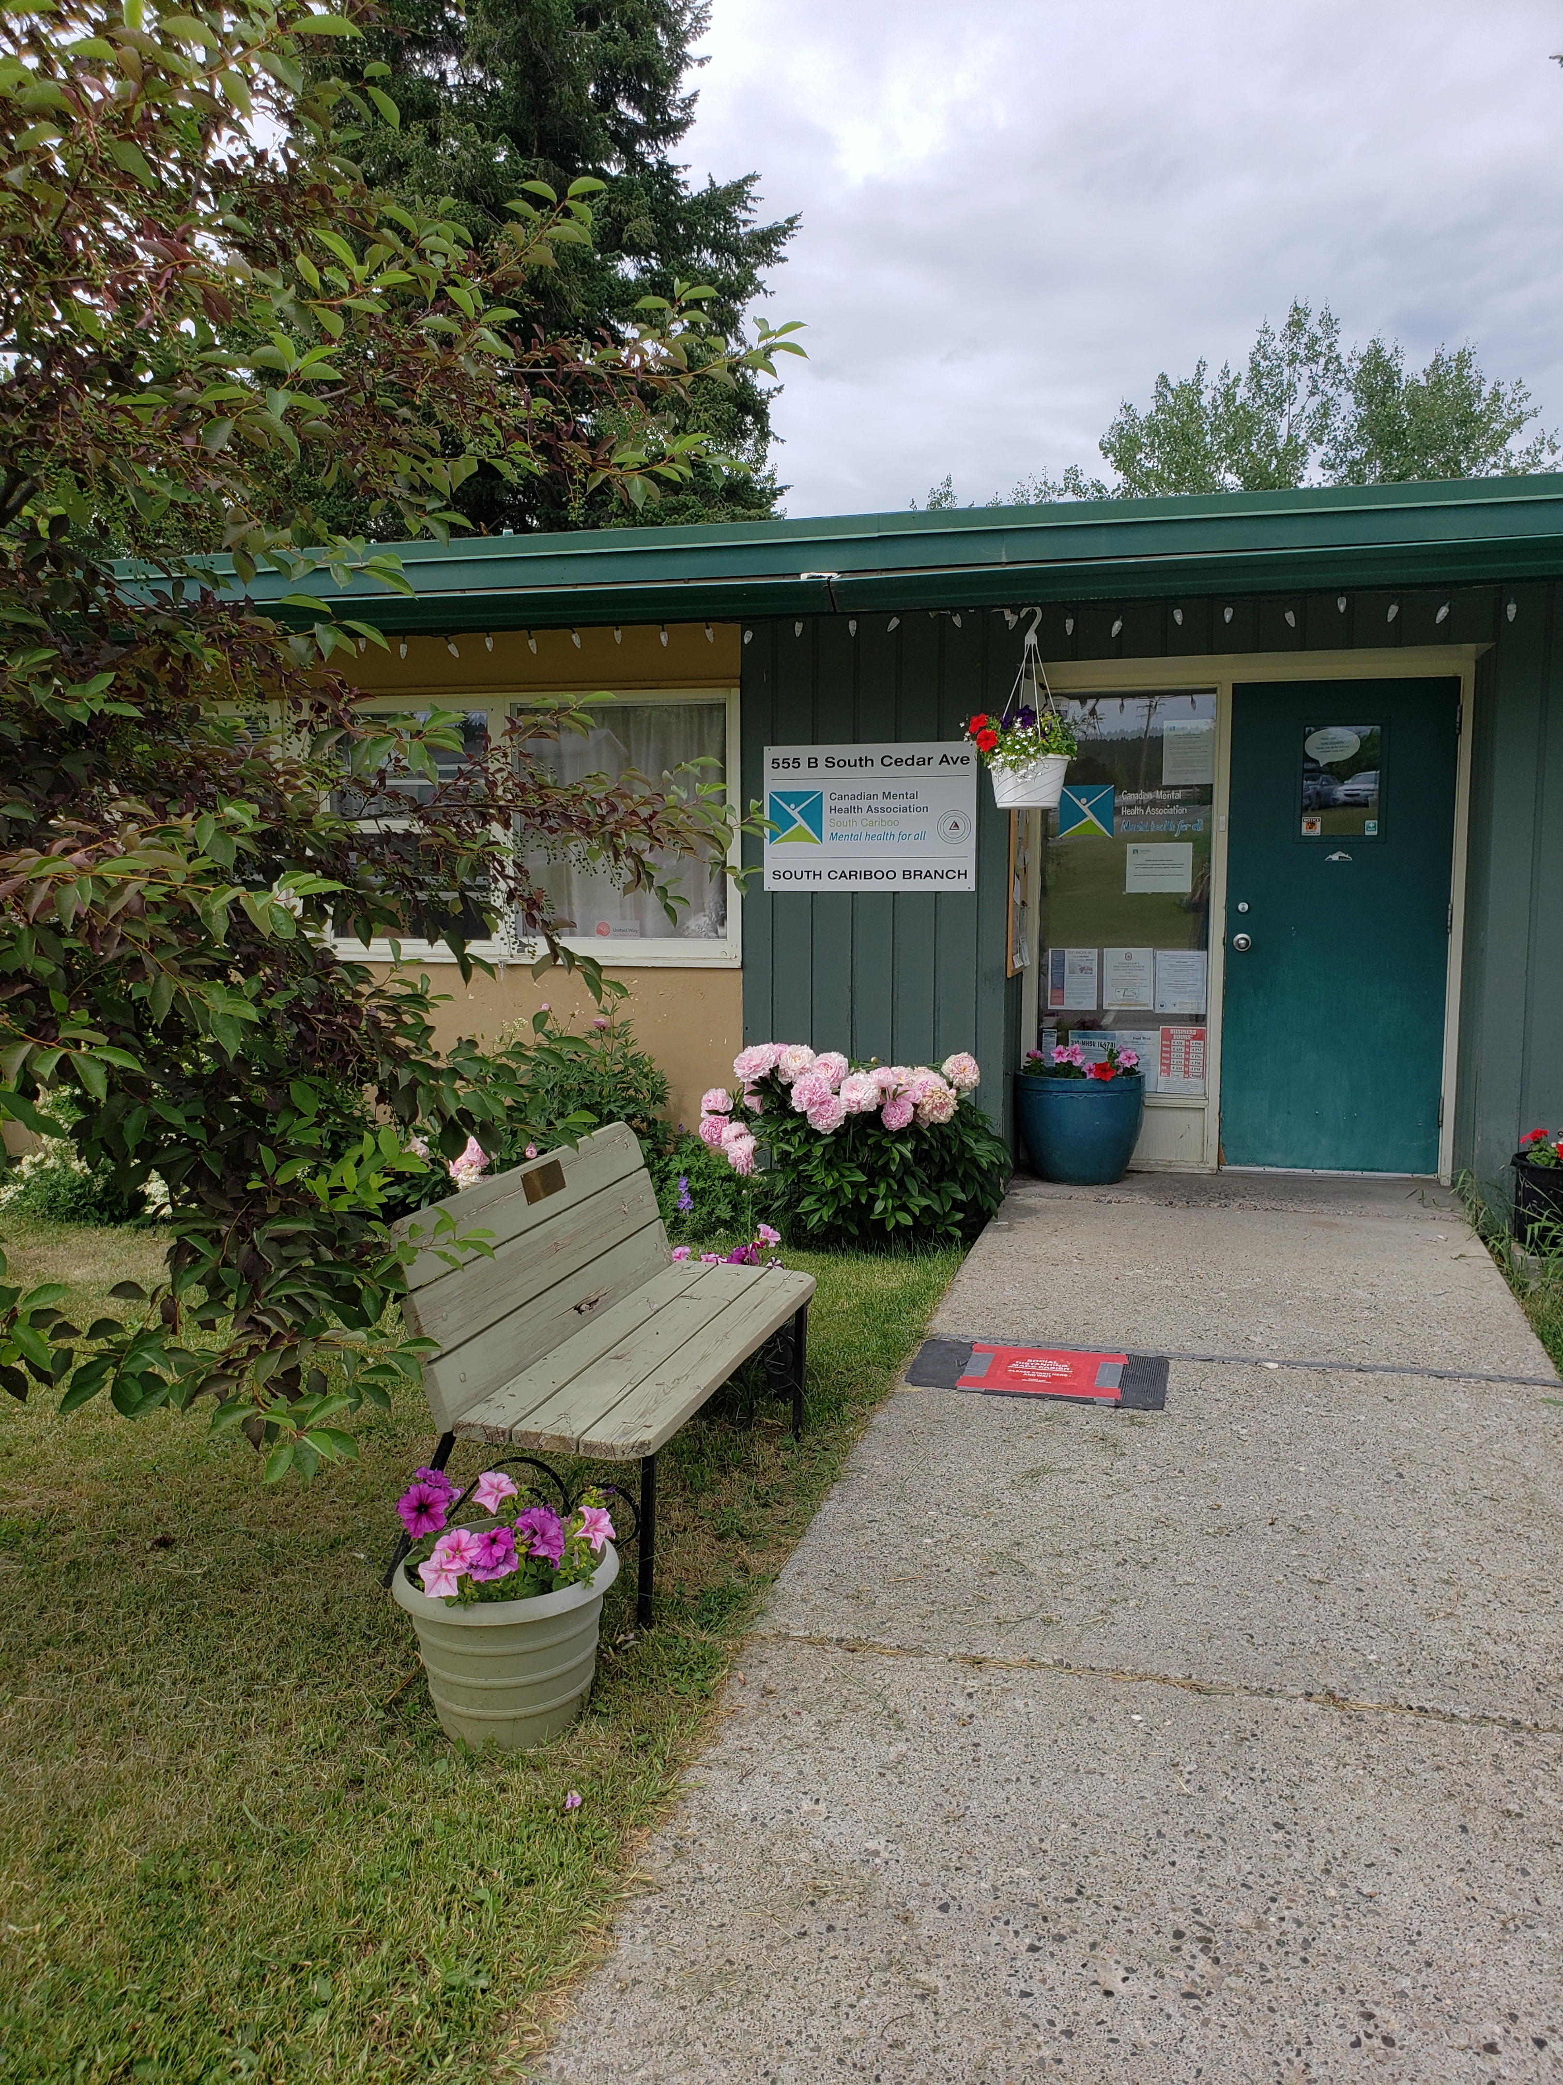

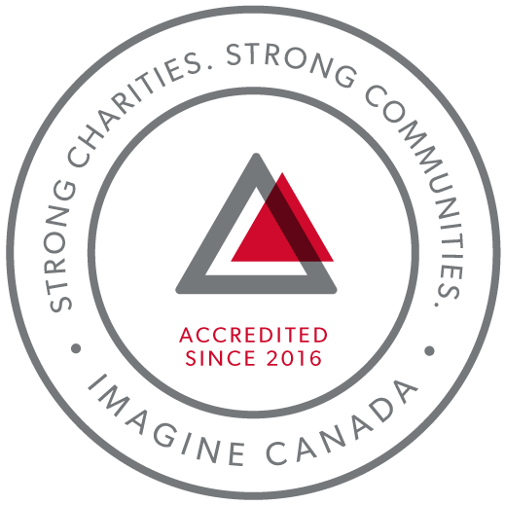
CMHA South Cariboo is an accredited organization through Imagine Canada’s Standards Program
Agency Profile: Canadian Mental Health Association, South Cariboo Branch, is an autonomous, non-profit, charitable organization with ethical and legal responsibilities to the National and BC Divisions of CMHA. Our mandate emphasizes the importance of people with lived experience of mental illness being involved in the delivery of service and governance wherever possible.

Our Vision: “Mentally Healthy People in a Healthy Society”

Our Mission: “To ensure that all people in Canada experience good mental health and well-being.”

CMHA South Cariboo Branch believes in:
- Social justice
- Individual and collective responsibility
- Access to appropriate and adequate resources and supports
- Self-determination
- Maximum community inclusion
- Working collaboratively with our community partners

Geographic Catchment area:
The South Cariboo is a sub-region of the Cariboo Regional District in the interior of British Columbia. Its main population center is the District Municipality of 100 Mile House, a community of approximately 2,000 residents. An additional 18,000 people live in the South Cariboo. The South Cariboo boundaries are roughly described as 70 Mile House in the South to Lac la Hache in the North, and the Fraser River to the West to Lac des Roches and Mahood Lake to the East. The region includes 100 Mile House and many smaller communities such as Forest Grove, Buffalo Creek, Lac la Hache, 108 Mile Ranch, Lone Butte, Sheridan Lake, Bridge Lake, and Watch Lake/Green Lake.

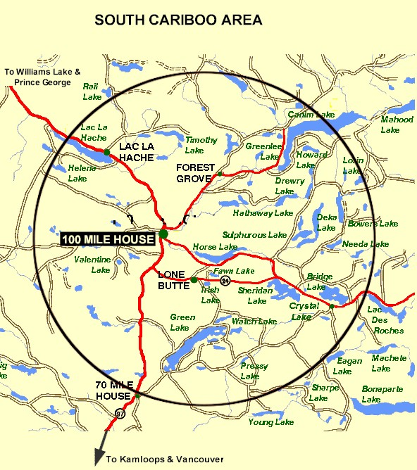

Board Chair’s Report:
This has been a personally challenging year for me. I have to thank Susann & Nicole, first and foremost, for supporting me all year by making my role as chair so easy. I have leaned on both of you, and I thank you. I also want to thank my fellow board members. You all bring thoughtful and caring perspectives to the table. I have enjoyed getting to know all of you and I hope to continue that. I am looking forward to reading about the exciting new projects to come for CMHA-South Cariboo and will always be a community champion for the branch.
I am really proud of all of us. It has been such a challenging few years and we are in a really strong place doing very important work. This branch’s success is due to the skills and energy shared by everyone, the staff, the clients, our wonderful executive director, and everyone on the board. Thank you.
Kimberly Vance-Lundsbye, Board Chair

Executive Directors Report:
The June 28th, 2022, Annual General Meeting provides an opportunity for our members to take a moment to look back upon and celebrate what we have accomplished over this past very busy year.
COVID-19: The pandemic continued throughout the 2021-2022 fiscal year, and we continued to provide services in all of our programs, including Soupe de Tour, which we managed to get up and running again, in an adapted way, at the end of the fiscal year.
I am so proud of our staff, and grateful for their continued hard work and dedication throughout the pandemic and the challenging times it has presented us with. Thank you for all you do every single day.
It has been another long year; a hard one for many, and we look forward to the unfolding of our new normal as restrictions lift.
Accreditation: All organizations accredited with Imagine Canada are required to go through the full accreditation application process every five years. This year is our first time going through the reaccreditation process. We are very proud to continue to be a part of this growing community of charitable and non-profit organizations dedicated to operational excellence.
I sincerely and gratefully thank the CMHA South Cariboo board of directors and staff members for their continuing hard work: they are heroes all. They are a group of dedicated and compassionate people whose support and exemplary service to CMHA South Cariboo Branch accomplishes so much to improve the lives of the citizens of our community.
Thank you to the people we serve; you are the heart of our organization and it is our honour to serve you.
Thank you as well to our members; your ongoing support is very important to us.
I would also like to thank community agencies, community members and volunteers that have allowed us to promote mental health in our community, joining us we work toward our goals of increasing mental health awareness, reducing the stigma associated with mental illness and raising the profile of CMHA’s work in the South Cariboo. This is an invaluable part of our work; locally, in BC and across Canada.
Susann Collins, Executive Director

History of the Canadian Mental Health Association

CMHA National: One of Canada’s Oldest Non-Profits
The Canadian Mental Health Association is one of the oldest national, charitable organizations in Canada and the oldest national mental health charity. Each year, CMHA divisions and branches across Canada provide service to more than 1.3 million Canadians through the combined efforts of more than 10,000 volunteers and staff in locally run organizations across the country. Visit CMHA National’s website for more information.
CMHA was founded in 1918 by Dr. Clarence M. Hincks, Dr. Charles K. Clarke and Clifford W. Beers as the Canadian National Committee for Mental Hygiene. The original goals of the organization centered on war recruits, mental examination of post-war immigrants, prevention, and support for adequate facilities and care for the treatment of mental illness.
CMHA is uniquely positioned in Canada as a charity that brings together community-based experience and expertise on the prevention of mental illness and community supports for the mental well-being of all Canadians. We are not only unique in our mental health promotion approach but also in our ability to speak to issues spanning the broad range of mental disorders and the full spectrum of those affected from those at risk, to those newly diagnosed, to those who have been living with a psychiatric disability over the longer-term, as well as family, friends and community gatekeepers.

CMHA South Cariboo Branch
CMHA in the South Cariboo was started by a group of concerned individuals in the late 1980s. The group’s early meetings took place in the Rosewood Building on Birch Avenue in 100 Mile House, and included individuals living with mental illness, their friends and family members, mental health service providers and local physicians. As mental health support services in the South Cariboo at that time were very limited, the initial goal for members was to begin to develop resources and a network of support - both for individuals living with a mental illness, and to those who were part of their lives. The branch was incorporated in June 1992. The branch’s early goals were to be actively involved in the development of psychiatric services to our community, and to find funds to develop a clubhouse or drop-in center where people who live with mental illness could congregate, socialize, and receive the help needed to live successfully in their homes and community. Since its inception, CMHA South Cariboo Branch has grown from a one staff office to a multi-program system. We continue to take pride in our identity as a grassroots organization that adapts to serve the need of our community.
Prevention is fundamental to all of the services we provide and is reflected through the work of the branch during Mental Health Week, Mental Illness Awareness Week and through community information displays, health fairs and public awareness campaigns. It is also reflected in the services we provide to individuals who live with a serious and persistent mental illness. The South Cariboo Branch is proud to be among the 14 branches that make up Canadian Mental Health Association BC Division, and one of over 75 branches/regions across Canada.

The Framework for Support
The Framework is the central philosophy guiding the activities of CMHA. This philosophy holds that the person experiencing mental illness is at the center of any supportive mental health system.
The Community Resource Base outlines a range of possible resources in addition to the formal mental health system which can provide support to a person with mental illness. Housing, income, work and education represent four basic elements of citizenship.
The ultimate goal of the Framework is to ensure that people with serious mental health problems live fulfilling lives in the community. The Framework for Support is referred to as the most comprehensive model for mental health planning by federal and provincial governments as well as by the Centre for Community Change in the US, and the Government of Ireland.

Scholarship Report

We provide a $500 Scholarship that is designed to help a student pursuing a career related to mental health (such as psychiatry or Community Mental Health Worker) when we receive applications that meet this criterion. The scholarship was awarded this year to 1 student.

Community Awareness Events

This past year, in order to comply with provincial restrictions in place due to the COVID-19 pandemic, we did not participate in face-to-face community awareness events.

Revenue :
Contract income - IHA: $ 216,537.98
B.C. Housing-H.O.W/Subsidies: $ 458,835.21
Grants: $ 185,662.56
Fundraising and Donations: $ 3,244.02
Rental (CTT): $ 156,206.00
Interest Income: $ 3,758.06
Legal Service Contract Income: $ 17,476.26
Miscellaneous: $ 2,858.00
COVID Relief $ 10,475.34
Contract income - STV: $ 104,287.49

=================Total: $1,159,340.92
Nicole Bissat - Finance Coordinator
Program Reports

Supported Independent Living Program (funded by Interior Health Authority)
The Supported Independent Living (SIL) Program supports clients to live independently in the community by providing emotional support, encouragement, and life skills coaching in areas such as budgeting, nutrition, self-care and wellness. Clients are referred through Interior Health Mental Health and Substance Use Services. A care plan is developed by the client and their Health Team, which can consist of Interior Health Case Managers, Psychiatrist, Doctor, Canadian Mental Health SIL Worker and other health care professionals. The SIL Worker makes appointments with the client to help them with the identified goals as outlined in their plan. Care plans are adjusted as necessary according to what the individual needs.
2021/2022 has seen a relaxing of the Covid 19 restrictions to a degree that is permitting the SIL program to allow clients back into the office. This is proving helpful for completing tasks requiring computer and phone communications with the client present. Clients are back to the Work Incentive Program, working in the community garden and enjoying a bit more leniency in the provincial regulations. The program is delivering Food Bank 4 times a month to those in need and those who don’t have transportation. We have 2 client helpers who enjoy being able to contribute and help with this task. With summer approaching we will be putting together safety plans for fire season and making sure everyone is prepared for any emergencies that may arise. We are looking forward to a happy and productive year ahead.
Kathy Provost - SIL Outreach Worker

Clubhouse/Activity Program (funded by Interior Health Authority & District of 100 Mile House and Cariboo Regional District)
The Clubhouse program provides a safe space where individuals with a mental illness can drop in Monday thru Friday between 9 or 10am until 3:15 pm. The focus of the Clubhouse program is to encourage social connection and peer support through preparing and sharing a meal together, recreation such as outings, picnics, gardening, etc. Members are encouraged to participate in all areas of the program, such as planning, preparing and cleanup of the lunches, planning the garden, as well as what outings and activities were chosen.
In 2021 we continued serving meals outside at picnic tables until November when we were able to move meal services inside with Covid safe protocols in place. We were required to provide 2 seating for meals to accommodate the number of participants attending. Clients were very cautious of the change to inside gathering and most were happy to follow new protocols.
In keeping with our commitment to recognize and share major holidays such as Thanksgiving and Christmas etc., a full course hot meal was prepared for our clients on these occasions. This brought on much pride since all of the vegetables (potatoes, carrots, brussels sprouts and peas) for our meals were grown ourselves in the CMHA garden out front. The turkeys were donated and 22 meals were served for the Christmas luncheon.
Interior Health has sent several new referrals to the Clubhouse program, mostly due to social isolation. It has been heartwarming to see these new members join in on conversation, helping others with their tea and coffee, being the first to come and the last to leave. Many of them say it is their only “real” meal in their day. Budgeting is also a challenge as the cost of groceries is ever rising.
We have a really fun group of participants right now.
Rick McKinney - Clubhouse/Activity Worker

Homeless Outreach Program (funded by BC Housing)
The Homeless Outreach Program helps break the cycle of homelessness by assisting people who are homeless, or at risk of homelessness.
In the 2021-2022 fiscal year, the Homeless Outreach Program provided over 3500 services to 1300 individuals. Of these individuals, 1020 were current clients, 185 were new, and 95 were clients who reconnected with our services.
The Homeless Outreach Program provided 375 bed stays to homeless individuals. This is an increase over the previous year. While having shelter options is helpful, we are seeing more and more people who cannot meet the requirements to stay in our high-barrier motel room shelter spaces. At least 55 hard to house individuals were turned away from our shelters, or had their shelter stay terminated because their needs exceeded what we are able to provide. This is a 100% increase over the previous year.
In response to the pandemic, BC Housing extended our shelter funding, allowing us to shelter individuals all year. This means that we can offer shelter to people outside of the usual Extreme Weather Response months of November to April.
Marnie Jensen - Homeless Outreach Worker

Cariboo Trail Terrace - Housing (funded by BC Housing)
Cariboo Trail Terrace is our subsidized family housing development located at 910 Cariboo Trail. Currently, all units are occupied with a combination of 2 Low-End Market Units and 23 Rent Geared to Income Units. As there is a housing crisis in this area, there is a long wait list for all the units.
Things are going very well at Cariboo Trail Terrace; we have good tenants who take care of their units, although we did have a very costly year with repairs. One unit was discovered to have an unnoticed leak that resulted in a long-term renovation and vacancy. Another vacant unit had a furnace failure during a cold spell which caused the pipes to burst. The fall inspections uncovered a lot of unreported repairs that needed to be completed. This was partly because we did not enter units during the first year of COVID, rather relied on the tenants to let us know if there was an issue. I am happy to say that with Melonie on board as the Caretaker, most of these repairs have been completed, and the process for reporting repairs needed has been made clear to the tenants. This spring a large bin was brought in to help tenants get rid of any unwanted items. This was very well received, and the outside carports look very tidy.
Nicole Bissat - Housing Manager

Acquired Brain Injury Program (funded by Interior Health Authority)
The Acquired Brain Injury (ABI) Program provides support and encouragement for survivors of illness and injuries resulting in brain injuries that make it difficult to live independently. It is an Outreach Program that helps equip the clients for successful independent living. The ABI Program is administered through Interior Health out of Kamloops and Kelowna which provides oversight, referrals, and resources for the ABI worker in the region. The ABI caseload currently stands at 8, with several referrals pending.
Some of the ways that support can be given include helping program participants to make and attend appointments, shop for themselves, access needed government or other services or resources, and learn and practice life skills necessary for living on their own. Life skills include cooking, budgeting, coping with stress, developing social skills and decision making; the needs are as individual as the people supported.
It has been a challenging year for the program. With the COVID-19 protocols for service, the ABI Program continued to aid, but physical distancing and limited personal contact made service provision a more challenging. However, during the pandemic, the ABI Program has become more vital in assisting people to be able to continue living successfully on their own. Despite the limitation to the program, helping access the service and figuring out how to make things work to get what they need has still been a crucial point of the contact and support, and something that we n=have been able to continue to do during the pandemic.
Despite the limitations of the pandemic, some important successes have been achieved by the participants in the program. Some clients have improved on their day-to-day life skills, some reintegrated into community activities, such as bowling, going to the library and the gym, and some accessed support from other programs with the aid of ABI Outreach worker (Soup de Tour, Community Navigator, and S.T.V.)
I am certainly looking forward to the year 2022, to seeing the improvements and continuing to walk alongside people who are invested in making their lives work better, despite the setback of their injuries and the challenges of everyday life.
Tshidi Machete - Acquired Brain Injury Support Worker

Receptionist (funded by the Red Cross and other funders)
The key responsibilities of the receptionist role are to:
- Receive visitors
- Provide information and support in crisis situations by connecting people to appropriate staff
- Act as a safety check-in person for staff working in the community
- Answer the telephone and direct to appropriate persons
- Type and create documents, reports and minutes
- Receive rent payments, issue receipts
- Update staff outlook calendar
- Maintain records and prepare summary reports
- Schedule shift coverage for when staff are away or sick
During COVID-19, ensuring staff and visitor entry checks, and COVID-19 signage, updates and additional safety precautions, ordering of personal protective equipment for both staff and office, and implementing the safety plan directives from management. As COVID-19 protocols started to ease up in the community we ensured that we were providing accurate and up-to-date information to inform the public of operating procedures and restriction updates in order to provide awareness of continued programs and operating hours of all services.
The receptionist's role continues to expand with flexibility and resiliency to the nature of the community and need of staff and clients in a friendly and professional manner. Between April 1, 2021, to March 31, 2022, approximately 2,290 front desk calls were received, the door was answered 1,843 times, and around 247 messages were received and answered.
Andrea Jongbloed and Kelly Lafrentz - Receptionists/Schedulers

Community Navigator Program (funded by BC Gaming Branch and the Canadian Red Cross)
The Community Navigator program was established to help support individuals in collaboration with various community agencies and professionals, to provide emergency and ongoing relief to marginalized people experiencing complex challenges, including poverty, mental health issues and geographic isolation, whose vulnerabilities have been compounded by the ongoing impacts of the 2017 and 2018 wildfires.
The program assists individuals and families in the South Cariboo region to meet essential needs, navigate local, provincial, and federal services, while connecting with supports and resources they require to recover from trauma in the aftermath of the wildfires. The Community Navigator Program will take individuals where they need to go to be connected in person or in a manner suited to the client’s individual needs and circumstances, by providing a range of information and support according to individual needs and circumstances. Some of these supports and services were modified due to COVID 19 pandemic, however the program continuously met people safely in person during the pandemic.
In the 2021-2022 fiscal year we worked with 948 clients, 119 of these clients were new, 193 outreach trips were taken, 2216 referrals went in and out of the program, and 2378 services were accessed.
The continued need for Community Navigator services is likely due to the rapidly rising food, rent, utility, and fuel costs and ongoing impacts from wildfires. Individuals reach out for assistance with basic needs in day-to-day living.
Leah Sinal and Kim Fraser - Community Navigators

Safe House Program (funded by BC Housing)
The CMHA Safe House Program helps break the cycle of domestic violence by assisting women and children who are fleeing abuse. The Safe House program provides emergency safe housing, groceries, emotional support, safety planning, referrals and transportation to longer term transition houses, and referrals to counselling services, legal aid and other community resources, according to the needs of the individual woman. A Safe House Coordinator is available 24 hours per day, every day of the year. Back up Safe House Coordinator services have been provided by Tshidi Machete and other CMHA staff.
Safe House Coordinators offer women the information needed to make informed decisions. In the 2020/2021 fiscal year 60 women and 2 children were supported, and 12 enquiries from other agencies about services available were responded to. During the 2021/2022 fiscal year, the number of clients has remained constant, 56 women were supported and 11 referrals from other agencies were responded to. All clients were provided with safety planning. 26 women who wished to stay in the 100 Mile area were referred to other community agencies and additional services, and 6 were referred to services in Williams Like, Quesnel and Prince George.
Finding longer term accommodation for Safe House clients has been challenging during the Covid pandemic as aside from Williams Lake Chiwid House, Amata House in Quesnel, and emergency shelters, transition houses in other locations have only recently been accepting clients from out of their geographical area. Even so, most have been regularly filled to capacity. This highlights the need for first and second stage housing in the 100 Mile area. During the past fiscal year, 6 women were provided with transportation by bus or assistance with gas for their own vehicles to go to the above-mentioned places as safe or supervised long term accommodation could not be provided to them in 100 Mile House. For most of the year, isolation protocols and being unable to provide the usual face-to-face emotional support and contact proved to be extremely stressful for some clients. Pre-Covid face to face contact and support to clients has only recently resumed.
This past year, most of the Safe House referrals have been from law enforcement, and a good working relationship continues between the Safe House program, the 100 Mile House RCMP, and Victims Assistance. Because of Covid restrictions and protocols, CMHA Safe House workers were unable to transport clients and the RCMP provided transportation services for clients whenever possible. Commander Sven Nielsen and Sergeant Brad McKinnon continue to inform new officers about the Safe House program and officers can call Safe House workers directly instead of going through Victimlink. This allows for faster communications in emergency situations. Constable Ootegard has been particularly helpful and supportive to Safe House clients when on duty. Other service providers such as the hospital, Cariboo Family Enrichment Centre and Child & Family Services also have the direct number.
The influx of families moving to the 100 Mile House area continues to result in a steady demand for Safe House services and accommodation. More clients have been referred to the STV counselling and other community resources. The lack of rental accommodations in 100 Mile House and vicinity makes finding housing for clients extremely challenging and Safe House has often depended on the Homeless Outreach Program to assist in this area. Many families are struggling financially and emotionally as a consequence of the Covid pandemic, and clients have said that financial stress and prolonged isolation have contributed to incidents of domestic violence.
Roxanne Salinas - Safe House Coordinator

Stopping the Violence Program (funded by the Ministry of Public Safety and Solicitor General and the Red Cross)
The Stopping the Violence Counselling (S.T.V.) Program offers essential services to women. The S.T.V. Counsellor and S.T.V. Assistant (active) and Outreach Program (ending April 30, 2022) continue to work very closely within the same office space and for client management. The S.T.V. Counsellor program offers counselling services for scheduled and unscheduled support, follow-up, and emergency appointments for individuals, as well as group services. The S.T.V. Counselling Assistant offers intake with reception services and had offered outreach services to women who experienced violence and abuse, childhood abuse and sexual assault.
Despite many changes with Covid-19, the S.T.V. Counselling Program offers stability in program and office management. A second move to another office environment down the hall in Room #228 offers a larger space where clients have commented on it being a more appropriate space with a larger reception, counselling, and storage.
Our statistics for the fiscal year 2021-2022 reflect program delivery changes made to comply with the COVID-19 restrictions and streamlined program delivery. The S.T.V. Counselling Program had 619 contacts (decrease), 283 scheduled sessions (decrease), and 318 support follow up contacts (decrease). The STV Counselling Assistant had 77 new intakes (remains the same) and provided outreach to 23 people (increase).
Kalika Moody - S.T.V. Counsellor and Tshidi Machete - S.T.V. Counselling Assistant

Soupe de Tour Report (funded by BC Gaming, the District of 100 Mile House and the CRD):
The pandemic continued throughout this past year and the commercial kitchen that our staff and volunteers had previously accessed to make the soup continued to be closed. Toward the end of this fiscal year, we were able to start up an adapted version of Soupe de Tour, having the soup made by the local Chartreuse Moose, and distributing the soup to people in need through various local organizations.

Senior’s Program (COVID 19 funding from the United Way by way of Interior Community Services)
In 2021, our organization received a further $6000 to support seniors during the pandemic.
This funding was used to purchase grocery store and gas station gift cards, prescriptions, Boost nutritional drinks, and frozen meals from the Roe Lake and District Recreation Commission. These items were distributed to 65 seniors in our community.
The increase in cost of living expenses can hit seniors especially hard and this funding has alleviated some of the stress associated with buying necessities.
On occasion, workers have provided phone, and socially distanced in-person check-ins with seniors to help limit social isolation. An unexpected benefit of these conversations was that we were sometimes able to refer seniors to other supports at CMHA or other organizations in our community.
Marnie Jensen - Homeless Outreach Worker and Leah Sinal - Community Navigator

Our Board of Directors during 2021-2022

President/Chair: Kimberly Vance Lundsbye
Co-Vice Chairs: Kathy (Kitten Cadrin) and Rick Meyer
Treasurer: Marna Forsyth
Secretary: Marty Norgren
Fundraising Committee: Kathy (Kitten) Cadrin
Directors: Kira Thomas and Marion Fallding

