2022-2023 Annual Report

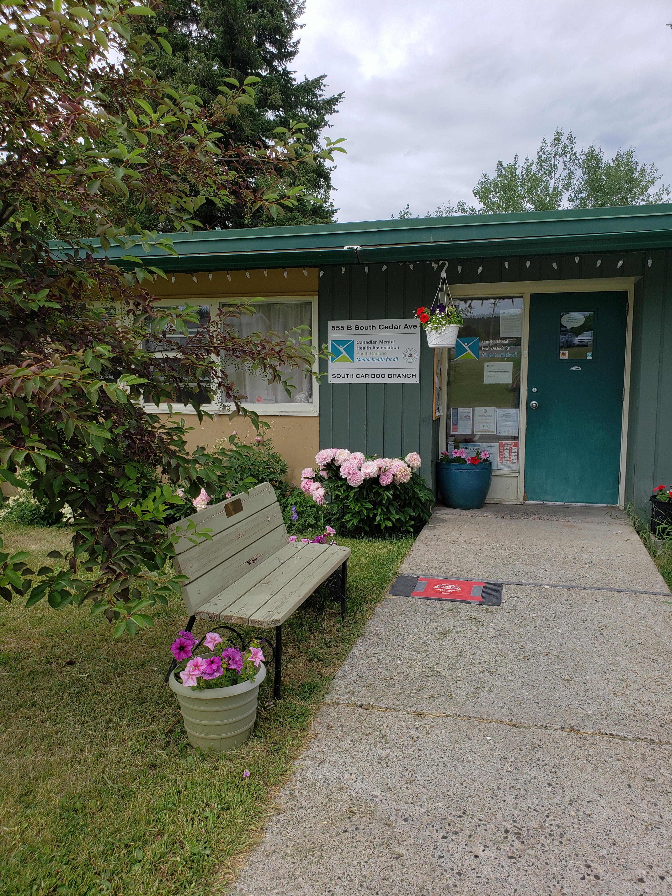

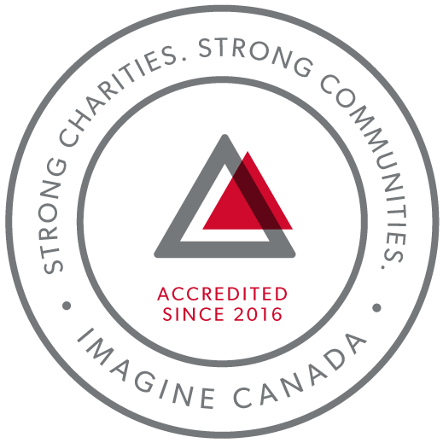
CMHA South Cariboo is an accredited organization through Imagine Canada’s Standards Program
Agency Profile: Canadian Mental Health Association, South Cariboo Branch, is an autonomous, non-profit, charitable organization with ethical and legal responsibilities to the National and BC Divisions of CMHA. Our mandate emphasizes the importance of people with lived experience of mental illness being involved in the delivery of service and governance wherever possible.

Our Vision: “Mentally Healthy People in a Healthy Society”

Our Mission: “To ensure that all people in Canada experience good mental health and well-being.”

CMHA South Cariboo Branch believes in:
- Social justice
- Individual and collective responsibility
- Access to appropriate and adequate resources and supports
- Self-determination
- Maximum community inclusion
- Working collaboratively with our community partners

Geographic Catchment area:
The South Cariboo is a sub-region of the Cariboo Regional District in the interior of British Columbia. Its main population center is the District Municipality of 100 Mile House, a community of approximately 2,000 residents. An additional 18,000 people live in the South Cariboo. The South Cariboo boundaries are roughly described as 70 Mile House in the South, to Lac la Hache in the North, the Fraser River to the West, and Lac des Roches and Mahood Lake to the East. The region includes 100 Mile House and many smaller communities such as Forest Grove, Buffalo Creek, Lac la Hache, 108 Mile Ranch, Lone Butte, Sheridan Lake, Bridge Lake, Watch Lake and Green Lake.

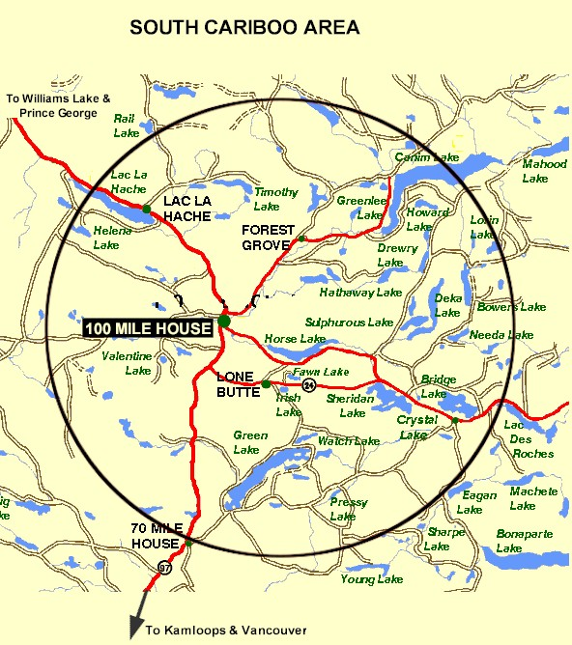

Board Chair’s Report:
First off, it’s important to give thanks. Thanks to Susann, Nicole, and their team of very dedicated staff of the South Cariboo CMHA Branch (CMHA SCB). It truly has been my pleasure to get to know some of the staff and what is happening in the operations side of the organization. Thank you one and all.
Now onto my Board colleagues; thank you for your enthusiasm & commitment for the work of CMHA SCB and your obligations as Board members. Once again, it’s been my pleasure working with you all.
So, what’s been happening over the past year? We have recruited a new skilled Board member: Trish Hoy, welcome. It appears we might have a lead on another quality candidate as well. If successful, that will bring our Board member numbers to 7.
Taking over the chair after a long-term chair departs takes a delicate balance of respect for the ways of the past and looking to impart any wisdom I may bring to the role. I believe that has/is happening. From sticking to the usual meeting day and time to urging everyone along to think bigger when it comes to raising our profile and fundraising capabilities.
The Covid pandemic seems to be behind the organization; Yay! Programs and client staff interactions are returning to pre-pandemic interactions. The Board is back meeting in person at the head office, with the option of using ZOOM for convenience.
My goal as Chair is to be available as often as possible for tasks such as cheque signing, attending events like the volunteer fair, heat mapping exercise, and the community safety awareness event. The role is to support the efforts of the Executive Director and the team of staff to provide the best service with the tools they have available.
The last big current task under way is the development of a new 5-year Strategic Plan for the organization. Draft one just went to the full board for review and comment. Hopefully, by years’ end we will have a living breathing document to guide us for 5 years to come. One of the exciting sections is something new for CMHA SCB. That is a section on climate change and the impacts it is/will continue to have on the community and its people and what can/should CMHA SCB be doing to support resilience and to move forward in a positive way.
Respectfully submitted by Marty Norgren, Board Chair

Executive Director Report:
The June 27th, 2023, Annual General Meeting provides an opportunity for our members to take a moment to look back upon and celebrate what we have accomplished over this past year.
The pandemic continued throughout the 2022-2023 fiscal year; we were able to provide services in all of our programs, and we are hopeful that we are moving into post pandemic times.
I am so proud of our staff, and grateful for their continued hard work and dedication. Thank you for all you do every single day. I sincerely and gratefully thank the CMHA South Cariboo board of directors and staff members for their continuing hard work: they are heroes all. They are a group of dedicated and compassionate people whose support and exemplary service to CMHA South Cariboo Branch accomplishes so much to improve the lives of the citizens of our community and the South Cariboo. Thank you to the people we serve; you are the heart of our organization, and it is our honour to serve you.
Thank you as well to our members; your ongoing support is very important to us.
I would also like to thank community agencies, community members and volunteers that have allowed us to promote mental health in our community, joining us as we work toward our goals of increasing mental health awareness, reducing the stigma associated with mental illness and raising the profile of CMHA’s work in the South Cariboo. This is an invaluable part of our work; locally, in BC and across Canada.
Susann Collins, Executive Director

History of the Canadian Mental Health Association

CMHA National: One of Canada’s Oldest Non-Profits
The Canadian Mental Health Association is one of the oldest national, charitable organizations in Canada and the oldest national mental health charity. Each year, CMHA divisions and branches across Canada provide service to almost 3 million Canadians through the combined efforts of more than 18,000 volunteers and staff in locally run organizations across the country. Visit CMHA National’s website for more information.
CMHA was founded in 1918 by Dr. Clarence M. Hincks, Dr. Charles K. Clarke and Clifford W. Beers as the Canadian National Committee for Mental Hygiene. The original goals of the organization centered on war recruits, mental examination of post-war immigrants, prevention, and support for adequate facilities and care for the treatment of mental illness.
CMHA is uniquely positioned in Canada as a charity that brings together community-based experience and expertise on the prevention of mental illness and community supports for the mental well-being of all Canadians. We are not only unique in our mental health promotion approach but also in our ability to speak to issues spanning the broad range of mental disorders and the full spectrum of those affected from those at risk, to those newly diagnosed, those who have been living with a psychiatric disability over the longer-term, as well as family, friends and community gatekeepers.

CMHA South Cariboo Branch
CMHA in the South Cariboo was started by a group of concerned individuals in the late 1980s. The group’s early meetings took place in the Rosewood Building on Birch Avenue in 100 Mile House, and included individuals living with mental illness, their friends and family members, mental health service providers and local physicians. As mental health support services in the South Cariboo at that time were very limited, the initial goal for members was to begin to develop resources and a network of support - both for individuals living with a mental illness, and to those who were part of their lives. The branch was incorporated in June 1992. The branch’s early goals were to be actively involved in the development of psychiatric services to our community, and to find funds to develop a clubhouse or drop-in center where people who live with mental illness could congregate, socialize, and receive the help needed to live successfully in their homes and community. Since its inception, CMHA South Cariboo Branch has grown from a one staff office to a multi-program system. We continue to take pride in our identity as a grassroots organization that adapts to serve the need of our community.
Prevention is fundamental to all of the services we provide and is reflected through the work of the branch during Mental Health Week, Mental Illness Awareness Week and at various community events throughout the year. It is also reflected in the services we provide to individuals who live with a serious and persistent mental illness. The South Cariboo Branch is proud to be among the branches that make up Canadian Mental Health Association BC Division, and part of our nation-wide federation.

The Framework for Support
The Framework is the central philosophy guiding the activities of CMHA. This philosophy holds that the person experiencing mental illness is at the center of any supportive mental health system.
The Community Resource Base outlines a range of possible resources in addition to the formal mental health system which can provide support to a person with mental illness. Housing, income, work and education represent four basic elements of citizenship.
The ultimate goal of the Framework is to ensure that people with serious mental health problems live fulfilling lives in the community. The Framework for Support is referred to as the most comprehensive model for mental health planning by federal and provincial governments as well as by the Centre for Community Change in the US, and the Government of Ireland.

Scholarship Report

We provide a $500 Scholarship to help a local student pursuing a career related to mental health (such as psychiatry or Community Mental Health Worker) when we receive applications that meet this criterion. The scholarship was awarded this year to 2 students.

Community Events

This past year we have started to participate in face-to-face community events, including Mental Health Week, the Santa Claus parade, and various other events.

Revenue :
Contract income - IHA: $ 218,007.24
B.C. Housing-H.O.W/Subsidies: $ 503,453.42
Grants: $ 151,271.89
Fundraising and Donations: $ 3,569.29
Rental (CTT): $ 165,274.00
Interest Income: $ 6,855.94
Legal Service Contract Income: $ 18,836.64
Miscellaneous: $ 3,170.00
COVID Relief $ 44,151.65
Contract income - STV: $ 107,361.13

=================Total: $1,221,951.20
Nicole Bissat - Finance Coordinator

Program Reports

Supported Independent Living Program (funded by Interior Health Authority)
The Supported Independent Living (SIL) Program supports clients to live independently in the community by providing emotional support, encouragement and life skills coaching in areas such as budgeting, nutrition, self-care and wellness. Clients are referred through Interior Health Mental Health and Substance Use Services. A care plan is developed by the client and their Health Team, which can consist of Interior Health Case Managers, Psychiatrist, Doctor, Canadian Mental Health SIL Worker and other health care professionals. The SIL Worker makes appointments with the client to help them with the identified goals as outlined in their plan. Care plans are adjusted as necessary according to what the individual needs.
The program is delivering Food Bank hampers 4 times a month to those in need and those who don’t have transportation. We have 2 client helpers who enjoy being able to contribute and help with this task.
With summer approaching we will be putting together safety plans for the fire season and making sure everyone is prepared for any emergencies that may arise. We are looking forward to a happy and productive year ahead.
Kathy Provost - SIL Outreach Worker and Lisa Higgins - SIL (Casual Outreach Worker)

Clubhouse/Activity Program (funded by Interior Health Authority)
The Clubhouse program provides a safe space where individuals with a mental illness can drop in Monday thru Friday from 12 pm until 3:45 pm. The focus of the Clubhouse program is to encourage social connection and peer support through preparing and sharing a meal together, recreation such as outings, picnics, gardening, etc. Members are encouraged to participate in all areas of the program, such as planning, preparing and cleanup of the lunches, planning the garden, as well as the outings and activities that are chosen.
In 2022 we continued serving meals inside, and after some time things returned to normal again, we returned to a single seating for lunch with more participant involvement in meal preparation and group activities.
In keeping with our commitment to recognize and share major holidays such as Thanksgiving and Christmas etc., a full course hot meal was prepared for our clients on these occasions. This brought on much pride since all of the vegetables (potatoes, carrots, brussels sprouts and peas) for our meals were grown ourselves in the CMHA garden out front. The turkeys were donated, and 19 meals were served for the Christmas meal.
Interior Health has sent several new referrals to the Clubhouse program, mostly due to social isolation. It has been heartwarming to see these new members join in on conversations, helping others with their tea and coffee, being the first to come and the last to leave. Many of them say it is their only “real” meal in their day. Budgeting is also a challenge as the cost of groceries is ever rising.
We have a really fun group of participants right now and the new activity of fishing on Fridays seems to be a popular one with a full van nearly every time we go, and even a couple of trips with up to 2 vehicles following us.
Rick McKinney - Clubhouse/Activity Worker

Homeless Outreach Program (funded by BC Housing)
The Homeless Outreach Program helps break the cycle of homelessness by assisting people who are homeless, or at risk of homelessness.
In the 2022-2023 fiscal year, the Homeless Outreach Program provided 4898 services to 2150 individuals - this is a 50% increase over the previous year. 10% of these individuals were new to our program.
The Homeless Outreach Program provided 1748 bed stays to homeless individuals -1400 more than the previous year.
While having shelter options is helpful, an increasing amount of people are unable to meet the requirements to stay in our high-barrier motel room shelter spaces. At least 85 hard to house individuals were turned away from our shelters or had their shelter stay terminated because their needs exceeded what we can provide.
BC Housing recently increased our shelter funding, which will allow us to shelter individuals all year.
Marnie Jensen - Homeless Outreach Worker

Cariboo Trail Terrace - Housing (funded by BC Housing)
Cariboo Trail Terrace is our subsidized family housing development located at 910 Cariboo Trail. Currently, all units are occupied with a combination of 3 Low-End Market Units and 22 Rent Geared to Income Units. As there is a housing crisis in this area, there is a long wait list for all the units.
Things are going very well at Cariboo Trail Terrace; we have good tenants who take care of their units, although we did have a very costly year with repairs. One unit was discovered to have frozen water pipes due to tenant moving out and turning the heat off prior to move out inspection, this resulted in damage to the kitchen cabinets and countertops, drywall, insulation and flooring. This repair caused the unit to be empty for 2 months while we renovated. We did also have 4 other tenants move out/ or into another unit and all 4 units recieved some updating and fresh paint. The fall inspections uncovered a lot of unreported repairs that needed to be completed and we worked away at the list and have now completed all identified defincies.
Rick McKinney - Housing Caretaker

Acquired Brain Injury Program (funded by Interior Health Authority)
The Acquired Brain Injury (ABI) Program provides support and encouragement for survivors of illness and injuries resulting in brain injuries that make it difficult to live independently. It is an Outreach Program that helps equip the clients for successful independent living. The ABI Program is administered through Interior Health out of Kamloops and Kelowna which provides oversight, referrals, and resources for the ABI worker in our region.
The ABI caseload has increased from 8 to 13, with several referrals pending.
Some of the ways that support can be given include helping program participants to make and attend appointments, shop for themselves, access needed government or other services or resources, and learn and practice life skills necessary for living on their own. Life skills include cooking, budgeting, coping with stress, developing social skills and decision making; the needs are as individual as the people supported.
Some important successes have been achieved by the participants in the program this past fiscal year. Some clients have improved their day-to-day life skills, some reintegrated into community activities, volunteering and returning to work part time.
Tshidi Machete - Acquired Brain Injury Support Worker
Receptionist (various funders)
The key responsibilities of the receptionist role are to:
- Receive visitors
- Provide information and support in crisis situations by connecting people to appropriate staff
- Act as a safety check-in person for staff working in the community
- Answer the telephone and direct to appropriate persons
- Type and create documents, reports and minutes
- Receive rent payments, issue receipts
- Update staff Outlook calendar
- Maintain records and prepare summary reports
- Schedule shift coverage when required for absent staff
- Other duties as assigned

The receptionist is the first voice and the first face the public sees when accessing our services. We must always remain professional, no matter the circumstances, and maintain a calm, supportive environment. We also support other staff members during challenging moments of the day. Between April 1, 2022, to March 31, 2023, approximately 1,488 front desk calls were received, and the door was answered 1,423 times.
During 2022, we followed all Interior Health protocols to ensure our staff and clients were safe. We ensured all PPE supplies were on hand for all departments. In 2023, we continue to follow the direction of Interior Health on appropriate measures to implement as conditions change.
Heather Richardson and Kelly Lafrentz - Receptionists/Schedulers

Community Navigator Program (funded by BC Gaming and the Canadian Red Cross)
The Community Navigator program was established to provide emergency and ongoing relief to marginalized people in the South Cariboo experiencing complex challenges, including poverty, mental health issues and geographic isolation, whose vulnerabilities have been compounded by the ongoing impacts of the wildfires.
The program assists individuals and families in the South Cariboo region to meet essential needs, navigate local, provincial, and federal services, and connection with the supports and resources they require to recover from trauma in the aftermath of the wildfires. The Community Navigator Program provides relevant information, accompaniment of individuals to support an in-person connection with a local resource, or provide other means of support and connection according to a client’s individual needs and circumstances.
In 2022/2023 fiscal year the Community Navigator program helped 717 clients with 88 of those being new clients.
The Community Navigators joined the Community Safety Committee with members of City Council, the Fire Chief, the Head Paramedic and the 100 Mile RCMP Staff Sargent. The Safety Committee meets once a month and talks about topical issues in and around the community and brainstorms ways to solve them.
The need for the Community Navigator program continues to be strong as the community faces a rental housing shortage and prices for food and fuel continue to rise.
Kristin Wells and Kim Fraser - Community Navigators

Safe House Program (funded by BC Housing)
The CMHA Safe House Program continues to help break the cycle of domestic violence by assisting women and children who are fleeing abuse. The Safe House program provides emergency safe housing, groceries, emotional support, safety planning, referrals and transportation to longer term transition houses, and referrals to counselling services, legal aid and other community resources, according to the needs of the individual woman.
A Safe House Coordinator is available 24 hours per day, seven days a week. Back up Safe House coordinator services have been provided by Tshidi Machete and other CMHA staff.
Safe House Coordinators offer women the information they need to make informed decisions. In the 2022/2023 fiscal year 41 women and 1 child were supported, and 18 enquiries from other agencies about services available were responded to. All clients were provided with safety planning.
While fewer women stayed in Safe House than the previous year, many stays were of longer duration. More pets, including emotional support animals, were also accommodated. The lack of rental accommodations in 100 Mile House and vicinity makes finding housing for clients extremely challenging and the Safe House program has often depended on the Homeless Outreach Program to assist in this area, reflecting the need for first and second stage housing for Safe House clients in the 100 Mile area.
5 women who were able to leave the community were provided with transportation by bus or assistance with gas for their own vehicle to get to longer term accommodation in transition houses in other areas.
The majority of Safe House referrals this past fiscal year have been from law enforcement, and a good working relationship continues between Safe House and the 100 Mile House RCMP and Victim Services. Officers can call Safe House workers directly instead of going through VictimLink. This allows for faster communications in emergency situations. Officers have been helpful and supportive to Safe House clients, providing transportation and occasional escort services when a client must attend an appointment but is fearful of encountering the abuser. Other service providers such as the hospital, Cariboo Family Enrichment Centre and Child & Family Services also have the direct number.
Clients who do not stay in Safe House but are looking for support services are regularly referred to the STV Counselling program, and other community resources.
Roxanne Salinas - Safe House Coordinator

Stopping the Violence Program (funded by the Ministry of Public Safety and Solicitor General and the Canadian Women’s Foundation)
The Stopping the Violence Counselling (S.T.V.) Program offers essential services to women. The S.T.V. Counsellor and S.T.V. Assistant (decreased hours) continue to work very closely within the same office space and for client management. The S.T.V. Counselling Program offers counselling services for scheduled, unscheduled, support, follow-up, and emergency appointments for individuals and group services. The S.T.V. Counselling Assistant offers intake support with reception services to women who experienced violence and abuse, childhood abuse and sexual assault. There have been referrals (Clinton RCMP Victim Services) and support needs for women/youth under age 19 who have been sexually assaulted.
The main highlight in 2022-2023 was developing, coordinating and facilitating a Shock Proofing Communities (S.P.C.) Program that was funded by Canadian Women’s Foundation. We offered two different services to women that would help determine their needs in Clinton and 70 Mile House. We listened to women about their personal and community needs and gaps in services during an interview process. Based upon this interview process, we provided a customized five-week workshop to women; “Honoring Ourselves, Building Resiliency”. The intention of the workshop was to support women in issues related to isolation, trust, trauma, coping strategies, behavior change, and capacity building for self and the community. Both services were well received and appreciated. The workshop gave the opportunity for women to be involved in psychoeducation, develop awareness, heal, and socialize with others in same or similar situations; an opportunity they may not have had otherwise.
Our statistics for the fiscal year 2022-2023 reflect program delivery of general contacts (including S.P.C. interviews), individual and group counselling (S.P.C.) services, and follow-up support. The S.T.V. Counselling Program had 726 contacts (increase from 619 for 2021-2022), 278 scheduled sessions (decrease from 283 for 2021-2022), 24 group counselling (S.P.C.) and 392 support follow-up contacts (increase from 319 for 2021-2022).
Kalika Moody - S.T.V. Counsellor and Tshidi Machete - S.T.V. Counselling Assistant

Soupe de Tour (funded by BC Gaming):
The program supplies soup every two weeks to different organizations and other community groups, who in turn distribute the soup to the people they serve. The soup is prepared by the Chartreuse Moose restaurant and has been appreciated by all.
This program provides soup to the following places: Cedar Crest Society for Community Living, CMHA Clubhouse, Loaves and Fish, Friendship Center and to the refugee program (for people fleeing the war in Ukraine).
Tshidi Machete - Soupe de Tour Worker

Senior’s Program (COVID 19 funding from the United Way by way of Interior Community Services)
In 2022, our organization applied for and received $20,000 from Interior Community Services Society to use for seniors supports.
This funding was used to purchase over 200 grocery store and gas station gift cards, prescriptions, Boost nutritional drinks, and 220 frozen meals from the Roe Lake and District Recreation Commission. These items were distributed to more than 70 seniors in our community.
The increase in cost-of-living expenses can hit seniors especially hard and this funding alleviated some of the stress associated with buying necessities.
Marnie Jensen - Homeless Outreach Worker
Kristin Wells and Kim Fraser - Community Navigators

Our Board of Directors during 2022-2023

President/Chair and Treasurer: Marty Norgren
Co-Vice Chairs: Kathy (Kitten) Cadrin and Rick Meyer
Fundraising Committee: Kathy (Kitten) Cadrin
Directors: Didi Henderson and Marion Fallding

